Introduction to Bayesian Statistics with R using NIMBLE and brms

Olivier Gimenez

2026-02-24

Table of Contents

# Introduction

Bayesian statistics can be found almost everywhere in science. For example, in epidemiology to predict the spread of viruses, in ecology to understand the extinction of plant and animal species, or in computer science to filter unwanted emails. The widespread adoption of Bayesian methods over the past decades has largely been driven by advances in computing power. But it is also due to the nature of the approach itself, which closely matches how we learn, reason, and accumulate knowledge.

In this book, I offer an introduction to Bayesian statistics. You are currently reading the electronic version of the book, which is the English version of a book published by Quae in March 2026.

My goals in writing this book were twofold:  
1) to synthesize the key methodological concepts that are essential to understand, and  
2) to provide practical tools so that you can apply Bayesian statistics yourself.

Because we learn best by doing, we will use software to practice statistics. That software is R, a free and open-source environment for statistical computing and data science.

For Bayesian analysis specifically, I present two practical tools:

* brms, which provides a simple and familiar syntax similar to classical regression modeling in R;
* NIMBLE, which requires more programming but offers great flexibility.

Rather than adopting a formal academic style, I chose to write this book as if we were in the same room - or on a video call - and I were explaining Bayesian statistics to you directly. As a result, I will occasionally (and sometimes often) use informal language and mathematical shortcuts to make the ideas easier to grasp. I hope you will not mind.

## Why learn Bayesian statistics?

Bayesian statistics provides a framework for analyzing data and making decisions under uncertainty, much like predicting the weather or rolling a die: we cannot know exactly what will happen, but we can estimate the probability of different outcomes.

Why adopt this approach? Several reasons may motivate its use:

* **A natural interpretation of probability**: in Bayesian statistics, probability represents a degree of belief in a hypothesis or parameter, aligning well with how we intuitively reason under uncertainty;
* **Great flexibility**: the Bayesian framework handles incomplete, heterogeneous, or scarce data, as well as complex models (hierarchical, nonlinear, dynamic, etc.);
* **Integration of prior knowledge**: previous studies or expert knowledge can be incorporated transparently and formally;
* **Explicit uncertainty quantification**: Bayesian inference provides not only parameter estimates but also direct measures of uncertainty.

## What you will learn in this book

My goal is to guide you through the learning process of Bayesian statistics. I have gathered the material that I consider essential for understanding and applying the approach. By the end, you should feel comfortable using Bayesian methods with your own data.

The objectives are to:

* demystify Bayesian statistics and Markov chain Monte Carlo (MCMC) methods;
* understand the differences between Bayesian and frequentist approaches;
* read and interpret the “methods” sections of scientific articles using Bayesian analysis;
* implement Bayesian analyses in R.

Chapter 1 introduces the foundations, revisiting key probability concepts and presenting core ideas through a simple example.

Chapter 2 takes you behind the scenes of Bayesian inference, explaining MCMC methods and guiding you through coding your own Bayesian analysis.

Chapter 3 introduces two powerful tools for Bayesian modeling: NIMBLE and brms.

Chapter 4 focuses on prior distributions—how to choose them, incorporate existing knowledge, and avoid common pitfalls.

Chapter 5 presents Bayesian linear regression, including model comparison and validation, with examples using both NIMBLE and brms.

Chapter 6 extends the discussion to generalized linear models, with and without random effects, illustrated through simulated data.

Finally, the last chapter summarizes the key take-home messages and offers practical advice for applying Bayesian statistics.

## How to read this book

There is no single “best” way to read this book. Personally, I always find it difficult to absorb all the information in a technical book in one pass. You may read it sequentially or dip into specific sections as needed.

In each chapter, the R code is provided; I have hosted it at <https://github.com/oliviergimenez/introduction-to-bayesian-statistics-with-R> and will update it. Practicing helps to better understand and to check that we have indeed understood. If you are reading the electronic version available at <https://oliviergimenez.github.io/introduction-to-bayesian-statistics-with-R>, you can copy the lines of code and then paste them into R to run them. To save some space and avoid disrupting the reading too much, some code is not shown, in particular the code used to produce the figures, but it is available at <https://github.com/oliviergimenez/introduction-to-bayesian-statistics-with-R>. There you will find (i) the complete R code and the texts that make up the chapters of this book (the following R Markdown files: index.Rmd, 01-principles.Rmd, 02-mcmcmethods.Rmd, 03-implementation.Rmd, 04-priors.Rmd, 05-regression.Rmd, 06-glms.Rmd and 07-conclusions.Rmd) as well as (ii) the R scripts cleaned of the text to allow you to run the code more easily (the compressed file scriptsR.zip).

## Further reading

If you would like to go further, I recommend the following books, whose list is of course not exhaustive. These books were a source of inspiration in writing this book. I hesitated to provide more references, and to cite (many) scientific articles, but I will not do so; the books below are more than sufficient.

* Bayesian Methods for Ecology (McCarthy 2007). A short and truly accessible book to understand how to apply Bayesian statistics in ecology without getting lost in the mathematics. The book website is here <https://bit.ly/4jSlfQL>.
* Applied Statistical Modelling for Ecologists: A Practical Guide to Bayesian and Likelihood Inference Using R, JAGS, NIMBLE, Stan and TMB (Kéry and Kellner 2010). A practical manual to learn how to model with the main Bayesian tools in R (JAGS, NIMBLE, Stan or TMB), based on concrete ecological examples and comparisons of results. The companion website with the code is here <https://www.elsevier.com/books-and-journals/book-companion/9780443137150>.
* Bayes Rules!: An Introduction to Applied Bayesian Modeling (Johnson, Ott, and Dogucu 2022). A very pedagogical book to discover the principles and applications of Bayesian statistics in an intuitive and progressive way. The book is available online here <https://www.bayesrulesbook.com/>.
* Doing Bayesian Data Analysis: A Tutorial with R and Bugs (Kruschke 2010). A thorough and visual tutorial that guides the learning of Bayesian statistics step by step with many practical examples. Everything is available at <https://sites.google.com/site/doingbayesiandataanalysis/>.
* Bayesian Data Analysis (A. Gelman et al. 2013). The reference book for those who wish to acquire a solid theoretical and applied understanding of Bayesian statistics. The book website is here <https://sites.stat.columbia.edu/gelman/book/>.
* Statistical Rethinking: A Bayesian Course with Examples in R and Stan (McElreath 2020). A captivating book to learn how to build and interpret Bayesian models by first developing statistical intuition. All the details are here <https://xcelab.net/rm/>, and I highly recommend the video course here <https://github.com/rmcelreath/stat_rethinking_2024>.

## How this book was written

This book was written in RStudio (<http://www.rstudio.com/ide/>) using the bookdown package (<http://bookdown.org/>). The website is hosted via GitHub Pages (<https://pages.github.com/>).

I used R version R-4.5.2_2025-10-31 and the following packages:

| package | version | source |
| --- | --- | --- |
| bookdown | 0.43 | CRAN (R 4.5.0) |
| brms | 2.22.0 | CRAN (R 4.5.0) |
| lme4 | 1.1-37 | CRAN (R 4.5.0) |
| MCMCvis | 0.16.3 | CRAN (R 4.5.0) |
| nimble | 1.3.0 | CRAN (R 4.5.0) |
| posterior | 1.6.1 | CRAN (R 4.5.0) |
| tidyverse | 2.0.0 | CRAN (R 4.5.0) |
| visreg | 2.7.0 | CRAN (R 4.5.0) |

## About the author

My name is Olivier Gimenez (<https://oliviergimenez.github.io/>). I am a senior scientist at CNRS. After studying mathematics, I completed a PhD in statistics applied to ecology. I later obtained my habilitation (HDR) in ecology and evolution and returned to university to study sociology.

I have authored scientific articles (<https://oliviergimenez.github.io/publication/papers/>) using Bayesian statistics and co-written several books (<https://oliviergimenez.github.io/publication/books/>), some of which also cover Bayesian methods.

You can find me on BlueSky ([oaggimenez.bsky.social](https://bsky.app/profile/oaggimenez.bsky.social)) and LinkedIn ([olivier-gimenez-545451115/](https://www.linkedin.com/in/olivier-gimenez-545451115/)), or contact me by email.

## Acknowledgements

I thank my employer, the French National Centre for Scientific Research (CNRS). Being a researcher is a meaningful and valuable profession. However, we are witnessing a gradual deterioration of working conditions in academia, with increased competition, precarity, and fewer permanent positions. I am fortunate to work in a supportive environment at the Centre for Functional and Evolutionary Ecology (CEFE), where collaboration and collective spirit remain strong.

My interest in Bayesian statistics dates back to my postdoctoral years in England and Scotland. I thank Byron Morgan for giving me the freedom to explore this field, Ruth King for our collaborations and my first experience writing a book, and Steve Brooks for the many stimulating discussions.

I am grateful to the Master’s students I have taught for over ten years - they have unknowingly contributed to shaping this project. I also thank all students and postdoctoral researchers who have shared part of their journey with me.

Thanks to the people who kindly agreed to read parts of this book.

Finally, this book is dedicated to Eleni, Gabriel, and Mélina.

# The Bayesian approach

## Introduction

In this chapter, we lay the foundations by revisiting a few probability concepts that will be useful later on. I introduce the key ideas of Bayesian statistics through a simple example that helps fix ideas, and that we will often use throughout the book. We will also draw parallels between classical (or frequentist) statistics and Bayesian statistics.

## Bayes’ theorem

Let us not delay any further and get to the heart of the matter. Bayesian statistics relies on Bayes’ theorem (or Bayes’ formula), whose first formulation is attributed to the mathematician and Reverend Thomas Bayes. This theorem was published in 1763, two years after Bayes’ death, thanks to the efforts of his friend Richard Price. It was also discovered independently by Pierre-Simon Laplace.

Bayes’ theorem concerns conditional probabilities, which can sometimes be a bit tricky to understand. The conditional probability of an event A given an event B, denoted $Pr\left(A∣B\right)$, is the probability that A occurs, revised by taking into account the additional information that event B has occurred. For example, imagine that one of your friends rolls a (fair) die and asks you for the probability that the result is a six (A). Your answer is 1/6 because each face of the die has the same chance of appearing. Now, imagine that you are told that the number obtained is even (B) before you answer. Since there are only three even numbers, and only one of them is six, you can revise your answer: $Pr\left(A∣B\right)=1/3$.

Do you see how the additional information (here, knowing that the number is even) changes the estimate? This is exactly the kind of reasoning that Bayes’ theorem formalizes and generalizes: it makes it possible to compute the probability of an event A given that another event B has occurred. More precisely, Bayes’ theorem gives you $Pr\left(A∣B\right)$ using the marginal probabilities $Pr\left(A\right)$ and $Pr\left(B\right)$ and the probability $Pr\left(B∣A\right)$:

$$Pr\left(A∣B\right)=\frac{Pr\left(B∣A\right) Pr\left(A\right)}{Pr\left(B\right)}.$$

We talk about a marginal probability when we are interested in the probability of an event “on its own”, without any particular condition. For example, $Pr\left(A\right)$ or $Pr\left(B\right)$ are the overall chances of A or of B, without taking anything else into account. We say “marginal” because, if you made a table with all possible combinations (for instance, die outcomes classified as even/odd and as “six/not six”), then $Pr\left(A\right)$ and $Pr\left(B\right)$ would be obtained by adding the cells in a row or a column—i.e., what you read in the margin of the table.

Bayes’ theorem is often seen as a way to go from an effect B back to an unknown cause A, by knowing the probability of the effect B given the cause A. Think, for example, of a situation where a medical diagnosis is needed, with A an unknown disease and B symptoms; the physician knows the risks of having certain symptoms depending on several diseases, i.e. $Pr\left(\text{symptoms}|\text{disease}\right)$ , and wishes to infer the probability of having a disease given the symptoms, i.e. $Pr\left(\text{disease}|\text{symptoms}\right)$ . This way of “reversing” $Pr\left(B∣A\right)$ into $Pr\left(A∣B\right)$ is why Bayesian reasoning is sometimes called “inverse probability”.

Rather than using letters at the risk of getting confused, I find it easier to remember Bayes’ theorem written like this:

$$Pr\left(\text{hypothesis}∣\text{data}\right)=\frac{Pr\left(\text{data}∣\text{hypothesis}\right) Pr\left(\text{hypothesis}\right)}{Pr\left(\text{data}\right)}.$$

The hypothesis can be a parameter such as the probability that a disease occurs, or regression coefficients linking this probability to risk factors (for example, place of residence, smoking). Bayes’ theorem tells us how to obtain the probability of a hypothesis from the available data.  
This is relevant because, think about it: this is exactly what the scientific method does. We want to know how plausible a hypothesis is given data that we have collected, and perhaps compare several hypotheses with one another. From this point of view, Bayesian reasoning aligns with scientific reasoning, which probably explains why the Bayesian framework feels so natural for doing and understanding statistics.

You might then ask why Bayesian statistics is not the norm. For a long time, implementing Bayes’ theorem was limited by computational difficulties, as we will see in the next chapter. Fortunately, increases in computing power and the development of new algorithms have led to a marked rise of the Bayesian approach over the past thirty years.

## What is Bayesian statistics?

Typical statistical problems consist in estimating one (or several) parameters from available data. Let us denote this parameter (or these parameters) generically, say $θ$. To estimate $theta$, you are probably more familiar with the frequentist approach than with the Bayesian approach. The frequentist approach, in particular maximum likelihood estimation, assumes that parameters are fixed but unknown. Classical estimators are therefore generally point values; for instance, an estimator of the probability of obtaining a face of a die is the number of times that face was observed divided by the number of times the die was rolled. The Bayesian approach assumes that parameters are not fixed and follow an unknown distribution. A probability distribution is a mathematical expression that gives the probability that a random variable takes certain values. It can be discrete (for example, the Bernoulli distribution, the binomial distribution, or the Poisson distribution) or continuous (such as the normal or Gaussian distribution).

The Bayesian approach rests on the idea that you start with some knowledge about the system even before studying it yourself. Then, you collect data and update this prior knowledge based on the observations. This updating process relies on Bayes’ theorem. In simplified form, taking $A=θ$ and $B=\text{data}$, Bayes’ theorem makes it possible to estimate the parameter $θ$ from the data as follows:

$$Pr\left(θ∣\text{data}\right)=\frac{Pr\left(\text{data}∣θ\right)×Pr\left(θ\right)}{Pr\left(\text{data}\right)}.$$

Let us take a moment to review each term in this formula.

On the left, we have $Pr\left(θ∣\text{data}\right)$, the posterior distribution: the probability of $θ$ given the data. It represents what you know about $θ$ after seeing the data. This is the basis of inference and it is precisely what you are looking for: a distribution, possibly multivariate if you have several parameters.

On the right, we have $Pr\left(\text{data}∣θ\right)$, the likelihood. The probability of the data given $θ$. This quantity is the same as in the classical or frequentist approach. Yes: Bayesian and frequentist approaches share the same component, the likelihood, which explains why their results are often close. The likelihood expresses the information contained in your data, given a model parameterized by $θ$. We will come back to it in Section 1.5.

Next, we have $Pr\left(θ\right)$, the prior distribution. This quantity represents what you know about $θ$ before seeing the data. This prior distribution should not depend on the data; in other words, one should not use the data to construct it. It can be vague or non-informative if you know nothing about $θ$. Often, you never really start from zero, and ideally you would like your prior to reflect existing knowledge. I will discuss priors in more detail in Chapter 4.

Finally, there is the denominator $Pr\left(\text{data}\right)$, sometimes called the average likelihood, averaged with respect to the prior, because it is obtained by integrating the likelihood under the prior distribution: $Pr\left(\text{data}\right)=∫Pr\left(\text{data}∣θ\right)×Pr\left(θ\right) dθ$. This quantity normalizes the posterior distribution so that it integrates to 1. In other words, since $∫Pr\left(θ∣\text{data}\right) dθ=1$ because the integral of a probability density equals 1, we have $∫\frac{Pr\left(\text{data}∣θ\right)×Pr\left(θ\right)}{Pr\left(\text{data}\right)} dθ=1$. And since $Pr\left(\text{data}\right)$ does not depend on $θ$, we have $Pr\left(\text{data}\right)=∫Pr\left(\text{data}∣θ\right)×Pr\left(θ\right) dθ$. This is an integral whose dimension equals the number of parameters $\text{theta}$ to estimate: for two parameters, a double integral; for three parameters, a triple integral; and so on. However, beyond three dimensions, it becomes difficult, even impossible, to compute this integral. This is one of the reasons why the Bayesian approach was not used earlier, and why we need algorithms to estimate posterior distributions, as I explain in Chapter 2. In the meantime, we will work through a relatively simple example in which the posterior distribution has an explicit form.

## A running example

Let us take a concrete example to fix ideas. I work on the coypu (*Myocastor coypus*) (Figure 1), a semi-aquatic rodent native to South America, introduced into Europe for fur farming. It is now considered an invasive alien species, because of the damage it causes in wetlands (bank erosion, destruction of vegetation) and its possible role in transmitting leptospirosis to humans, a potentially severe bacterial infection transmitted through water. Thanks to its high fecundity and good adaptation to temperate climates, the coypu has proliferated rapidly.



Figure 1: Photograph of coypus (Myocastor coypus) taken in the Lez watershed near Montpellier, France. Credits: Yann Raulet.

One of the questions I am interested in is estimating the probability of surviving the winter, coypus being particularly sensitive to cold. To do this, we equip several individuals with a GPS tag at the beginning of winter, say here $n=57$. At the end of winter, we observe that $y=19$ coypus are still alive. The goal is to estimate the winter survival probability, which we denote $θ$. Here are the data:

y <- 19 # number of individuals that survived the winter  
n <- 57 # number of individuals monitored at the start of winter

You are probably thinking that, with this information, we can already estimate a survival probability. Intuitively, we think of the proportion of individuals that survived, i.e. $19/57$ . And you are not wrong. This is a reasonable estimate of $θ$, the winter survival probability. Let us now try to formalize this intuition, in order to better understand what it represents, and what it assumes.

As mentioned above, the likelihood is a central concept found in both frequentist and Bayesian approaches. So let us start by constructing this likelihood. To do that, we need to make a few assumptions.

First, we assume that individuals are independent, meaning that the survival of one coypu does not influence the survival of other coypus. This is a strong assumption, especially when we know that a female can reproduce two to three times per year and give birth to up to ten offspring that depend on her early in life. But, in modeling, it is often better to start simple.

Second, we assume that all individuals have the same survival probability. Again, this is a simplification: we know, for example, that juvenile mortality is higher than adult mortality.

Under these two assumptions, the number $y$ of animals still alive at the end of winter follows a binomial distribution, with $θ$ as the probability of success (survival) and $n$ as the number of trials (monitored individuals). We write $y∼\text{Bin}\left(n,θ\right)$. The binomial distribution is in fact the sum of several independent Bernoulli trials, as in the classic heads-or-tails example. At each trial—here, the release of a GPS-tagged coypu at the beginning of winter—we assume a probability $θ$ of success, i.e. surviving the winter, and failure, i.e. dying from cold. If all these trials are independent and have the same probability of success (our assumptions), then the number of successes, or the number of coypus alive at the end of winter, follows a binomial distribution (see also Chapter 6). I provide examples of Bernoulli and binomial draws in Figure 2.

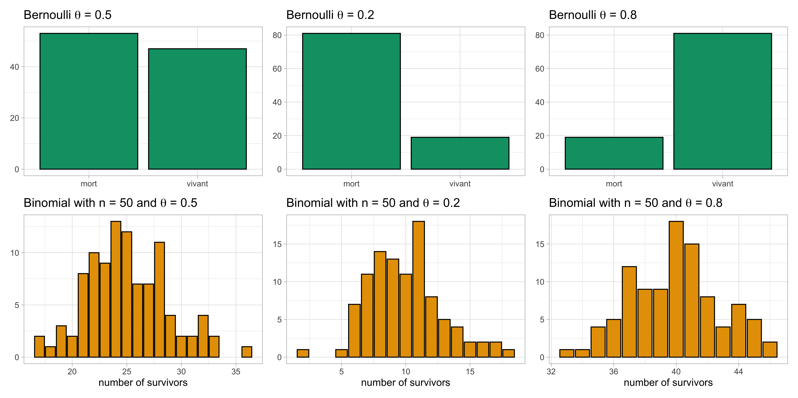

Figure 2: Discrete probability distributions, Bernoulli and binomial, illustrated with 100 simulations (random draws generated by computer). On the top row, we show the observed frequency from a Bernoulli draw for different values of survival probability $θ$. On the bottom row, we show histograms for a binomial draw with 50 trials and different values of survival probability $θ$.

As an aside, it is easy to get mixed up between all the terms used to describe a Bernoulli and a binomial distribution (and the normal distribution): you can remember that a probability is a number, a distribution is a law, and a density is the function that represents it.

## Maximum likelihood

In the classical (or frequentist) approach, we estimate the survival probability $θ$ using the maximum likelihood method. But what does that mean in practice? It means finding the value of $θ$ that makes the observed data most likely. In other words, since the data are what they are—they have been observed—we look for the value of $θ$ that maximizes the probability that this dataset was generated.

How do we justify this rather intuitive idea mathematically? Read carefully the end of the previous paragraph. The idea of looking for the value that gives the largest probability amounts to maximizing something. But what exactly? The probability of the data, given a certain model parameterized by $θ$—in other words, the likelihood, or $Pr\left(\text{data}|θ\right)$, which we saw in Section 1.3. Classical estimation therefore relies on maximizing the likelihood—or rather the likelihood function, i.e. the likelihood considered as a function of $θ$.

In our case, we have a binomial experiment: we follow $n$ coypus over the winter, each having a probability $θ$ of surviving. We know the probability of each possible outcome (the probability mass function). For example, the probability that no coypu survives is ${\left(1-θ\right)}^{n}$, because each of the $n$ individuals dies with probability $1-\text{theta}$. If we take, for example, a survival probability of 0.5, we have ${\left(1-0.5\right)}^{57}≈0$. We can compute this probability in R with the dbinom() function:

dbinom(x = 0, size = 57, prob = 1 - 0.5)  
#> [1] 6.938894e-18

where the first argument x = 0 corresponds to no coypu alive. Conversely, the probability that all survive is $θ^{n}$, which has the same value. You can check in R with dbinom(x = 57, size = 57, prob = 0.5). If exactly one coypu survives, then one of the $n$ survives with probability $θ$, and the other $n-1$ die with probability ${\left(1-θ\right)}^{n-1}$. Since any of the $n$ coypus can be the one that survives, we obtain a total probability of $n,θ,{\left(1-θ\right)}^{n-1}$. We can compute this probability with dbinom(x = 1, size = 57, prob = 0.5). More generally, the probability that $y$ individuals survive is given by $\left({n \atop y}\right)θ^{y}{\left(1-θ\right)}^{n-y}$. If we consider this expression as a function of $θ$ (and not of $y$), we obtain the likelihood function $L\left(θ\right)=\left({n \atop y}\right)θ^{y}{\left(1-θ\right)}^{n-y}$. The term $\left({n \atop y}\right)$ is called the binomial coefficient and is read “ $y$ out of $n$”. It corresponds to the number of different ways to choose $y$ survivors among the $n$ coypus, without regard to their order.

We can plot this likelihood in R as in Figure 3:

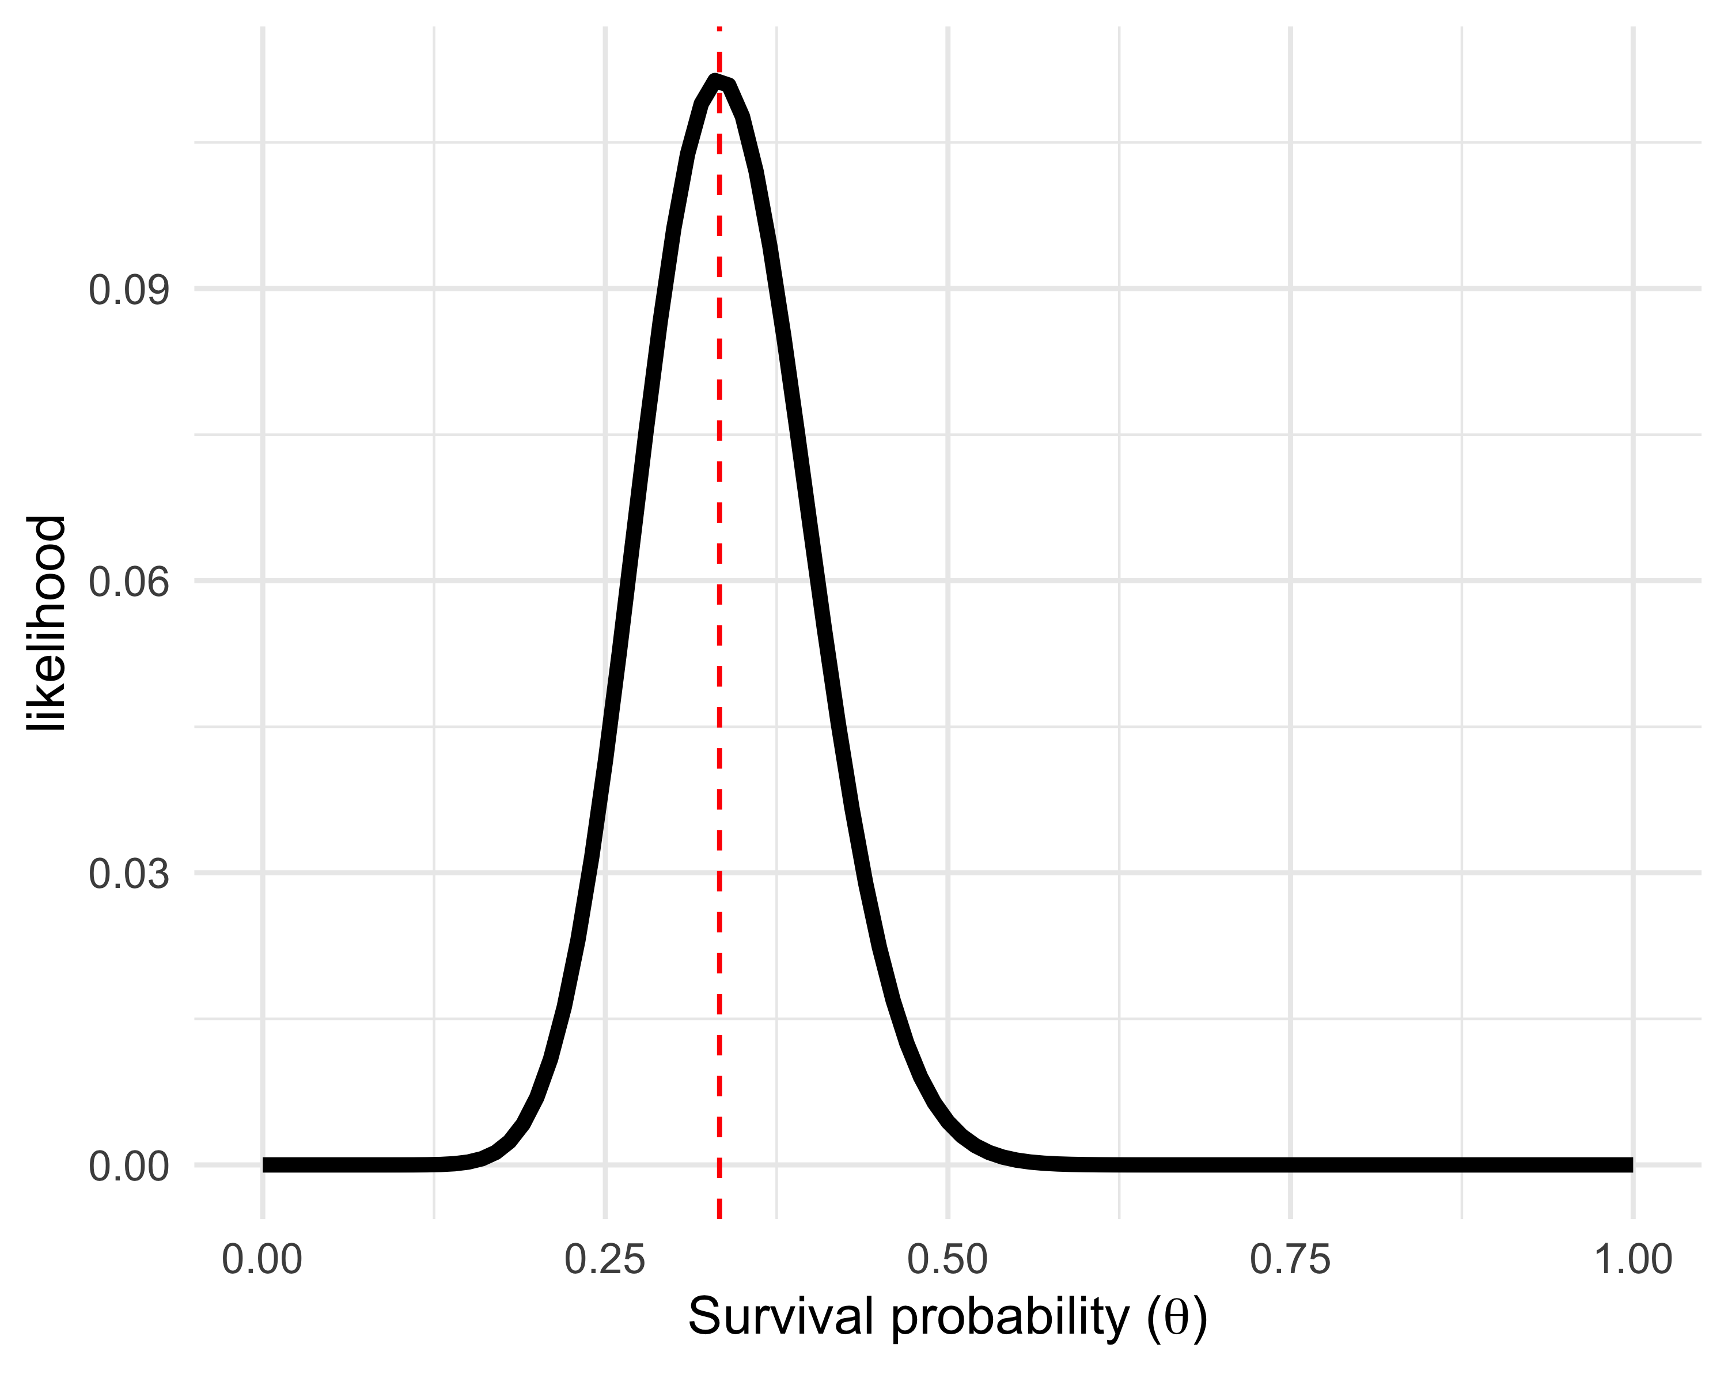

Figure 3: Likelihood function for the winter survival probability of the coypu, computed from $y=19$ survivors out of $n=57$ individuals monitored by GPS. The maximum likelihood estimate is indicated by the red dashed line.

Our goal is to find the value of $θ$ that maximizes this function. In other words, we look for the survival value (on the x-axis in Figure 3) that maximizes the likelihood (on the y-axis). This value corresponds to the maximum likelihood estimator, often denoted $\hat{θ}$. To do this, it is often more convenient to work with the logarithm of the likelihood (the log-likelihood), because sums are numerically more stable and easier to differentiate than products:

$$l\left(θ\right)=logL\left(θ\right)=log\left({n \atop y}\right)+ylogθ+\left(n-y\right)log\left(1-θ\right).$$

The first term, $log\left({n \atop y}\right)$, does not depend on $θ$, so we can ignore it in what follows. We then differentiate the log-likelihood with respect to $\text{theta}$:

$$\frac{dl\left(θ\right)}{dθ}=\frac{y}{θ}-\frac{n-y}{1-θ}.$$

We look for the value of $θ$ that makes this derivative equal to zero:

$$\frac{y}{θ}-\frac{n-y}{1-θ}=0.$$

After a few simplifications, we obtain that the maximum likelihood estimator $\hat{θ}$ is:

$$\hat{θ}=\frac{y}{n}.$$

This result matches our initial intuition: the maximum likelihood estimator is the proportion of individuals that survived, i.e. $19/57≈0.333$ . We can visualize this result in Figure 3, where the maximum likelihood estimate is indicated by the red dashed line.

In practice, models contain multiple parameters—dozens or even hundreds—and we cannot apply the same analytic method to maximize the likelihood and find the maximum likelihood estimators. Instead, we use iterative optimization algorithms that solve the problem for us, adjusting step by step an initial value until they find the one that maximizes the likelihood. For example, in R, we can obtain exactly the same result by using a logistic regression without covariates (see Chapter 6):

mod <- glm(cbind(y, n - y) ~ 1, family = binomial)  
theta_hat <- plogis(coef(mod))  
theta_hat  
#> (Intercept)   
#> 0.3333333

The direct calculation $\hat{θ}=y/n$ and the result of calling the glm function are consistent: they give the same value.

## And in the Bayesian framework?

In the Bayesian approach, we start by expressing our prior knowledge about the quantity we want to estimate—here, the winter survival probability theta. We know that theta is a continuous variable between 0 and 1. A natural prior distribution in this case is the beta distribution. The beta distribution is defined by two parameters, $a$ and $b$, which control its shape:

$$q\left(θ∣a,b\right)=\frac{1}{\text{Beta}\left(a,b\right)}θ^{a-1}{\left(1-θ\right)}^{b-1}$$

with:

$$\text{Beta}\left(a,b\right)=\frac{Γ\left(a\right)Γ\left(b\right)}{Γ\left(a+b\right)}, Γ\left(n\right)=\left(n-1\right)!$$

You can forget these equations if you are not comfortable with them. Let us instead visualize this distribution as in Figure 4:

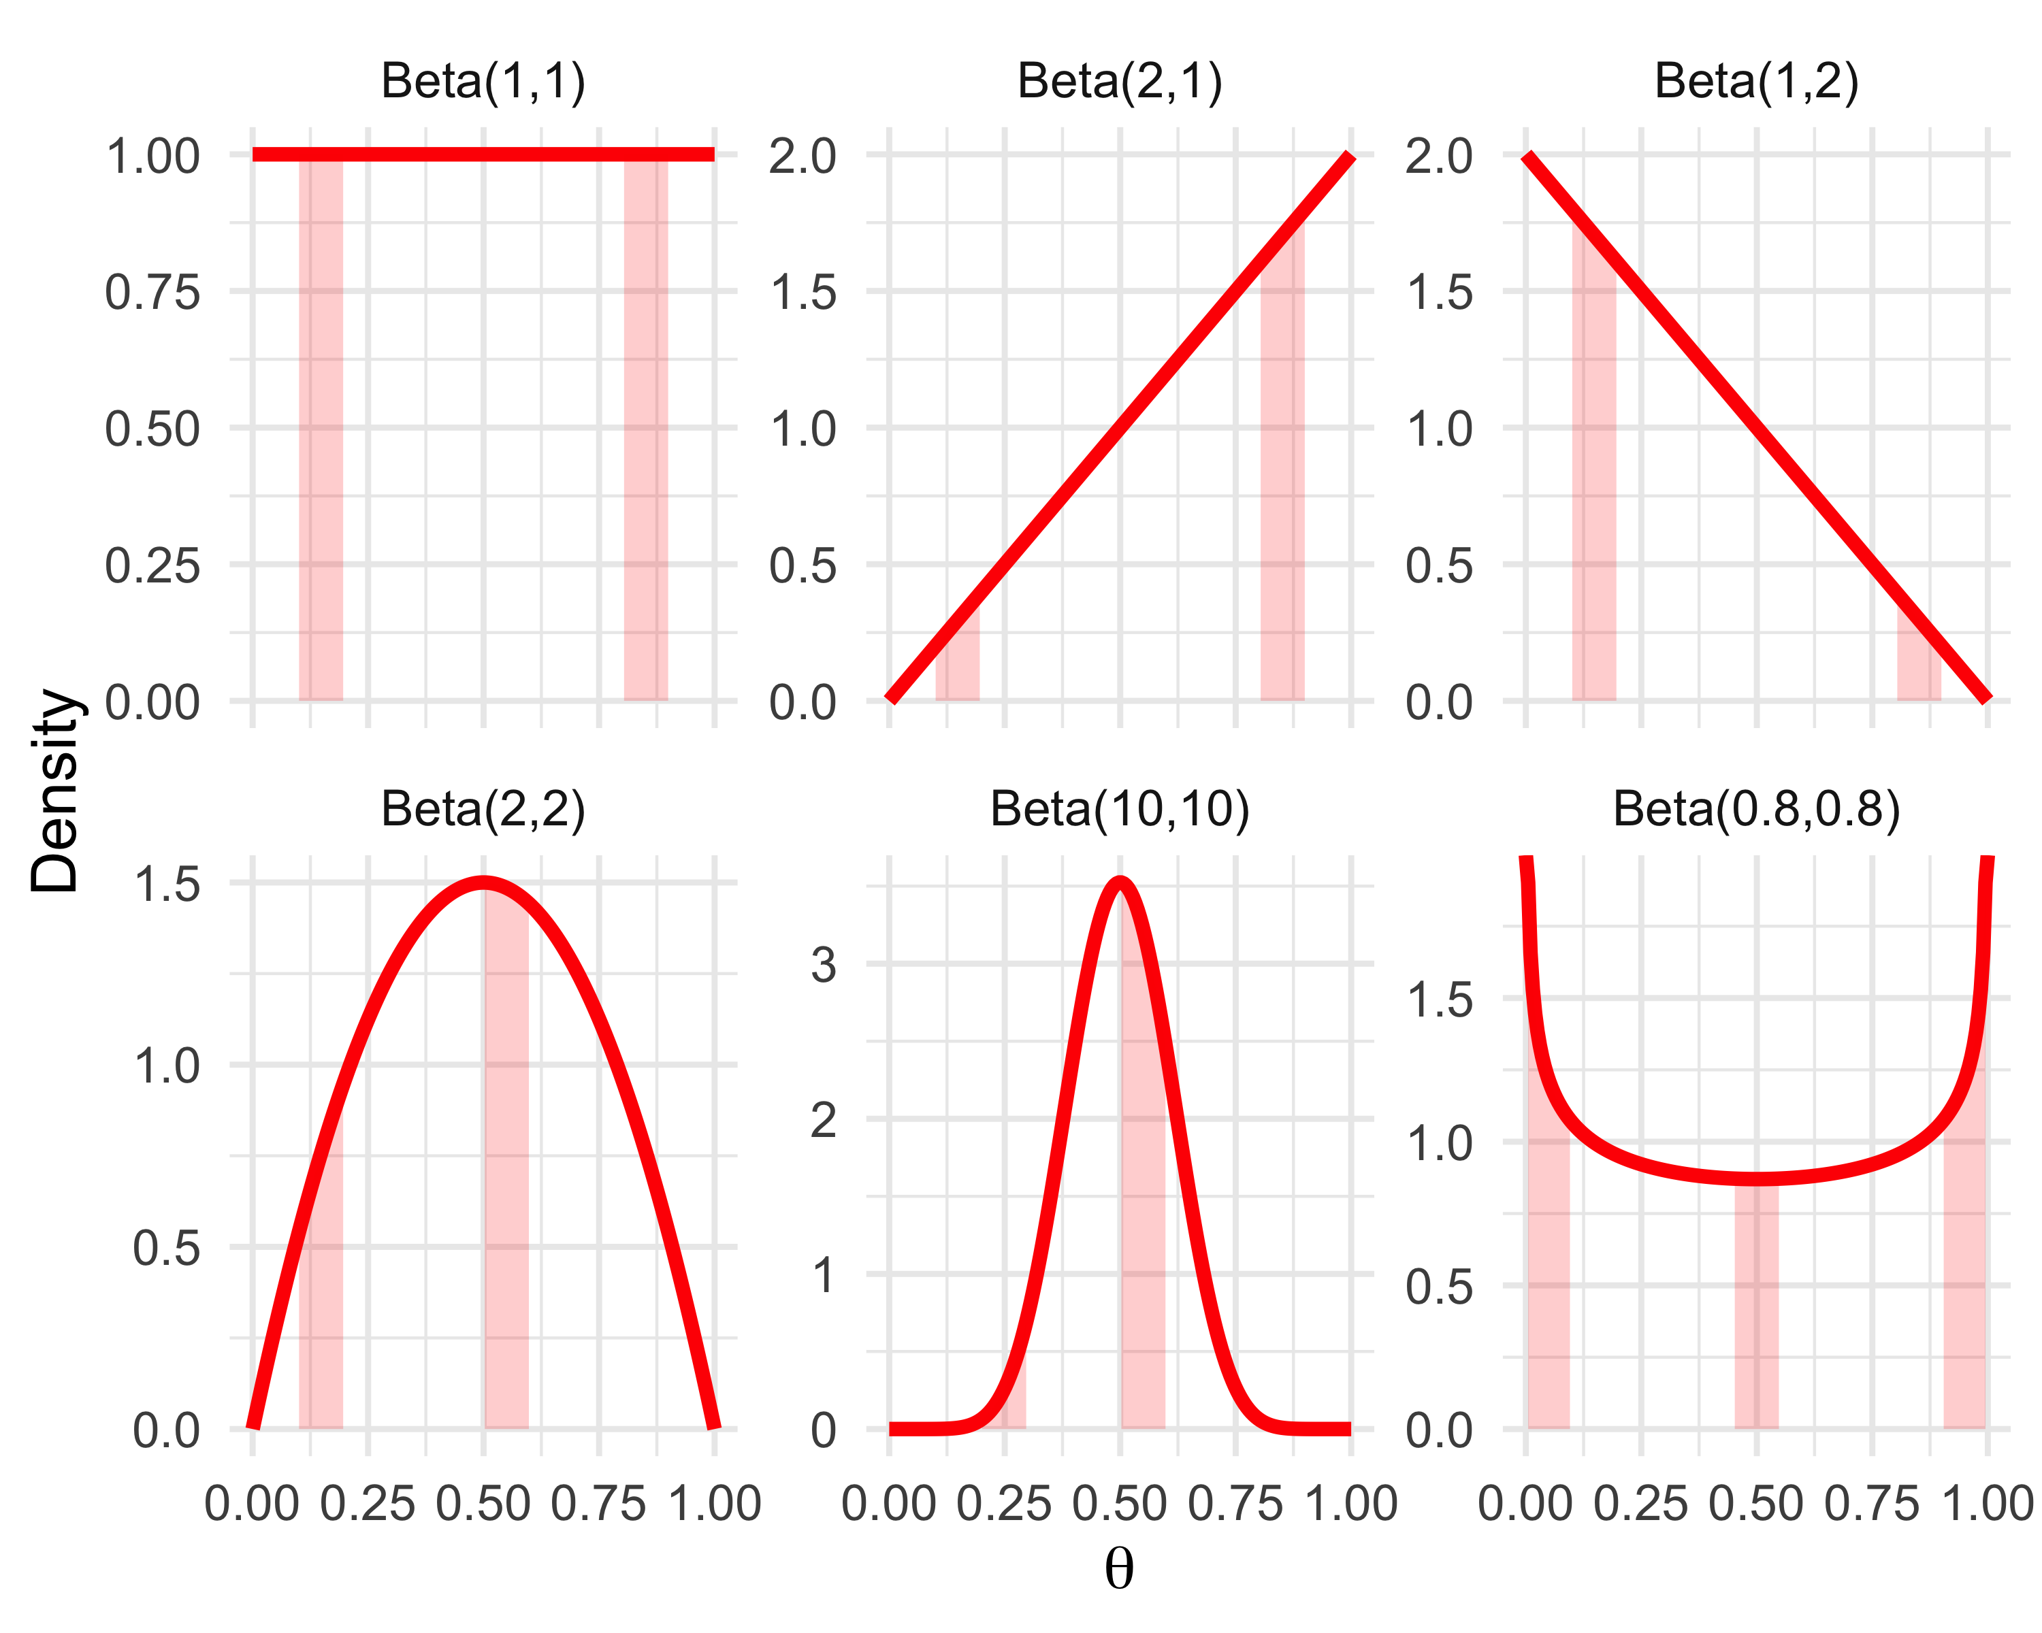

Figure 4: Examples of beta distributions for different values of parameters $a$ and $b$. In each panel, the shaded areas illustrate the probability of observing a value within a given interval.

Each panel of the figure shows the shape of a beta distribution for a given pair of parameters $\left(a,b\right)$. Several characteristic behaviors can be observed.

* Beta(1,1) (top left) corresponds to the uniform distribution between 0 and 1: all values of theta between 0 and 1 are considered equally likely. The density is constant, which means that the probability of observing a value between 0.1 and 0.2 is the same as that of observing one between 0.8 and 0.9. This probability is the area of the rectangle bounded by the red curve and the vertical lines at 0.1 and 0.2 (or 0.8 and 0.9), i.e. the red shaded areas. This corresponds to a situation with no prior knowledge.
* Beta(2,1) and Beta(1,2) represent asymmetric knowledge: the former is biased toward values close to 1, the latter toward values close to 0. The probability of observing a value between 0.1 and 0.2 is smaller than that of observing one between 0.8 and 0.9, and vice versa.
* Beta(2,2) is symmetric but puts more weight on central values than a uniform distribution. The probability of observing a value between 0.1 and 0.2 is smaller than that of observing one between 0.5 and 0.6.
* Beta(10,10) represents knowledge that is highly concentrated around 0.5: it is a very informative prior. The probability of observing a value between 0.2 and 0.3 is much smaller than that of observing one between 0.5 and 0.6.
* Beta(0.8,0.8) illustrates a U-shaped (bathtub-shaped) distribution that favors extreme values (close to 0 or to 1). The probabilities of observing a value between 0 and 0.1 and between 0.9 and 1 are larger than that of observing one between 0.45 and 0.55.

These examples make it possible to visualize how parameters $a$ and $b$ influence the shape of the prior. How do we go from this prior to the posterior distribution?

We assume that $θ∼\text{Beta}\left(a,b\right)$ and we observed $y=19$ survivors among $n=57$ individuals. The likelihood is $\left({n \atop y}\right)θ^{y}{\left(1-θ\right)}^{n-y}$. For now, we will ignore the denominator $Pr\left(y\right)$ in Bayes’ theorem; we will see in the next chapter why. Thus, the posterior is proportional to the product of the likelihood and the prior: $Pr\left(θ∣y\right)∝Pr\left(y∣θ\right)×Pr\left(θ\right)$. In our case, we multiply the likelihood and the prior term by term, and by rearranging the terms in $θ$ and $1-θ$, we obtain:

$$\begin{matrix}Pr\left(θ∣y\right) & ∝\underset{\text{binomial likelihood}}{\underset{⏟}{θ^{y}{\left(1-θ\right)}^{n-y}}}×\underset{\text{beta prior}}{\underset{⏟}{θ^{a-1}{\left(1-θ\right)}^{b-1}}} \\ & ∝\underset{\text{yet another beta distribution}}{\underset{⏟}{θ^{a+y-1}{\left(1-θ\right)}^{b+n-y-1}}}\end{matrix}$$

In other words, we again obtain a beta distribution, with updated parameters $a+y$ and $b+n-y$. We say that the binomial and beta distributions are conjugate: when we use a beta distribution as the prior for a probability parameter in a binomial model, the resulting posterior distribution is also a beta distribution. If we use a uniform prior between 0 and 1 (i.e. Beta(1,1)), we obtain that the posterior distribution of winter survival is $\text{Beta}\left(1+19,1+57-19\right)=\text{Beta}\left(20,39\right)$. Moreover, the posterior distribution is known, which greatly facilitates computations and interpretation. For example, we know that the mean of $\text{Beta}\left(a,b\right)$ is $\frac{a}{a+b}$, i.e. $\frac{20}{59}≈0.339$ . We can compare this value to the maximum likelihood estimator $19/57≈0.333$. We can also visualize the posterior distribution as in Figure (**ref?**)(fig:posterior-survie), since we know the equation of the beta density:

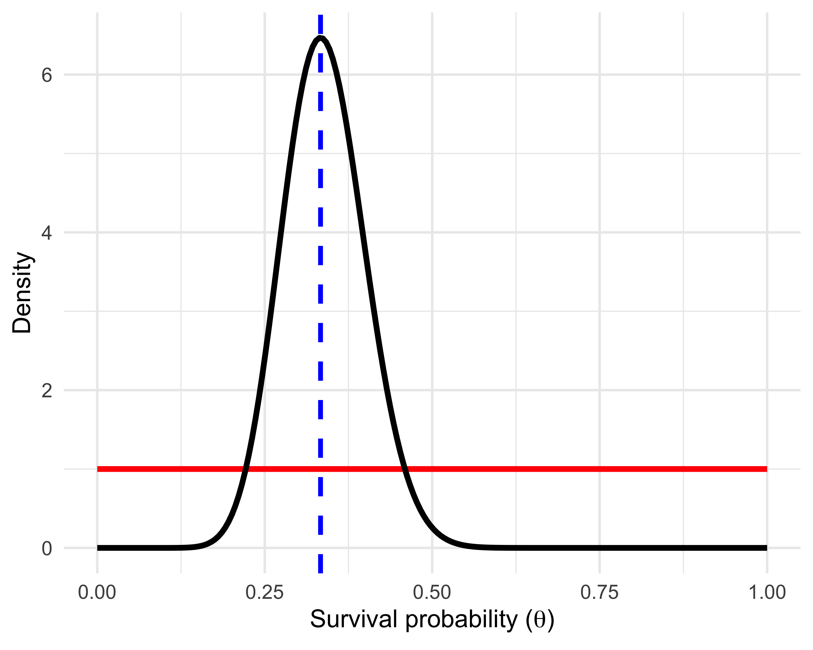

Figure 5: Uniform prior (red) and posterior distribution (black) of the coypu winter survival probability. The blue dashed line corresponds to the maximum likelihood estimate.

More generally, when we have enough data, Bayesian and frequentist estimators tend to be very close. Intuitively, the data end up “dominating” the prior information. Roughly speaking, the mode of the posterior distribution (the value at which the density is maximal) corresponds exactly to the maximum likelihood estimator.

This illustrates the link between the two approaches and the central role of the likelihood in statistics: it is the fundamental common component of Bayesian and frequentist approaches.

## In summary

* Bayes’ theorem is a tool for updating knowledge.
* Bayesian statistics relies on the likelihood and a prior distribution for the model parameters.
* Frequentist statistics provides a point estimator, whereas Bayesian statistics estimates a distribution for each parameter.
* Often, classical and Bayesian approaches yield similar estimates.
* In some cases, the posterior distribution is explicit (for example, in the case of beta/binomial conjugacy).
* In most cases, we will need to use simulations to obtain the posterior distribution, as we will see in Chapter 2.

# MCMC methods

## Introduction

I hope I did not lose you (too much) in the previous chapter with all those equations. In this new chapter, we go behind the scenes of Bayesian statistics by introducing Markov chain Monte Carlo (MCMC) methods. You will see how and why these simulation techniques have become essential for implementing Bayesian inference in practice. And because nothing beats practice, we will get our hands a little dirty by coding ourselves, using our running example on estimating a survival probability.

## Applying Bayes’ theorem

Let us return to our running example on coypus; I repeat the data:

y <- 19 # number of individuals that survived the winter  
n <- 57 # number of individuals monitored at the start of winter

Let us apply Bayes’ theorem more directly than in Chapter 1, where we set aside the denominator $Pr\left(\text{data}\right)$. Let us see whether we can handle it. As we saw, this denominator is given by $Pr\left(\text{y}\right)=∫Pr\left(\text{data}∣θ\right)Pr\left(θ\right) dθ$. So we will have to compute this integral. Let us start by writing an R function that computes the product of the (binomial) likelihood and the prior (Beta(1,1)), i.e. the numerator in Bayes’ theorem, $Pr\left(\text{data}∣θ\right)×Pr\left(θ\right)$:

num <- function(theta) dbinom(y, n, theta) * dbeta(theta, 1, 1)

We can now write the function that computes the denominator. To do so, we will use R’s integrate() function, which computes the integral of a one-variable function. The integrate() function uses quadrature techniques to approximate the area under the curve defined by the function to integrate, by breaking it into small pieces and summing them.

den <- integrate(num, 0, 1)$value

We then obtain a numerical approximation of the posterior distribution of winter survival, as in Figure 6:

# Create a grid of possible values for the survival probability (between 0 and 1)  
grid <- seq(0, 1, 0.01)  
  
# Compute posterior density values on the grid  
# num(grid) is likelihood * prior, and den is the normalizing constant  
posterior <- data.frame(  
 survival = grid,  
 ratio = num(grid) / den # normalized posterior density  
)  
  
# Plot the posterior density curve  
posterior %>%  
 ggplot(aes(x = survival, y = ratio)) +  
 geom_line(size = 1.5) +  
 labs(x = "Survival probability", y = "Density") +  
 theme_minimal()

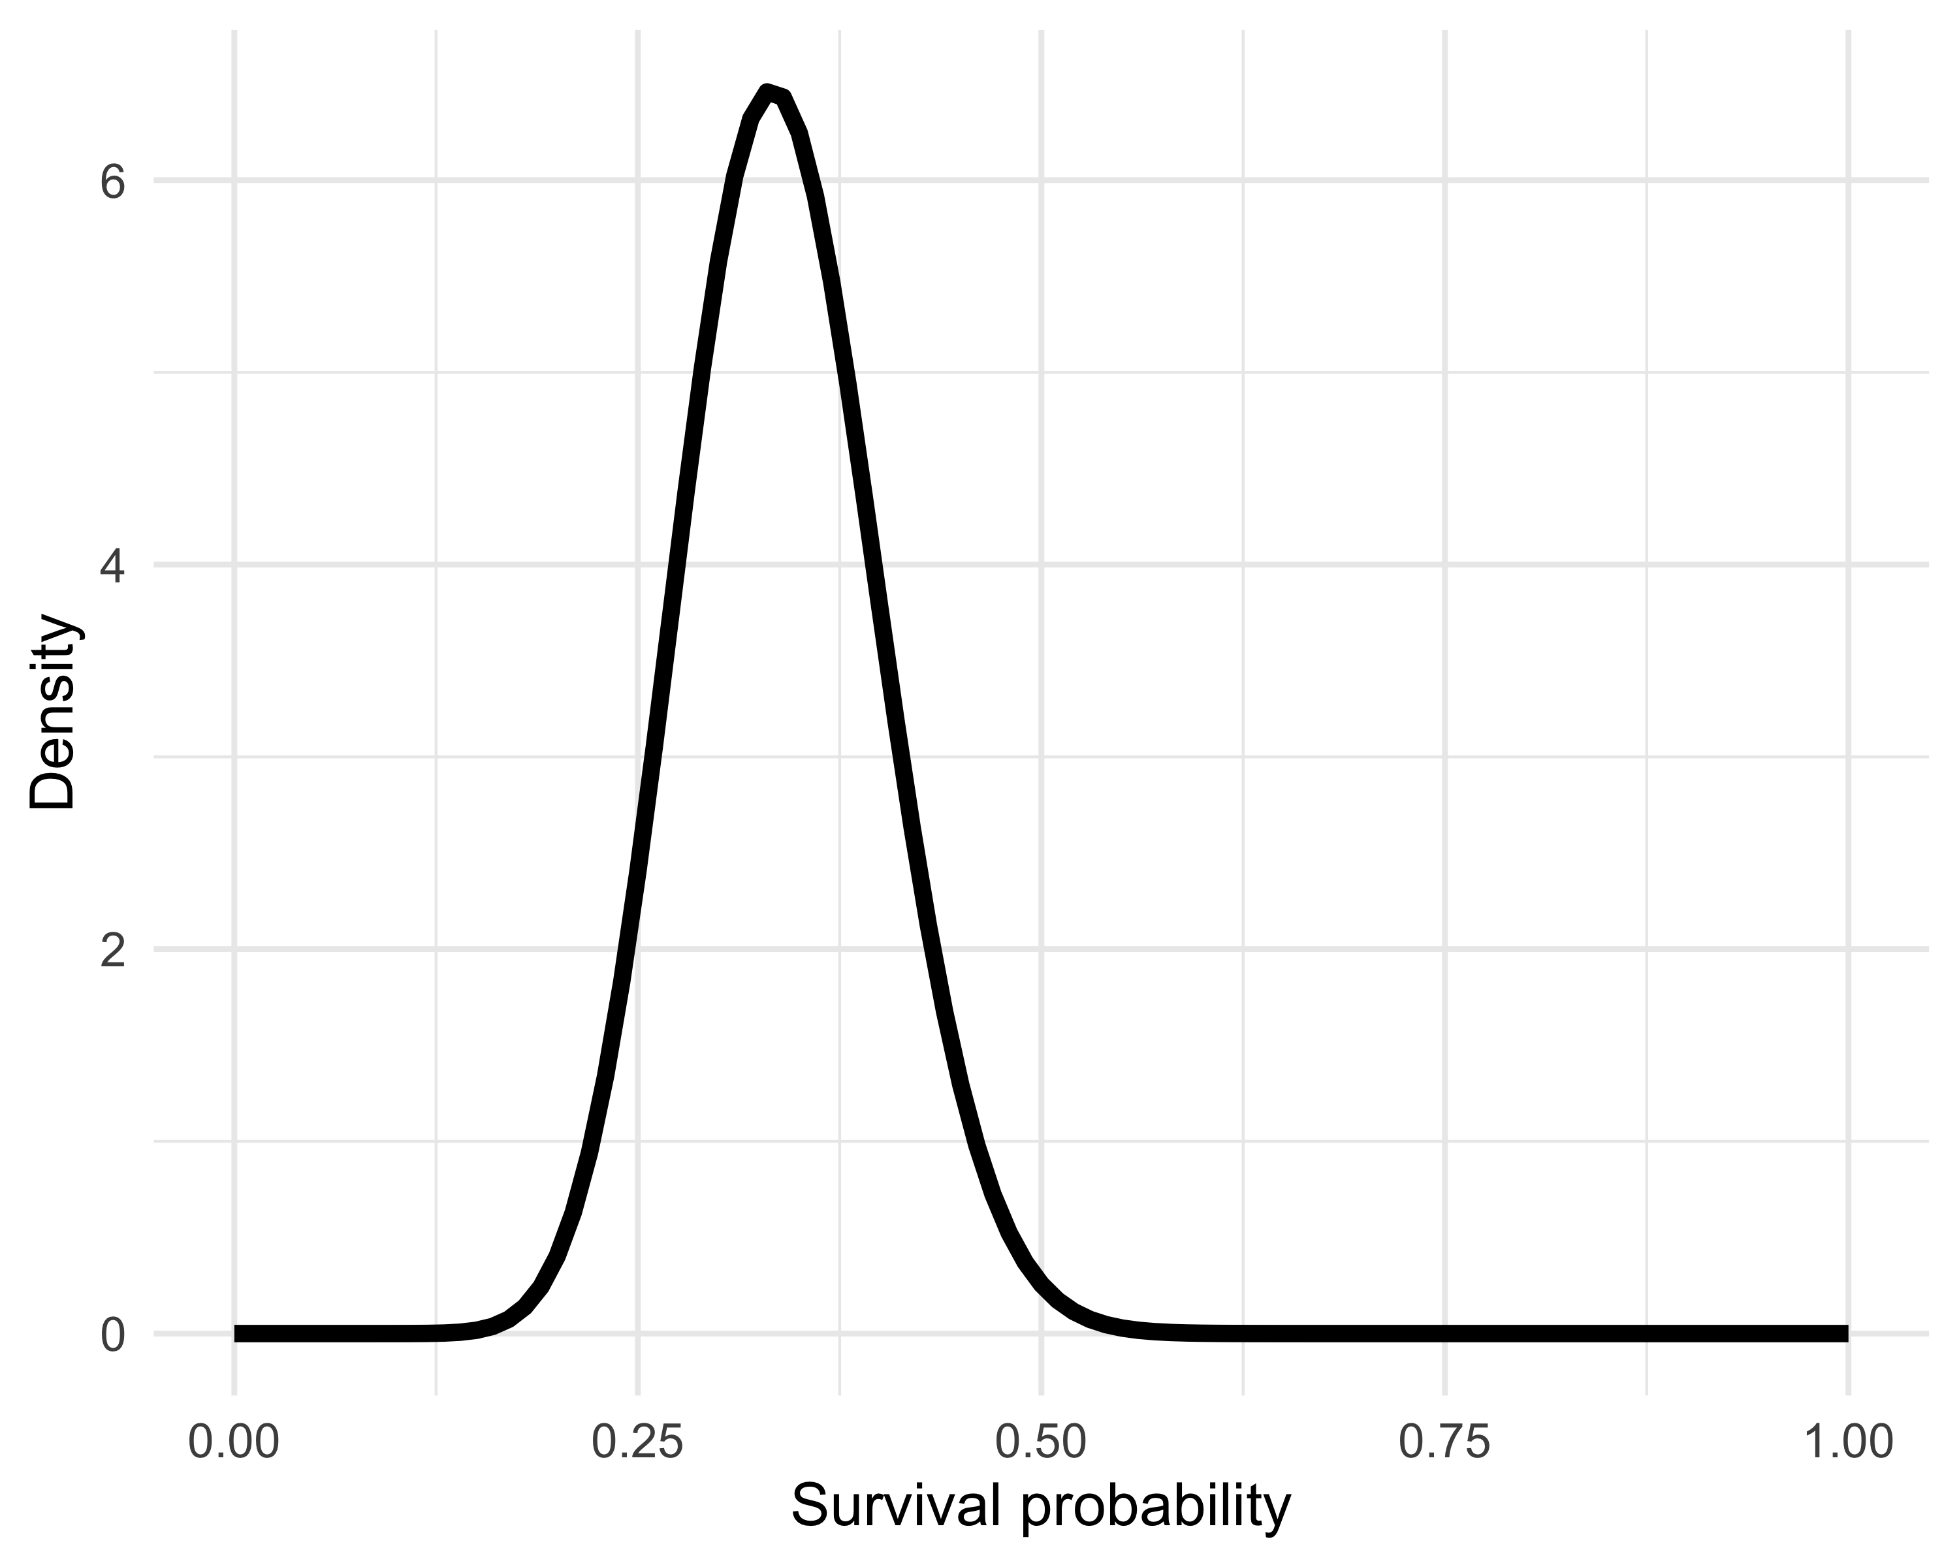

Figure 6: Numerical approximation of the posterior distribution of winter survival.

How good is this numerical approximation? Ideally, we would like to compare the approximation to the true posterior distribution. Conveniently, we obtained it in Chapter 1: it is a beta distribution with parameters 20 and 39. In Figure 7, you can see that the two curves overlap perfectly.

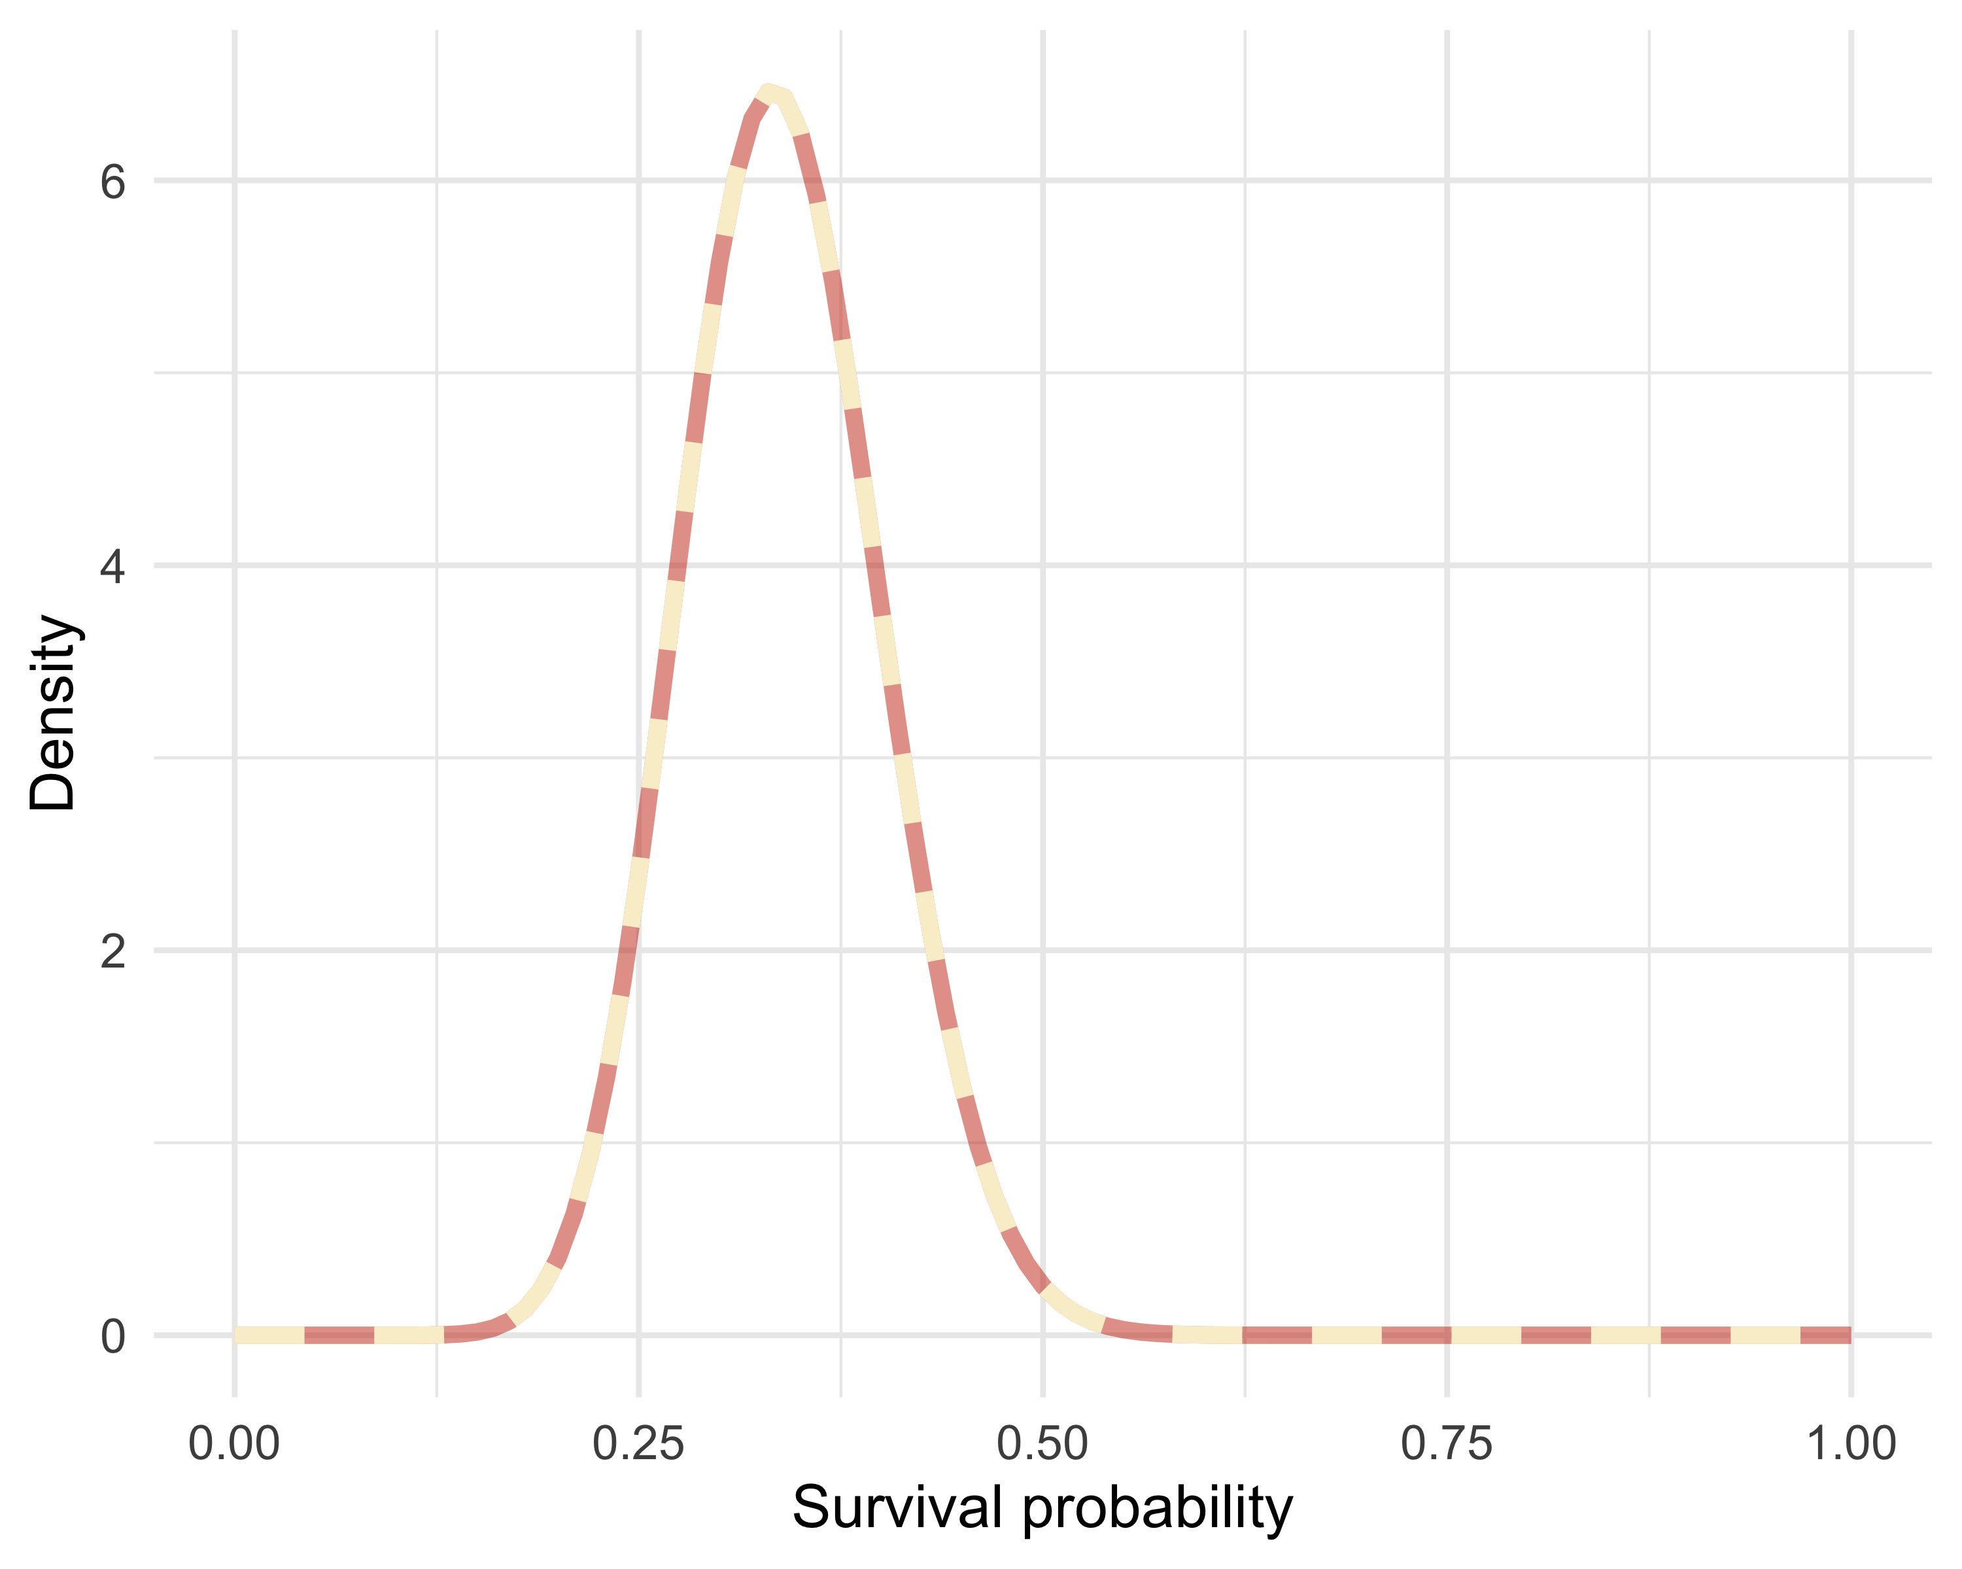

Figure 7: Comparison between the exact posterior (brick red) and the numerical approximation (cream).

The exact posterior distribution (brick red) and the numerical approximation (cream) for winter survival are indistinguishable, suggesting that the numerical approximation is more than satisfactory.

In our example, we have a single parameter to estimate: winter survival. This means the denominator involves a one-dimensional integral, which is fairly easy to handle with quadrature techniques and R’s integrate() function.

But what happens if we have several parameters? For example, imagine that you want to fit a regression model in which survival depends on an explanatory variable, say coypu body mass. The effect of this variable is captured by regression parameters $β_{0}$ (intercept) and $β_{1}$ (slope), and we also have the residual error with standard deviation $σ$ (see Chapter 5). Bayes’ theorem then gives the joint posterior distribution of these parameters (i.e. the three parameters together):

$$Pr\left(β_{0},β_{1},σ∣\text{y}\right)=\frac{Pr\left(\text{y}∣β_{0},β_{1},σ\right)×Pr\left(β_{0},β_{1},σ\right)}{∭Pr\left(\text{y}∣β_{0},β_{1},σ\right)Pr\left(β_{0},β_{1},σ\right) dβ_{0} dβ_{1} dσ}$$

There are two major numerical challenges:

* Do we really want to compute a triple integral? No, because classical methods rarely go much beyond two dimensions.
* We are often interested in marginal distributions of parameters (for example, that of $β_{1}$, the effect of mass on survival), obtained by integrating the joint posterior distribution over the other parameters (here, a double integral with respect to $β_{0}$ and $σ$) — which quickly becomes intractable as the number of parameters increases.

In the next section, we introduce powerful simulation methods to overcome these limitations.

## MCMC algorithms

In short, the idea of Markov chain Monte Carlo (MCMC) methods is to use simulations to approximate posterior distributions with a given precision by drawing a large number of samples. This avoids the explicit computation of the multidimensional integrals that arise when applying Bayes’ theorem.

These simulation algorithms consist of two parts: Markov chains and Monte Carlo. Let us try to understand these two terms.

What does Monte Carlo mean? Monte Carlo integration is a simulation technique used to compute integrals of arbitrary functions $f$ of a random variable $X$ with distribution $Pr\left(X\right)$, such as $∫f\left(X\right)Pr\left(X\right)dX$. We draw values $X_{1},…,X_{k}$ from $Pr\left(X\right)$, apply the function $f$ to these values, and then compute the mean of the resulting values, $\frac{1}{k}\sum_{i=1}^{k}{f\left(X_{i}\right)}$, to approximate the integral.

How do we use Monte Carlo integration in a Bayesian context? The posterior distribution contains all the information we need about the parameter(s) we want to estimate. But when there are multiple parameters, we often want to summarize this information by computing numerical summaries. The simplest summary is the posterior mean, $E\left(θ\right)=∫θPr\left(θ∣\text{data}\right) dθ$, where $X$ is $θ$ and $f$ is the identity. This posterior mean can be estimated by Monte Carlo integration; for example, for coypu survival:

# draw 1000 values from the Beta(20,39) posterior  
sample_from_posterior <- rbeta(1000, 20, 39)  
# compute the mean by Monte Carlo integration  
mean(sample_from_posterior)  
#> [1] 0.3406246

We can verify that the resulting mean is close to the theoretical expectation of a beta distribution:

20/(20+39) # expectation of the Beta(20,39) distribution  
#> [1] 0.3389831

Another useful numerical summary is a credible interval within which the parameter lies with a given probability, usually 0.95, i.e. a 95% credible interval. Determining the bounds of such an interval requires computing quantiles, which also relies on integrals, and therefore on Monte Carlo integration. A 95% credible interval for winter survival can be obtained with:

quantile(sample_from_posterior, probs = c(2.5/100, 97.5/100))  
#> 2.5% 97.5%   
#> 0.2289417 0.4695077

By the way, there is a difference between a credible interval in Bayesian statistics and a confidence interval in frequentist statistics. A 95% confidence interval means that if we repeated the experiment a very large number of times (tag coypus with GPS and record the number of winter survivors), about 95% of the intervals constructed in this way would contain the true parameter value $θ$. But we cannot say that the probability that the parameter lies within a given interval is 95%. A 95% credible interval, in contrast, means that there is a 95% probability that the parameter lies within that interval. The interpretation of a credible interval is a bit more intuitive than that of a confidence interval.

Now, what is a Markov chain? A Markov chain is a random sequence of numbers in which each number depends only on the previous one. One example is the weather in my city, Montpellier, in the south of France, where a sunny day is very likely to be followed by another sunny day, say with probability 0.8, and a rainy day is rarely followed by another rainy day, say with probability 0.1. The dynamics of this Markov chain are captured by the transition matrix:

$$\begin{matrix} & \text{Sunny tomorrow} & \text{Rainy tomorrow} \\ & & \\ \text{Sunny today} & 0.8 & 0.2 \\ & & \\ \text{Rainy today} & 0.9 & 0.1\end{matrix}$$

Rows indicate today’s weather and columns indicate tomorrow’s. The cells give the probability of having a sunny or rainy day tomorrow depending on today’s weather (conditional probabilities; see Chapter 1).

Under certain conditions, a Markov chain converges to a unique stationary distribution. In our weather example, let us iterate the chain for 20 steps:

temps <- matrix(c(0.8, 0.2, 0.9, 0.1), nrow = 2, byrow = T) # transition matrix  
etapes <- 20  
for (i in 1:etapes){  
 temps <- temps %*% temps # matrix multiplication  
}  
round(temps, 2) # matrix product after 20 steps  
#> [,1] [,2]  
#> [1,] 0.82 0.18  
#> [2,] 0.82 0.18

Each row of the matrix converges toward the same distribution $\left(0.82,0.18\right)$ as the number of steps increases. The convergence occurs regardless of the starting state: we then have probability 0.82 of sun and 0.18 of rain.

Let us return to MCMC methods. The central idea is that we can construct a Markov chain whose stationary distribution is precisely the posterior distribution of our parameters. Keep this idea in mind: it is fundamental.

By combining Monte Carlo and Markov chains, MCMC methods allow us to generate a sample of values whose distribution converges to the posterior distribution (Markov chain) and to use that sample to compute posterior numerical summaries (Monte Carlo), such as the mean or credible intervals.

There are several ways to build Markov chains for Bayesian inference. You may have heard of the Metropolis–Hastings algorithm or the Gibbs sampler. You can consult <https://chi-feng.github.io/mcmc-demo/> for an interactive gallery of MCMC algorithms. Here, I illustrate the Metropolis algorithm and its practical implementation. For this I draw inspiration from the excellent book by Jim Albert (2009). The goal is not to be able to write such an algorithm from scratch, but to grasp the main ideas and, above all, the notion of simulation.

Let us return to our survival example. We will illustrate sampling from the posterior distribution of survival. Let us start by writing functions for the likelihood, the prior, and the posterior. We work on the log scale to manipulate sums and differences rather than products and ratios, which can make numerical calculations unstable:

# 19 animals found alive out of 57 captured, marked and released  
y <- 19  
n <- 57  
  
# binomial log-likelihood Bin(n = 57,p)  
loglikelihood <- function(x, p){  
 dbinom(x = x, size = n, prob = p, log = TRUE)  
}  
  
# uniform prior density  
logprior <- function(p){  
 dunif(x = p, min = 0, max = 1, log = TRUE)  
 # or dbeta(x = p, shape1 = 0, shape2 = 1, log = TRUE)  
}  
  
# posterior density (log scale)  
posterior <- function(x, p){  
 loglikelihood(x, p) + logprior(p)  
}

The Metropolis algorithm works as follows:

1. Choose an initial value for the parameter to estimate. This is our starting value, or the initial point of the Markov chain.
2. To decide the next step, propose moving away from the current parameter value—this is the candidate value. We add to the current value a draw from a normal distribution with some variance—this is the proposal distribution. The Metropolis algorithm is a special case of Metropolis–Hastings with symmetric proposals.
3. Compute the ratio of posterior densities between the candidate position and the current position: $R=\frac{Pr\left(\text{candidate value}|\text{data}\right)}{Pr\left(\text{current value}|\text{data}\right)}$. To compute numerator and denominator, we simply apply Bayes’ theorem, and this is where the magic of MCMC happens: because $Pr\left(\text{data}\right)$ appears in both numerator and denominator, it cancels, and we no longer need to compute it. We have replaced the computation of an integral by simulations.
4. If the posterior density at the candidate position is larger than at the current position, i.e. if the candidate value is more plausible, we accept it immediately. Otherwise, we accept it with probability $R$, and reject it with probability $1-R$. For example, if the candidate value is ten times less plausible, we accept it with probability 0.1. We use a uniform random number between 0 and 1 (call it $X$): if $X<R$, we accept the candidate value; otherwise, we stay at the current value. In practice, we aim for an acceptance rate between 0.2 and 0.4, which can be adjusted by calibrating the proposal variance; this helps explore the whole parameter space.
5. Repeat steps 2 to 4 a certain number of times—these are the iterations.

Enough theory: let us implement it. We start by initializing:

steps <- 100 # number of steps (iterations) of the chain  
theta.post <- rep(NA, steps) # vector to store simulated values  
accept <- rep(NA, steps) # vector to record accept/reject decisions  
set.seed(666) # for reproducibility

Why do we need to initialize? Before running the Markov chain, we prepare the objects that will store the simulated values of our parameter (here, the survival probability) as well as information about whether each proposal was accepted. And what is set.seed(666) for? This command sets the seed of the random number generator. It ensures that the simulations are reproducible: if you rerun the code, you will obtain exactly the same simulated values as mine.

We choose a starting value:

inits <- 0.5 # chosen starting value for theta  
theta.post[1] <- inits # record this value as the first position of the chain  
accept[1] <- 1 # the initial value is accepted by default

Why a starting value? A Markov chain has to start somewhere: here, we arbitrarily choose 0.5 as the initial value of the survival probability. The only constraint is that this value must be compatible with the prior: we are not going to pick a negative survival probability or 15. We place this value in the first element of theta.post, and we indicate with accept[1] <- 1 that this first value is accepted by construction, since it is our starting point.

Next, we write a function to propose a candidate value from the current value:

move <- function(x, away = 1){  
 logitx <- log(x / (1 - x)) # logit transform: maps x from (0,1) to (-∞,+∞)  
 logit_candidate <- logitx + rnorm(1, 0, away) # add centered normal noise, sd controlled by away  
 candidate <- plogis(logit_candidate) # inverse transform (logit^-1): returns a value between 0 and 1  
 return(candidate) # return proposed value  
}

This function introduces a random proposal around the current value. We work on the logit scale to ensure that the final proposal (candidate) always remains in the interval (0,1) (see also Chapter 6). The away parameter controls the spread of proposals: the larger it is, the larger the jumps; the smaller it is, the closer proposals remain to the current value.

We then implement steps 2 to 4 of the algorithm in a loop (this is step 5: repeating iterations):

for (t in 2:steps){ # for each iteration, starting at the 2nd  
  
 # Step 2: propose a new value for theta  
 theta_star <- move(theta.post[t-1]) # candidate drawn from the previous value  
  
 # Step 3: compute the ratio of posterior densities (log scale)  
 pstar <- posterior(y, p = theta_star) # posterior density at candidate  
 pprev <- posterior(y, p = theta.post[t-1]) # posterior density at current value  
 logR <- pstar - pprev # difference on the log scale  
 R <- exp(logR) # back to the natural scale (density ratio)  
  
 # Step 4: accept or reject the proposal  
 X <- runif(1, 0, 1) # random draw between 0 and 1: the acceptance "roulette"  
 if (X < R){ # if the proposal is more plausible (or not too much worse)  
 theta.post[t] <- theta_star # accept and store the candidate  
 accept[t] <- 1 # record acceptance  
 } else {  
 theta.post[t] <- theta.post[t-1] # otherwise keep the previous value  
 accept[t] <- 0 # record rejection  
 }  
}

This loop builds the Markov chain iteratively. The probability of accepting a less plausible value is proportional to its likelihood ratio. The accept vector can then be used to diagnose the acceptance frequency, useful for calibrating the chain.

Let us take a look at the first and last simulated values:

head(theta.post)  
#> [1] 0.5000000 0.5000000 0.3021903 0.3021903 0.1853669 0.1853669  
tail(theta.post)  
#> [1] 0.4076667 0.4076667 0.4076667 0.4076667 0.2914464 0.2914464

We can now visualize the chain’s evolution with a trace plot, i.e. a curve showing the simulated values of theta across iterations (Figure 8):

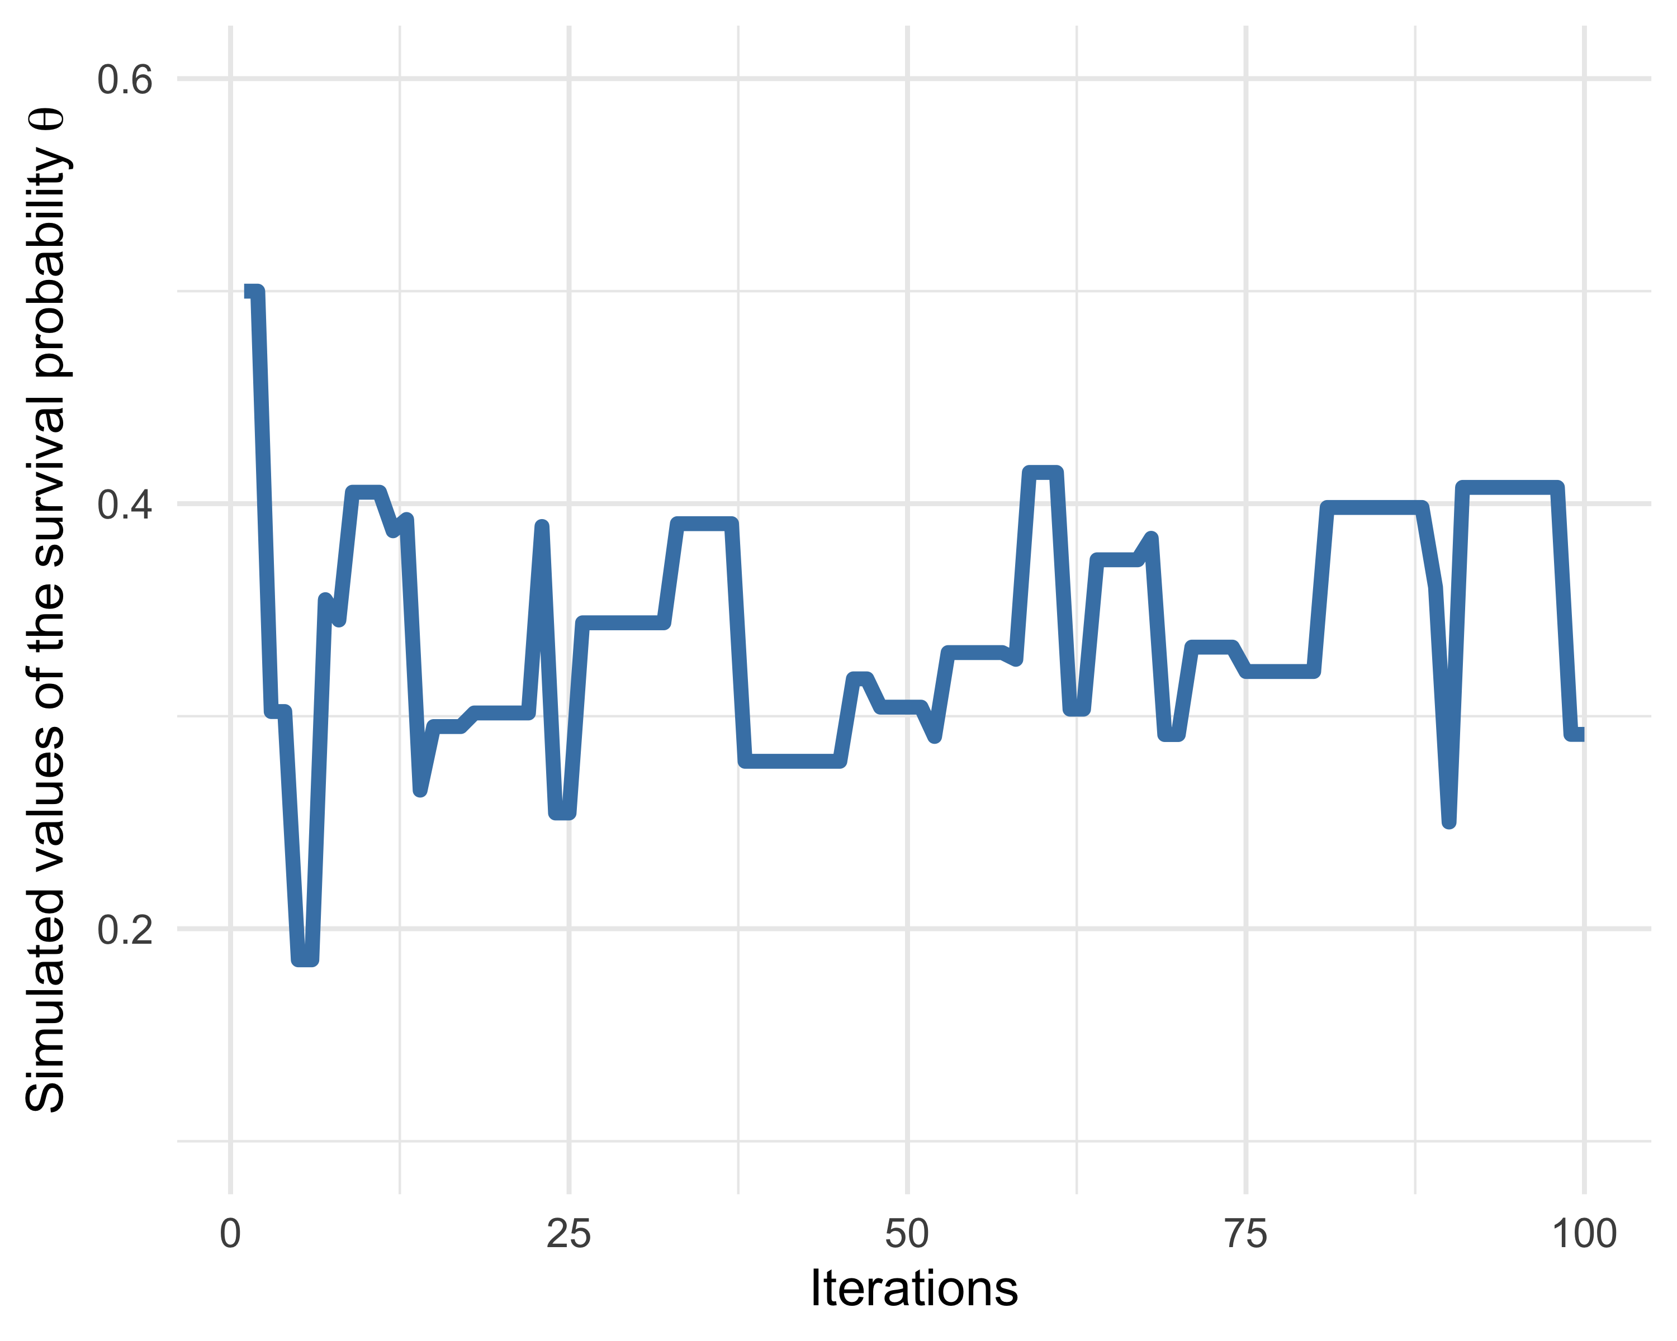

Figure 8: Trace plot of simulated values of the survival probability \(\theta\) across iterations.

What does this trace plot tell us? The horizontal axis represents iterations (or “time” in the Markov chain). The vertical axis shows the simulated values of the survival probability at each step. In the figure, we see that the chain sometimes stays at the same value for several consecutive iterations. This happens when the candidate value proposed by the algorithm is rejected—the chain then retains the previous (more precisely, current) value. At other times, we see jumps to new values, corresponding to accepted proposals.

We can then wrap the algorithm into a reusable function, making it easy to run multiple chains:

metropolis <- function(steps = 100, inits = 0.5, away = 1){  
  
 theta.post <- rep(NA, steps) # vector to store samples  
 theta.post[1] <- inits # initialize with starting value  
  
 for (t in 2:steps){ # loop over steps (starting at the 2nd)  
  
 theta_star <- move(theta.post[t-1], away) # propose a new value  
  
 # log-ratio of posterior density between candidate and current value  
 logR <- posterior(y, theta_star) -  
 posterior(y, theta.post[t-1])  
 R <- exp(logR) # back to non-log scale  
  
 X <- runif(1, 0, 1) # draw a uniform random number  
 theta.post[t] <- ifelse(X < R, # if draw < acceptance probability...  
 theta_star, # ... accept proposed value  
 theta.post[t-1]) # otherwise keep previous  
 }  
  
 return(theta.post) # return simulated sample  
}

We can now use metropolis() to run another chain, this time starting at 0.2:

theta.post2 <- metropolis(steps = 100, inits = 0.2) # start at 0.2

Note that we often talk about “running multiple MCMC chains” to diagnose convergence. In practice, these are independent realizations of the same Markov chain—like flipping the same coin multiple times, except with a more complicated distribution than Bernoulli.

We then plot both chains together, as in Figure 9:

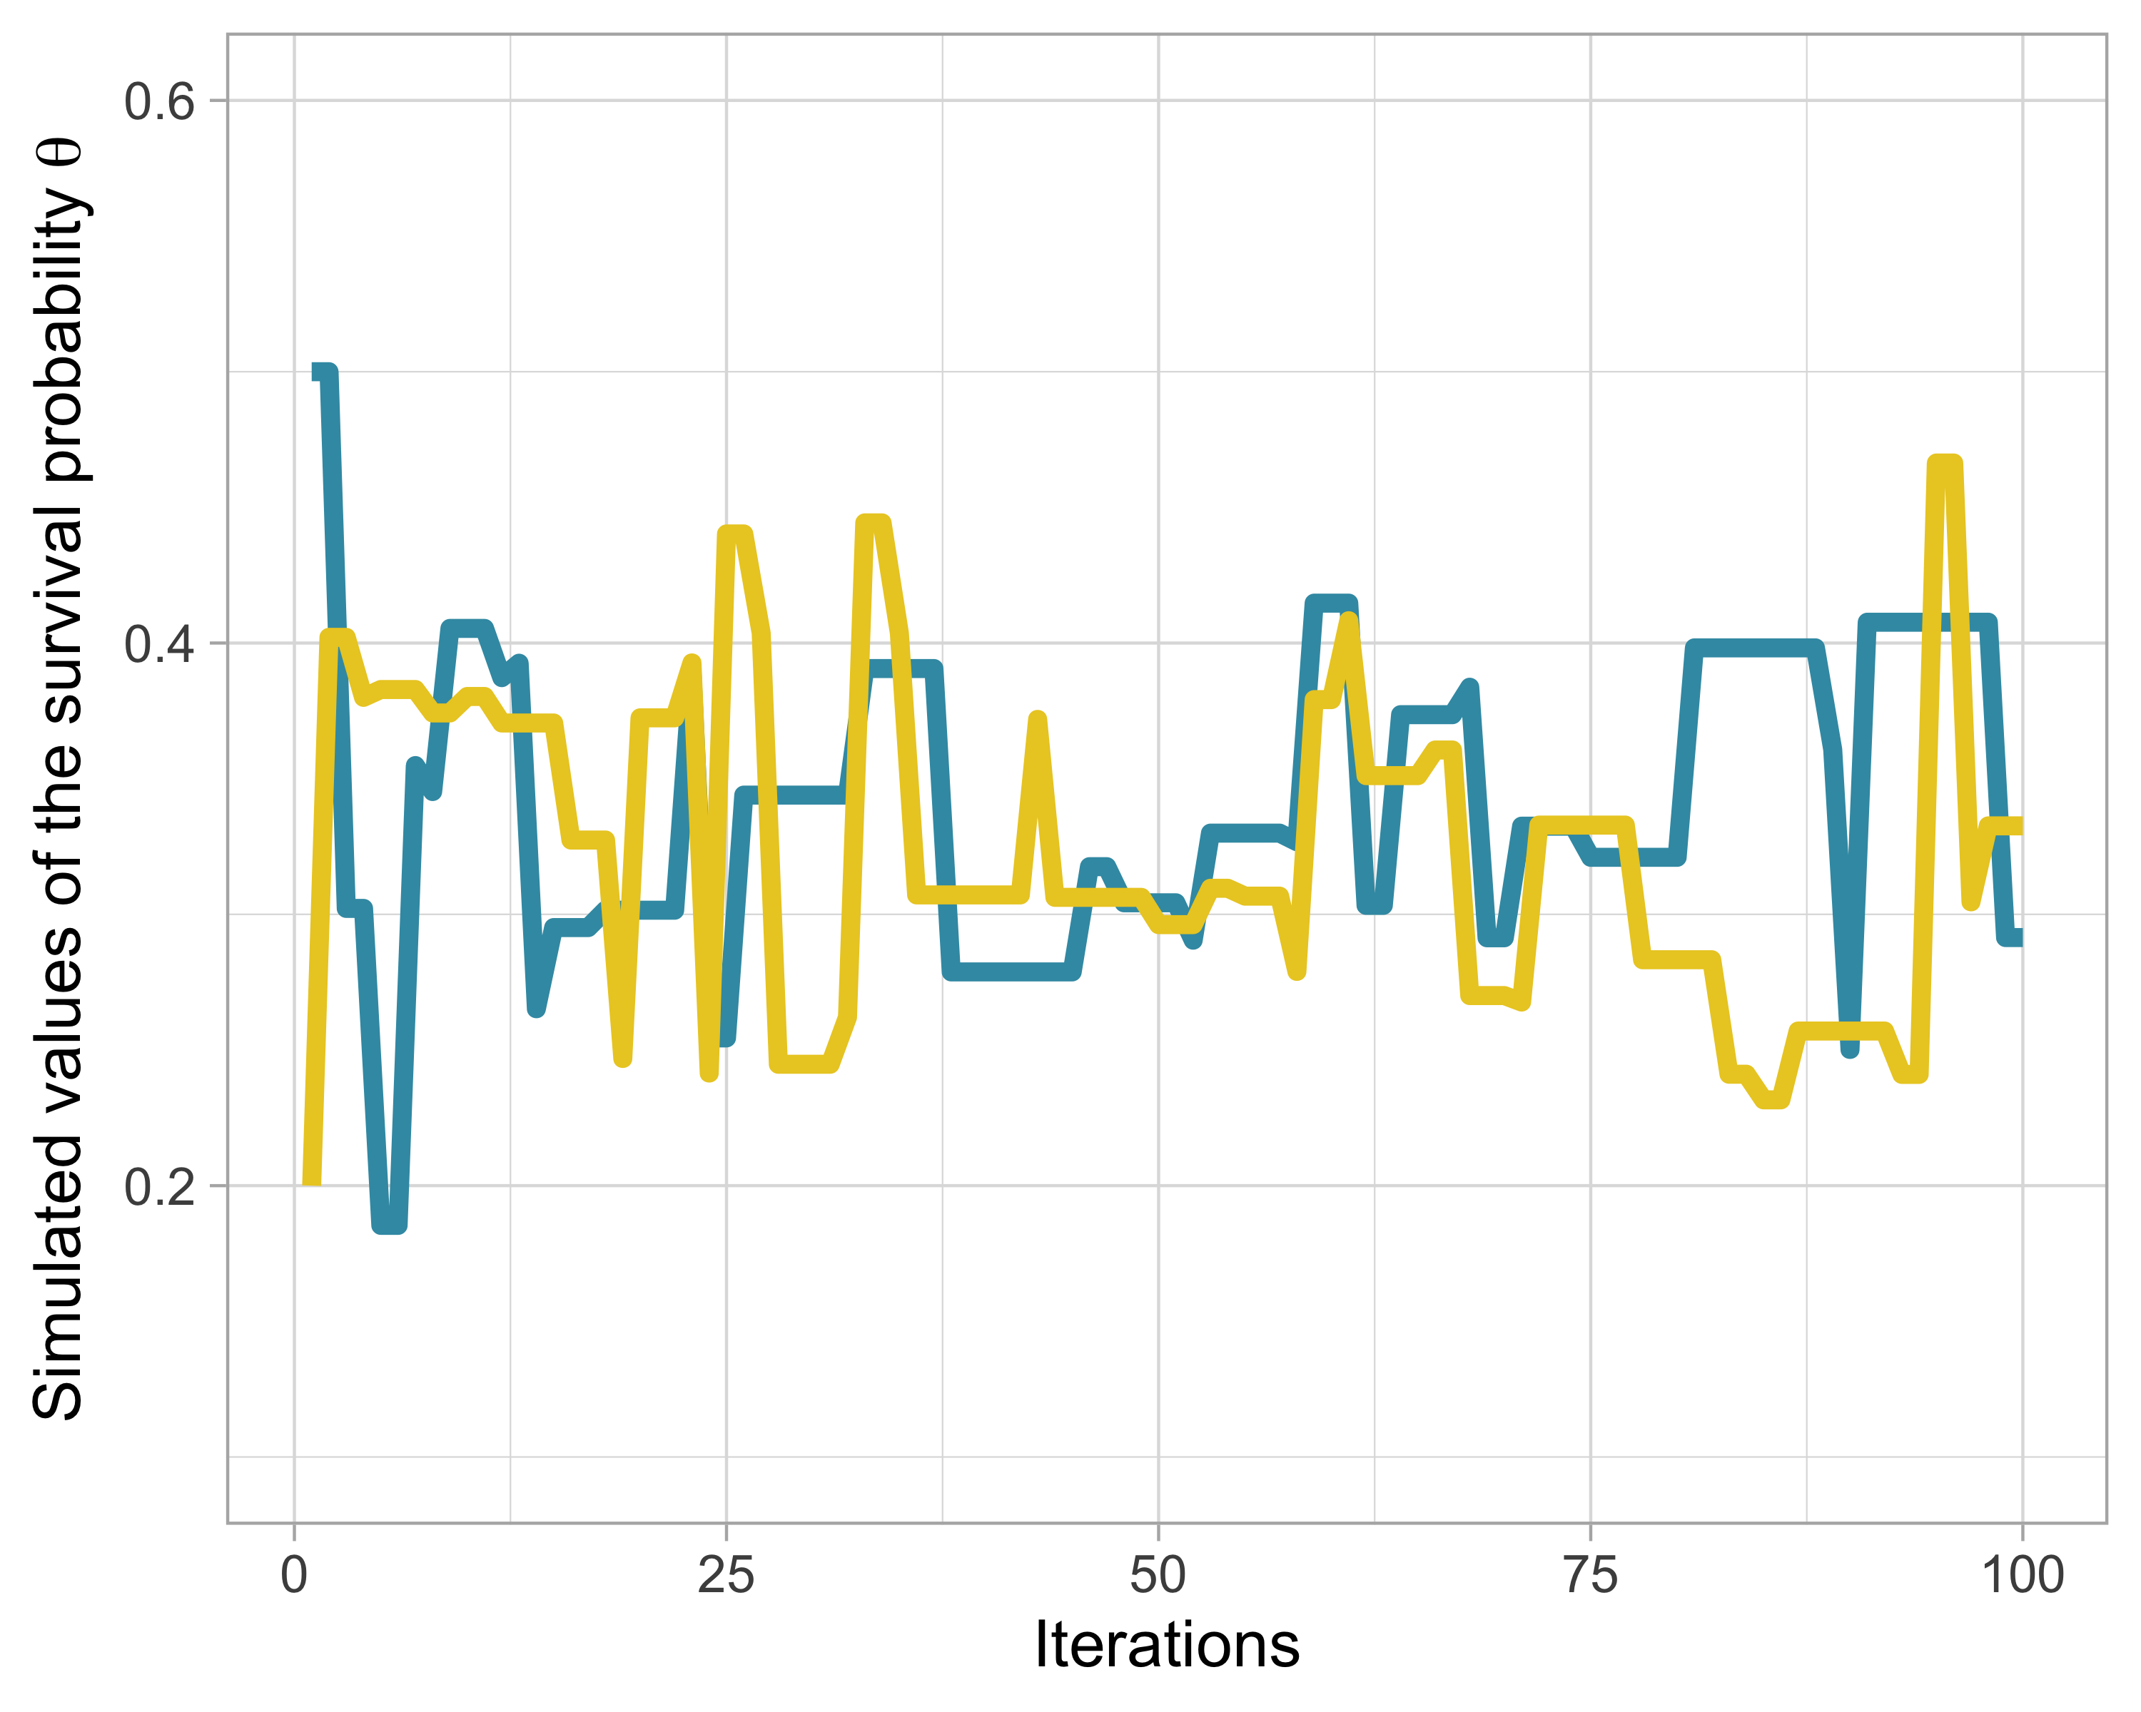

Figure 9: Trace plot of simulated values of the survival probability \(\theta\) across iterations. Two chains were run with different initial values, 0.5 in blue and 0.2 in yellow.

Note that we do not obtain exactly the same results because the algorithm is stochastic. We observe the parallel evolution of two chains started from different initial values. If the two chains quickly meet and then oscillate around the same values, this indicates good convergence toward the desired stationary distribution. This is a key step in MCMC convergence diagnostics, which we will cover later in this chapter. To observe convergence over a longer period, we run a chain with 1,000 iterations. This gives a smoother trace plot showing chain stability, as in Figure 10:

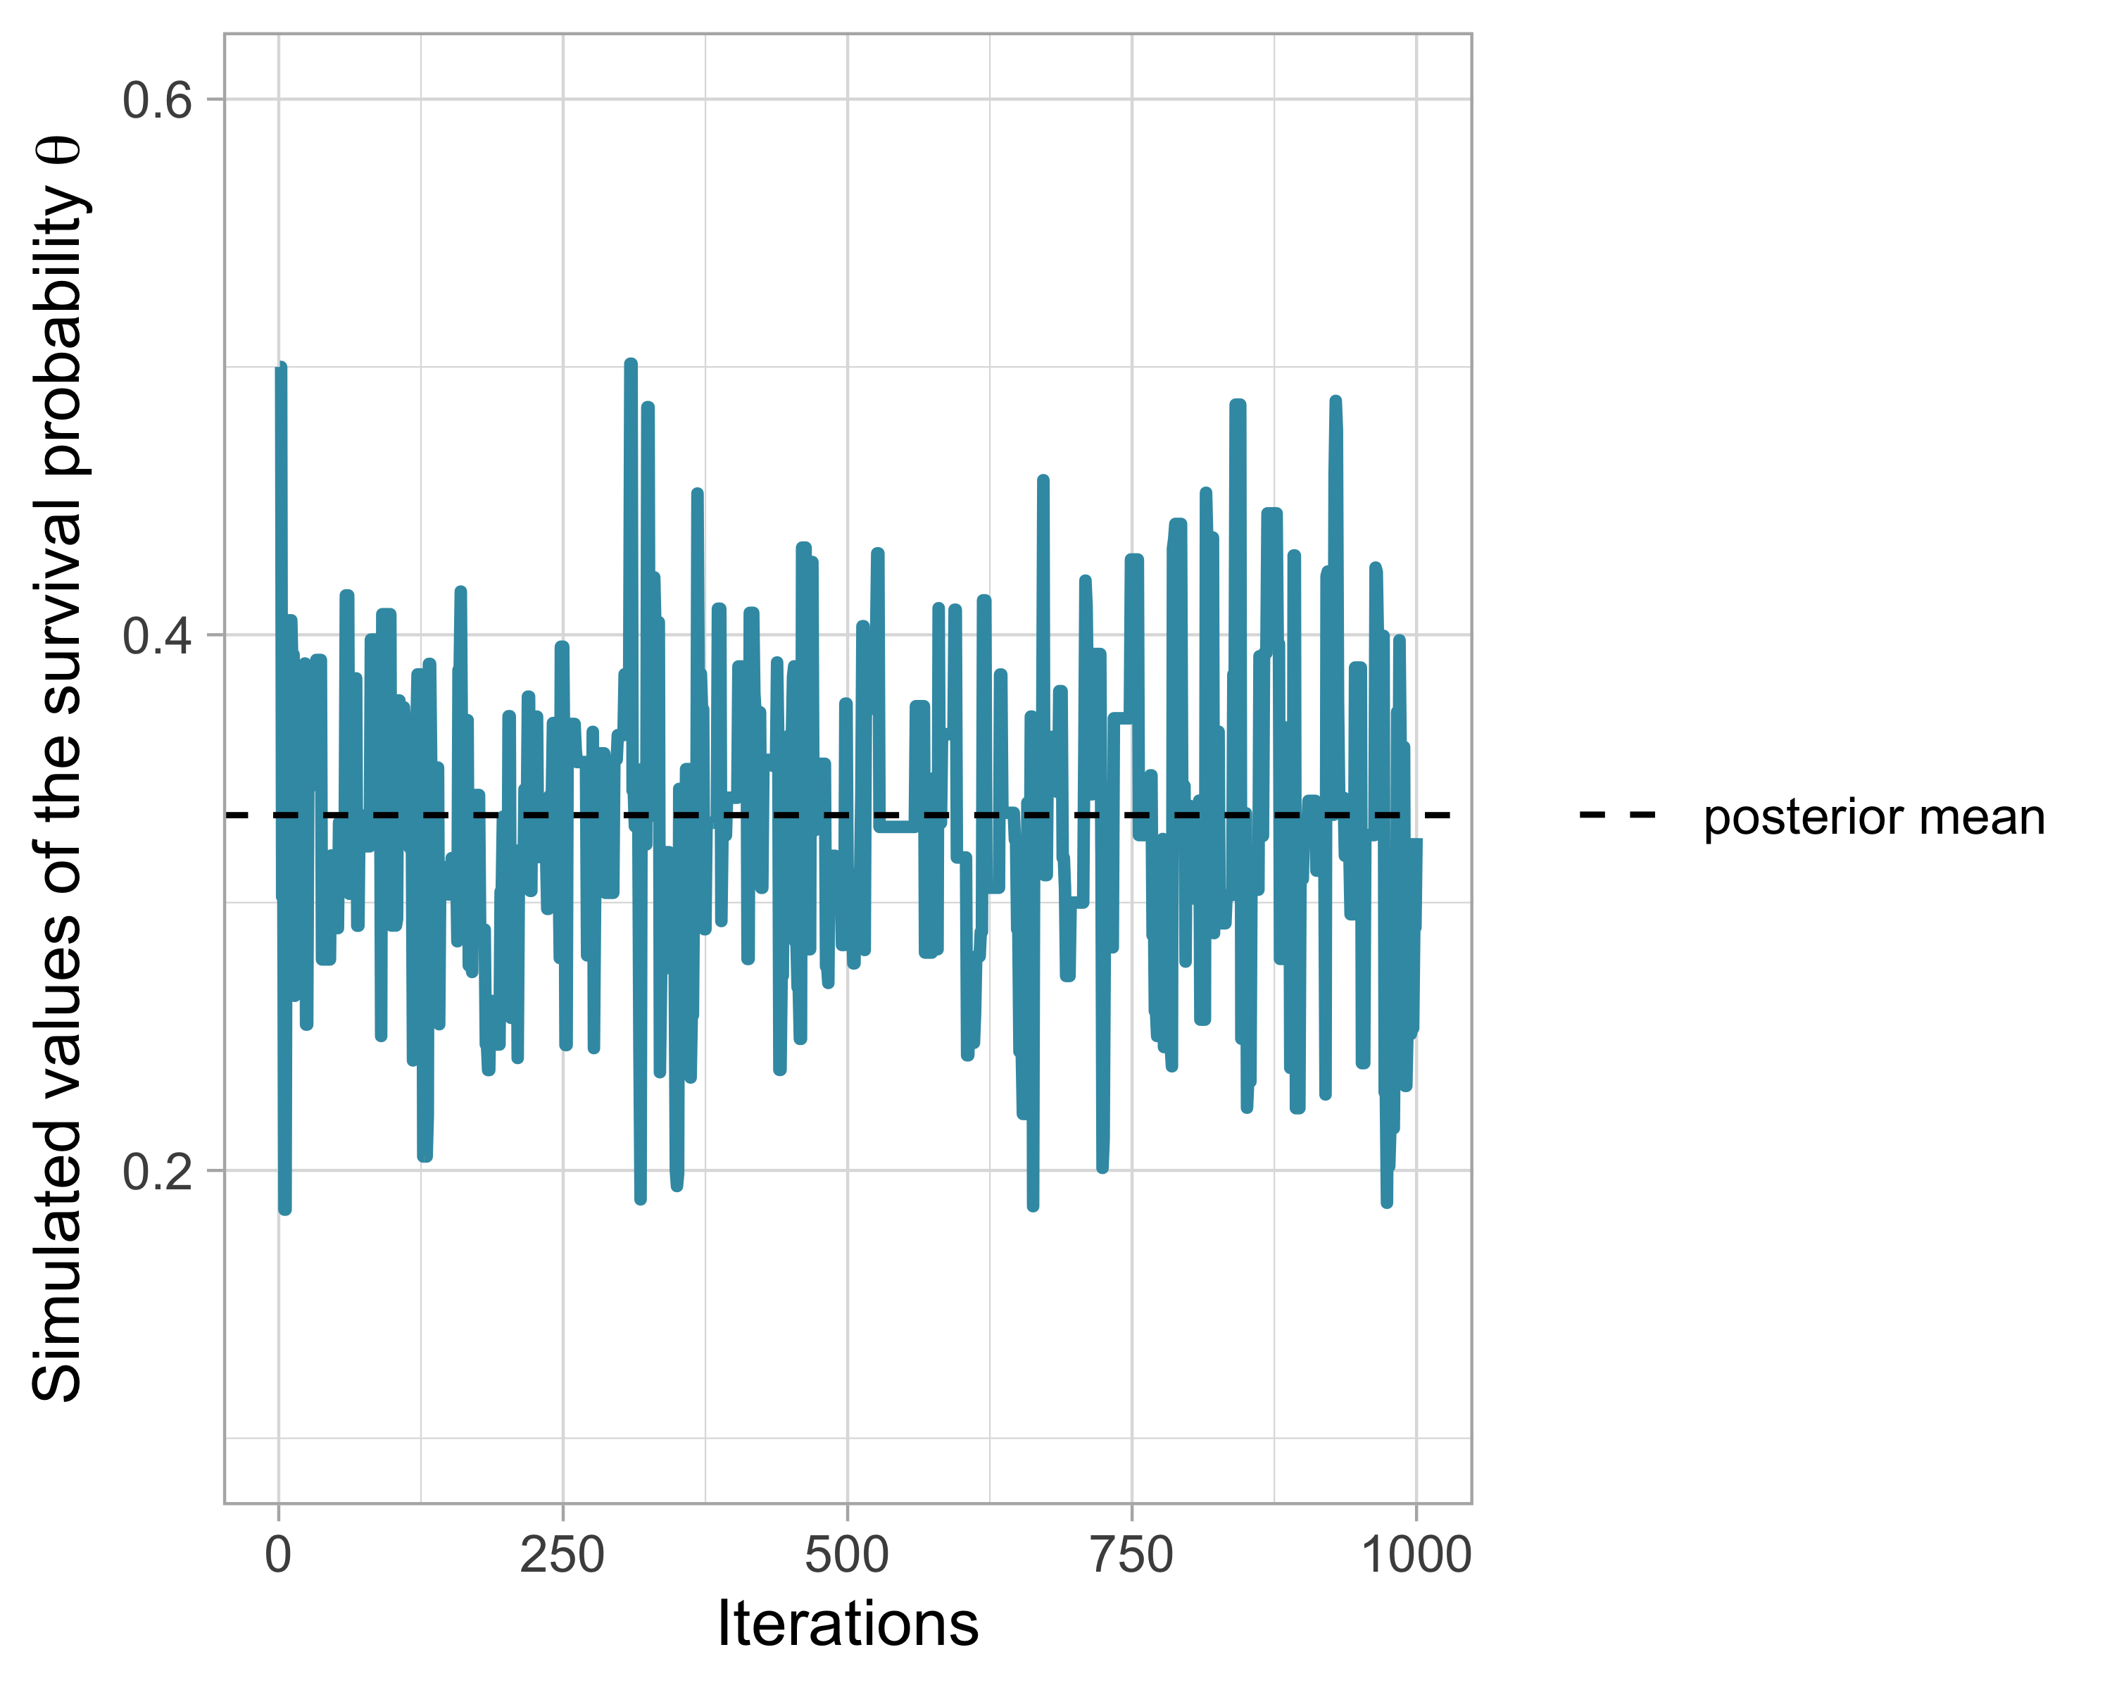

Figure 10: Trace plot of simulated values of the survival probability \(\theta\) across 1000 iterations.

With a large number of iterations, each chain should stabilize around its stationary distribution. Visually, we look for a dense, homogeneous, well-explored region—like a neatly mown lawn (that is an image).

Once the stationary distribution is reached, you can treat the simulated values of the Markov chain as a sample from the posterior distribution and compute numerical summaries of the parameters (posterior mean, credible interval).

When can we say that we have reached this stationary distribution? Once we have convergence, how many additional simulations do we need to obtain a good approximation of the posterior distribution of our parameters? I address these questions in the next section.

## Assessing convergence

When applying an MCMC method, we need to determine how long it takes the Markov chain to converge to the target distribution, and how many additional iterations are required after convergence to obtain reliable Monte Carlo estimates of numerical summaries (posterior means, credible intervals).

### Burn-in

In practice, we discard the first values of the Markov chain and use only values simulated after convergence. The initial observations that we discard are generally called the burn-in (or warm-up) period.

The simplest way to determine the length of the burn-in period is to inspect trace plots. Let us return to our example and look at Figure 11, a trace plot for a chain starting at 0.99:

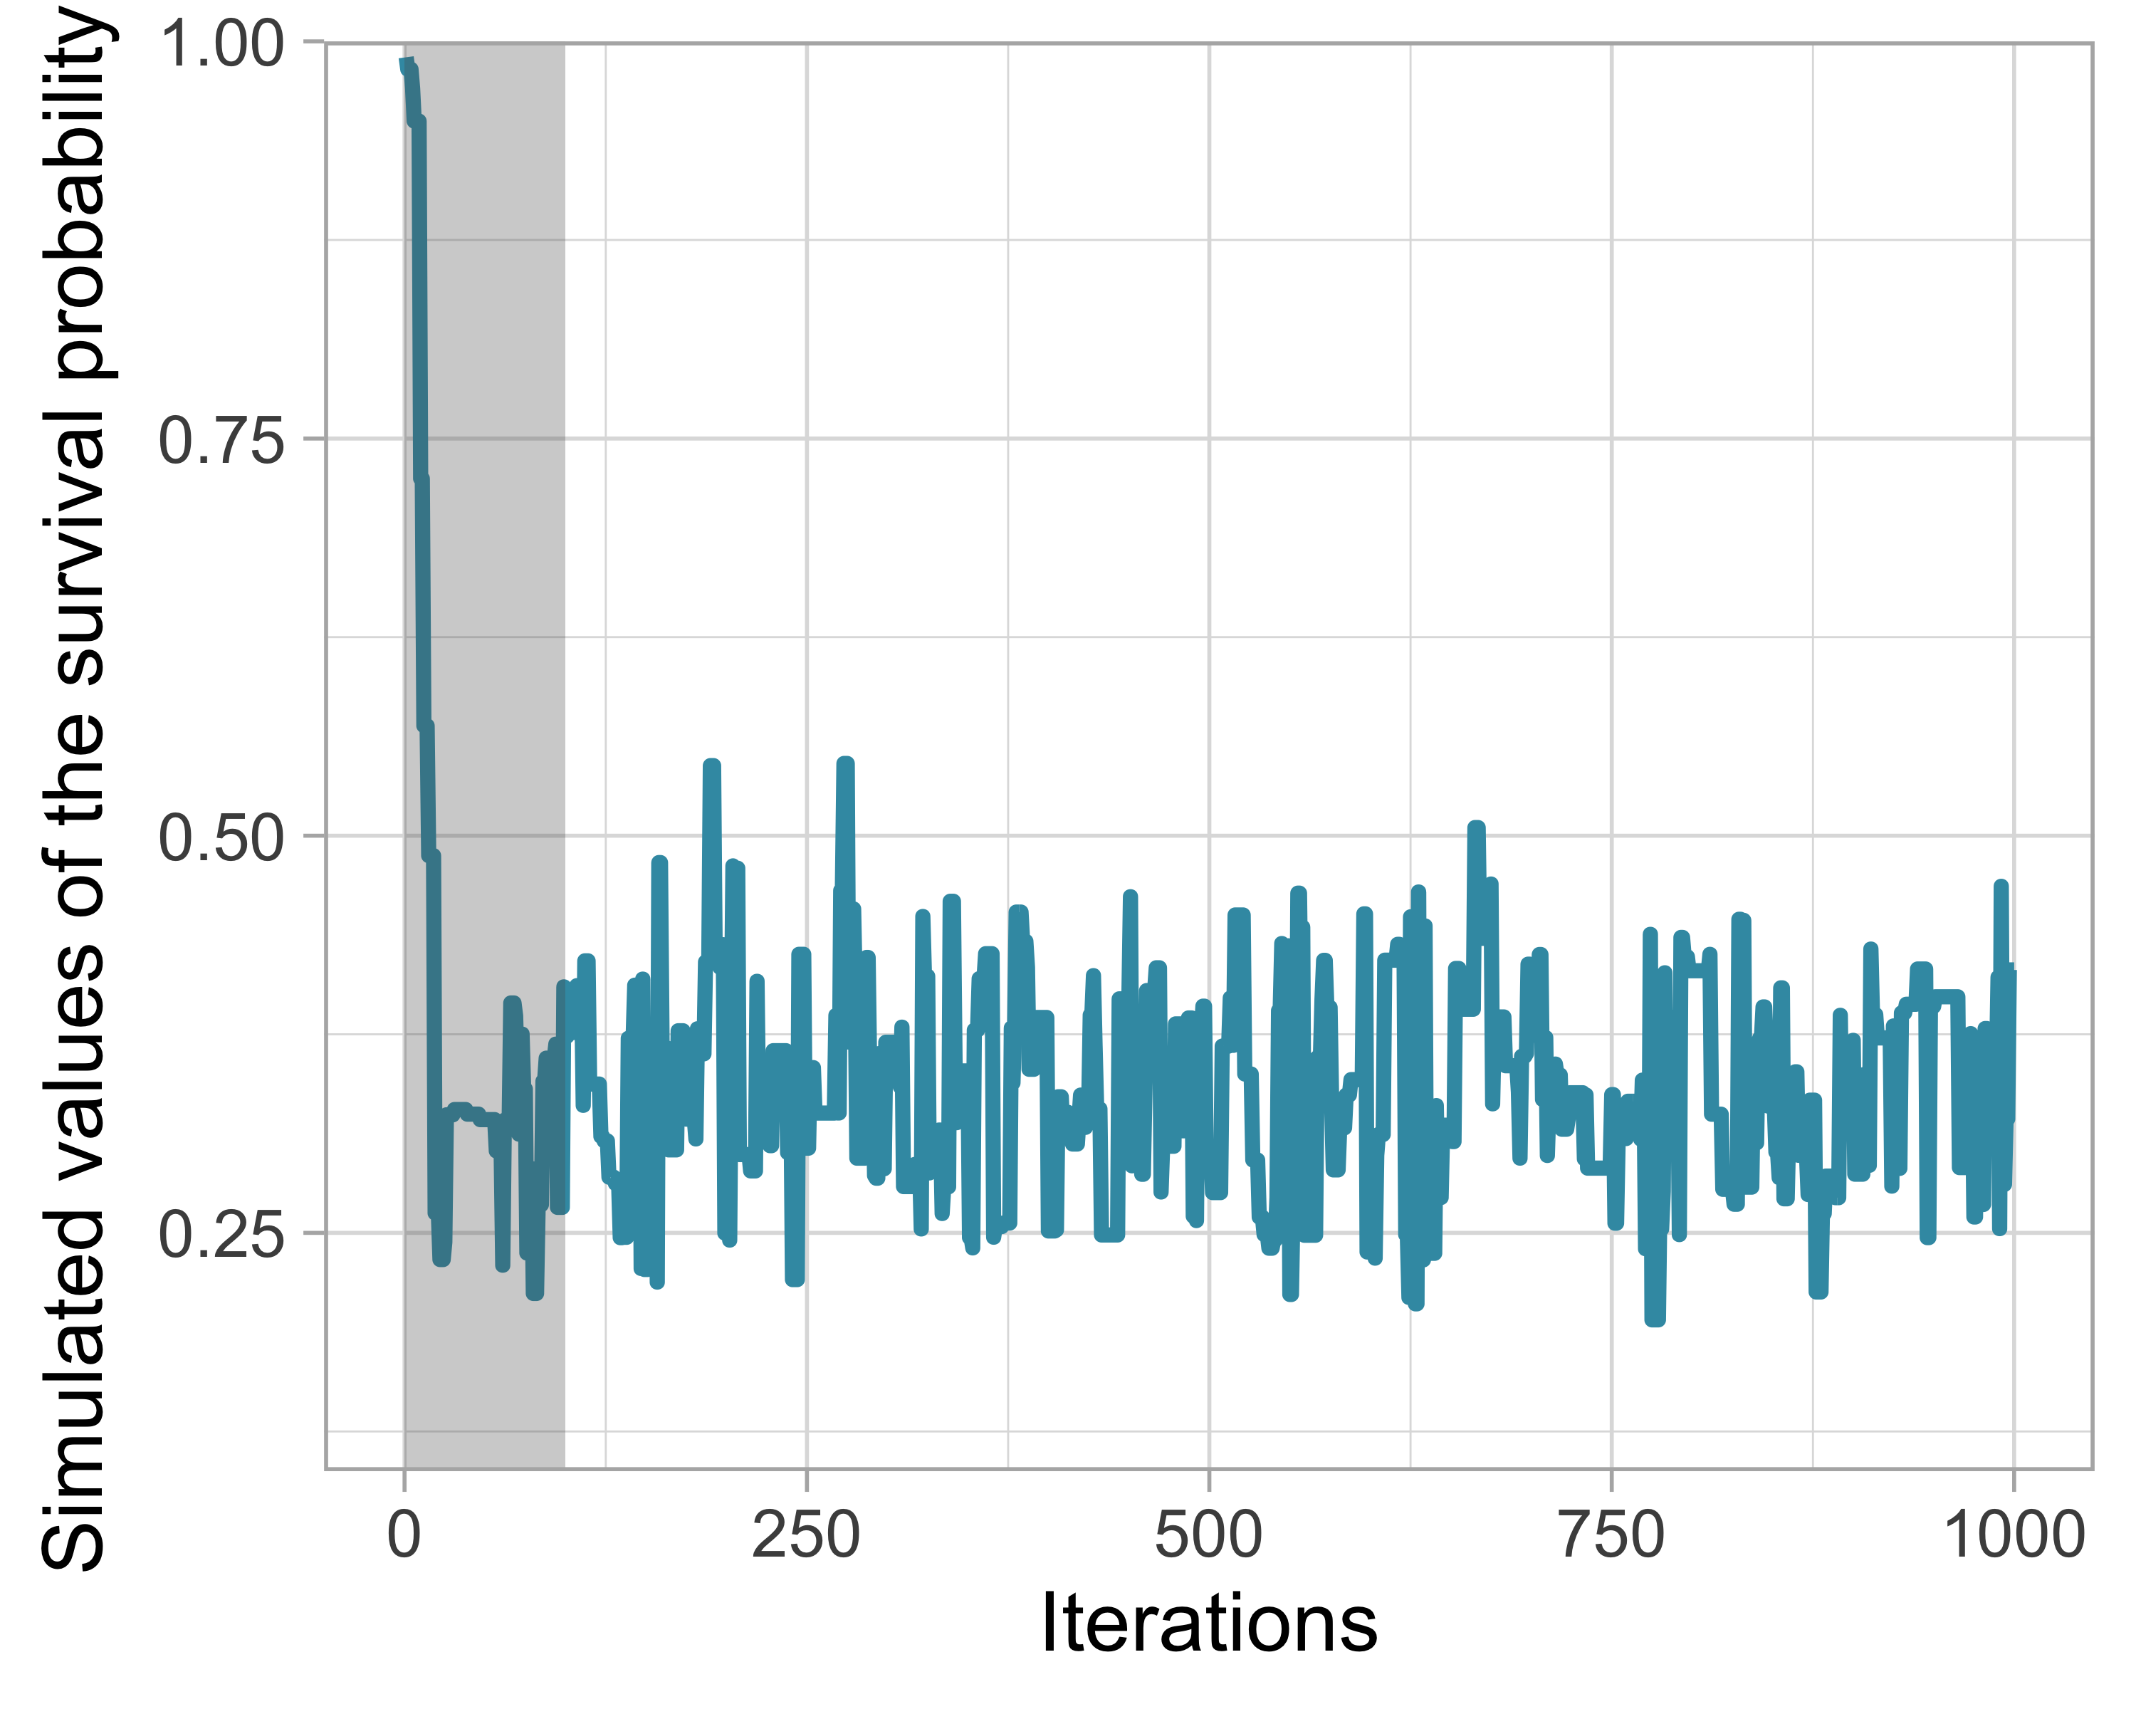

Figure 11: Trace plot for a chain starting at 0.99. The shaded area illustrates a possible burn-in period.

The chain starts at 0.99 and stabilizes quickly, with values oscillating around 0.3 from about iteration 100 onward. We can choose the shaded area as a burn-in period and discard the first 100 values. To be safe, one could use 250 or even 500 iterations as burn-in, provided it does not cost too much computation time, of course.

Inspecting a trace plot from a single chain is useful, but we generally run multiple chains with different initial values to check that they all reach the same stationary distribution. This approach is formalized by the Brooks–Gelman–Rubin statistic (BGR), denoted $\hat{R}$, which measures the ratio between total variability (between chains plus within each chain) and within-chain variability. It is close in spirit to an $F$ test in an analysis of variance (here, a one-factor ANOVA where the factor levels are the chains). A value below 1.1 indicates likely convergence.

Let us return to our example: we run two Markov chains with initial values 0.2 and 0.8, varying the number of iterations from 100 to 1000 in steps of 50, and we compute the BGR statistic using half the iterations as burn-in (Figure 12).

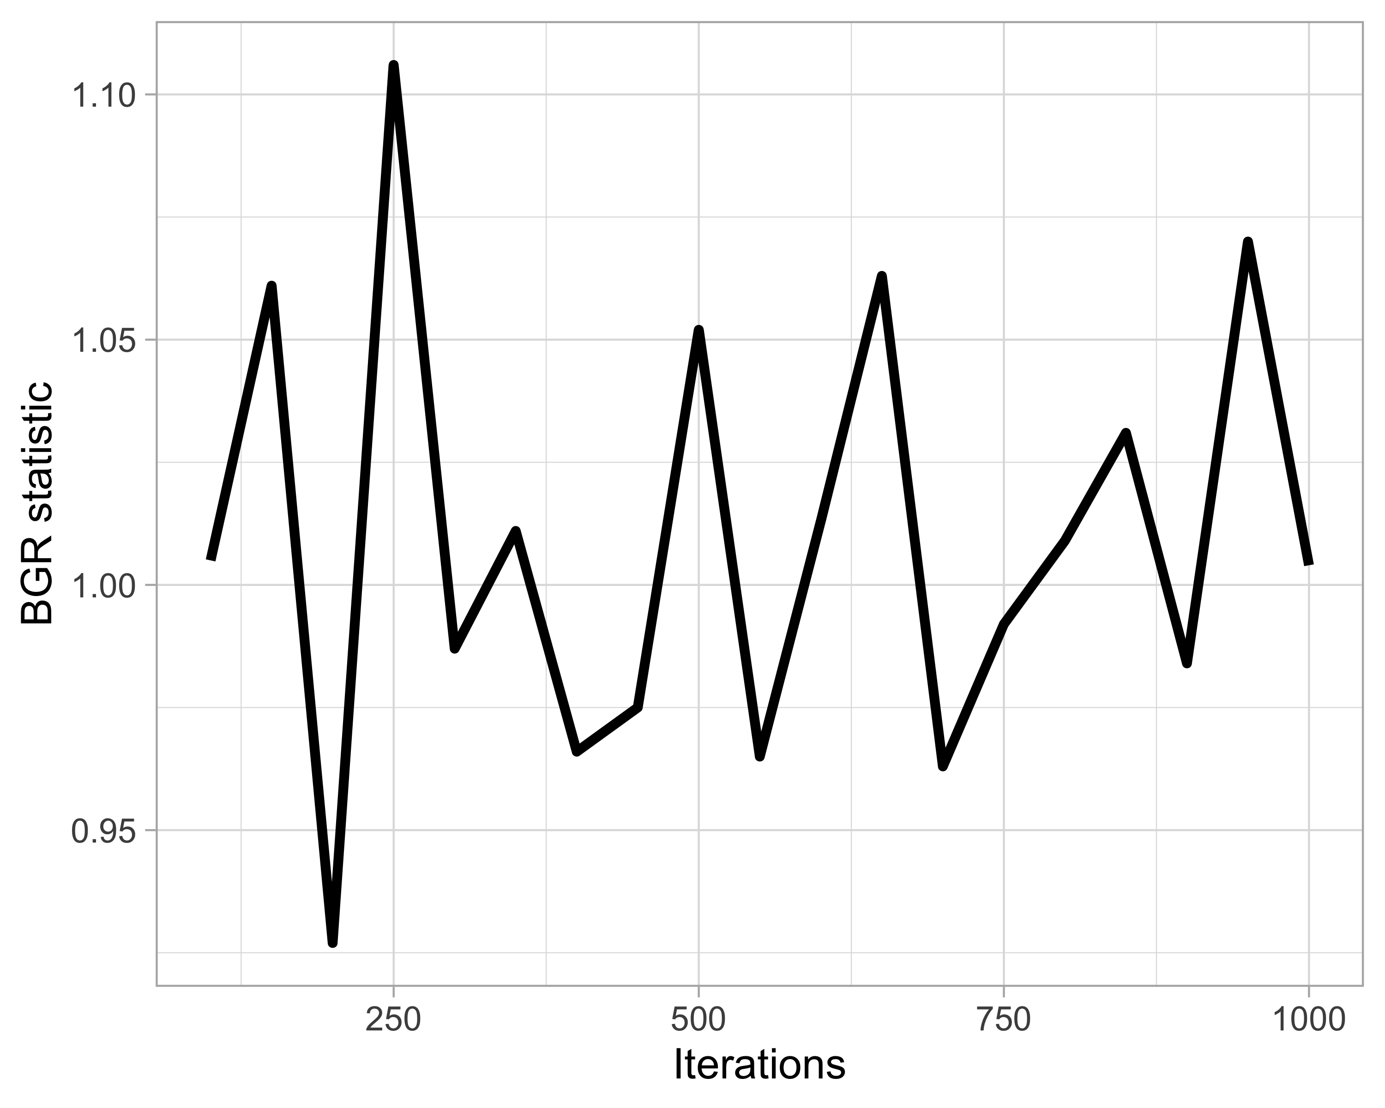

Figure 12: Value of the Brooks–Gelman–Rubin (BGR) statistic as a function of the number of iterations. A value close to 1 suggests convergence.

We obtain a BGR statistic close to 1 from about 300 iterations onward, suggesting that with a burn-in of 300 iterations, nothing indicates a convergence problem.

It is important to remember that a value close to 1 for the BGR statistic is a necessary but not sufficient condition for convergence. In other words, this diagnostic cannot assert with certainty that the chain has converged; it simply indicates that we do not detect an obvious sign that it has not. My advice: always take the time to look at the trace plots.

### Chain length

What chain length is needed to obtain reliable parameter estimates? Keep in mind that successive steps of a Markov chain are not independent. This is called autocorrelation. Ideally, we want to minimize this autocorrelation.

Here again, trace plots can diagnose autocorrelation issues. Returning to the survival example, Figure 13 shows trace plots (3000 iterations) for different values of the proposal normal standard deviation (parameter away) used to generate candidate values.

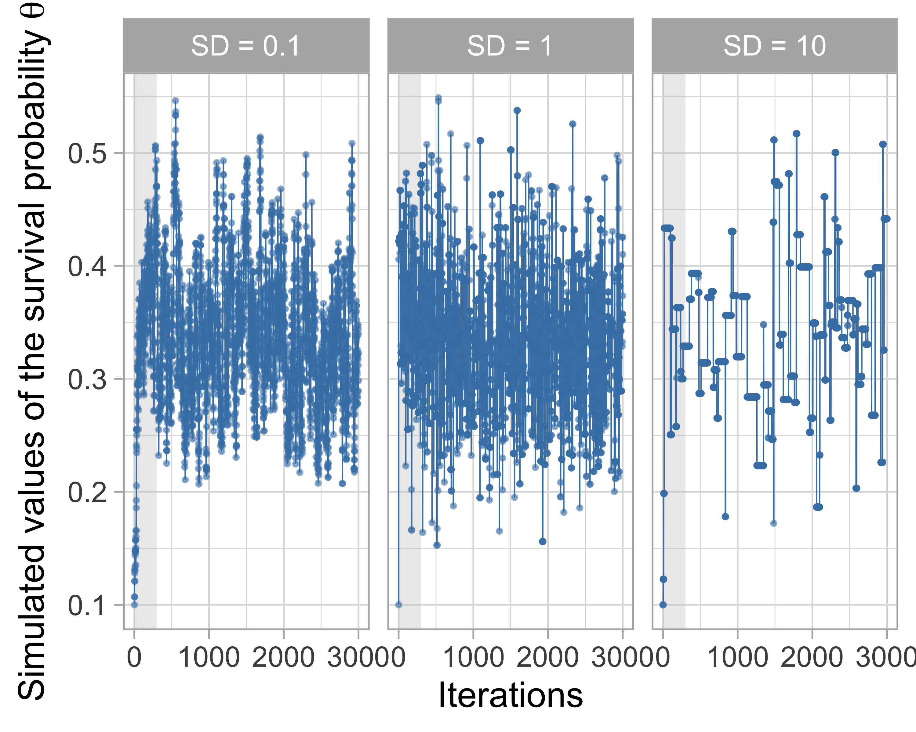

Figure 13: Trace plots for different values of the proposal standard deviation (away). Good mixing is observed with away = 1. The shaded gray area corresponds to a burn-in of 300 iterations.

The very small and very large moves visible in the left and right panels lead to strong correlation between successive observations of the Markov chain, whereas a standard deviation equal to 1 (center) allows efficient exploration of the parameter space. This movement through parameter space is called mixing. Mixing is considered poor when the chain makes jumps that are too small or too large, and good otherwise.

In addition to trace plots, autocorrelation function (ACF) plots provide a convenient way to visualize the strength of autocorrelation in a given sample. ACF plots show the correlation between successively sampled values separated by an increasing number of iterations, called the lag. In Figure 14, we obtain ACF plots for different proposal standard deviations using forecast::ggAcf():

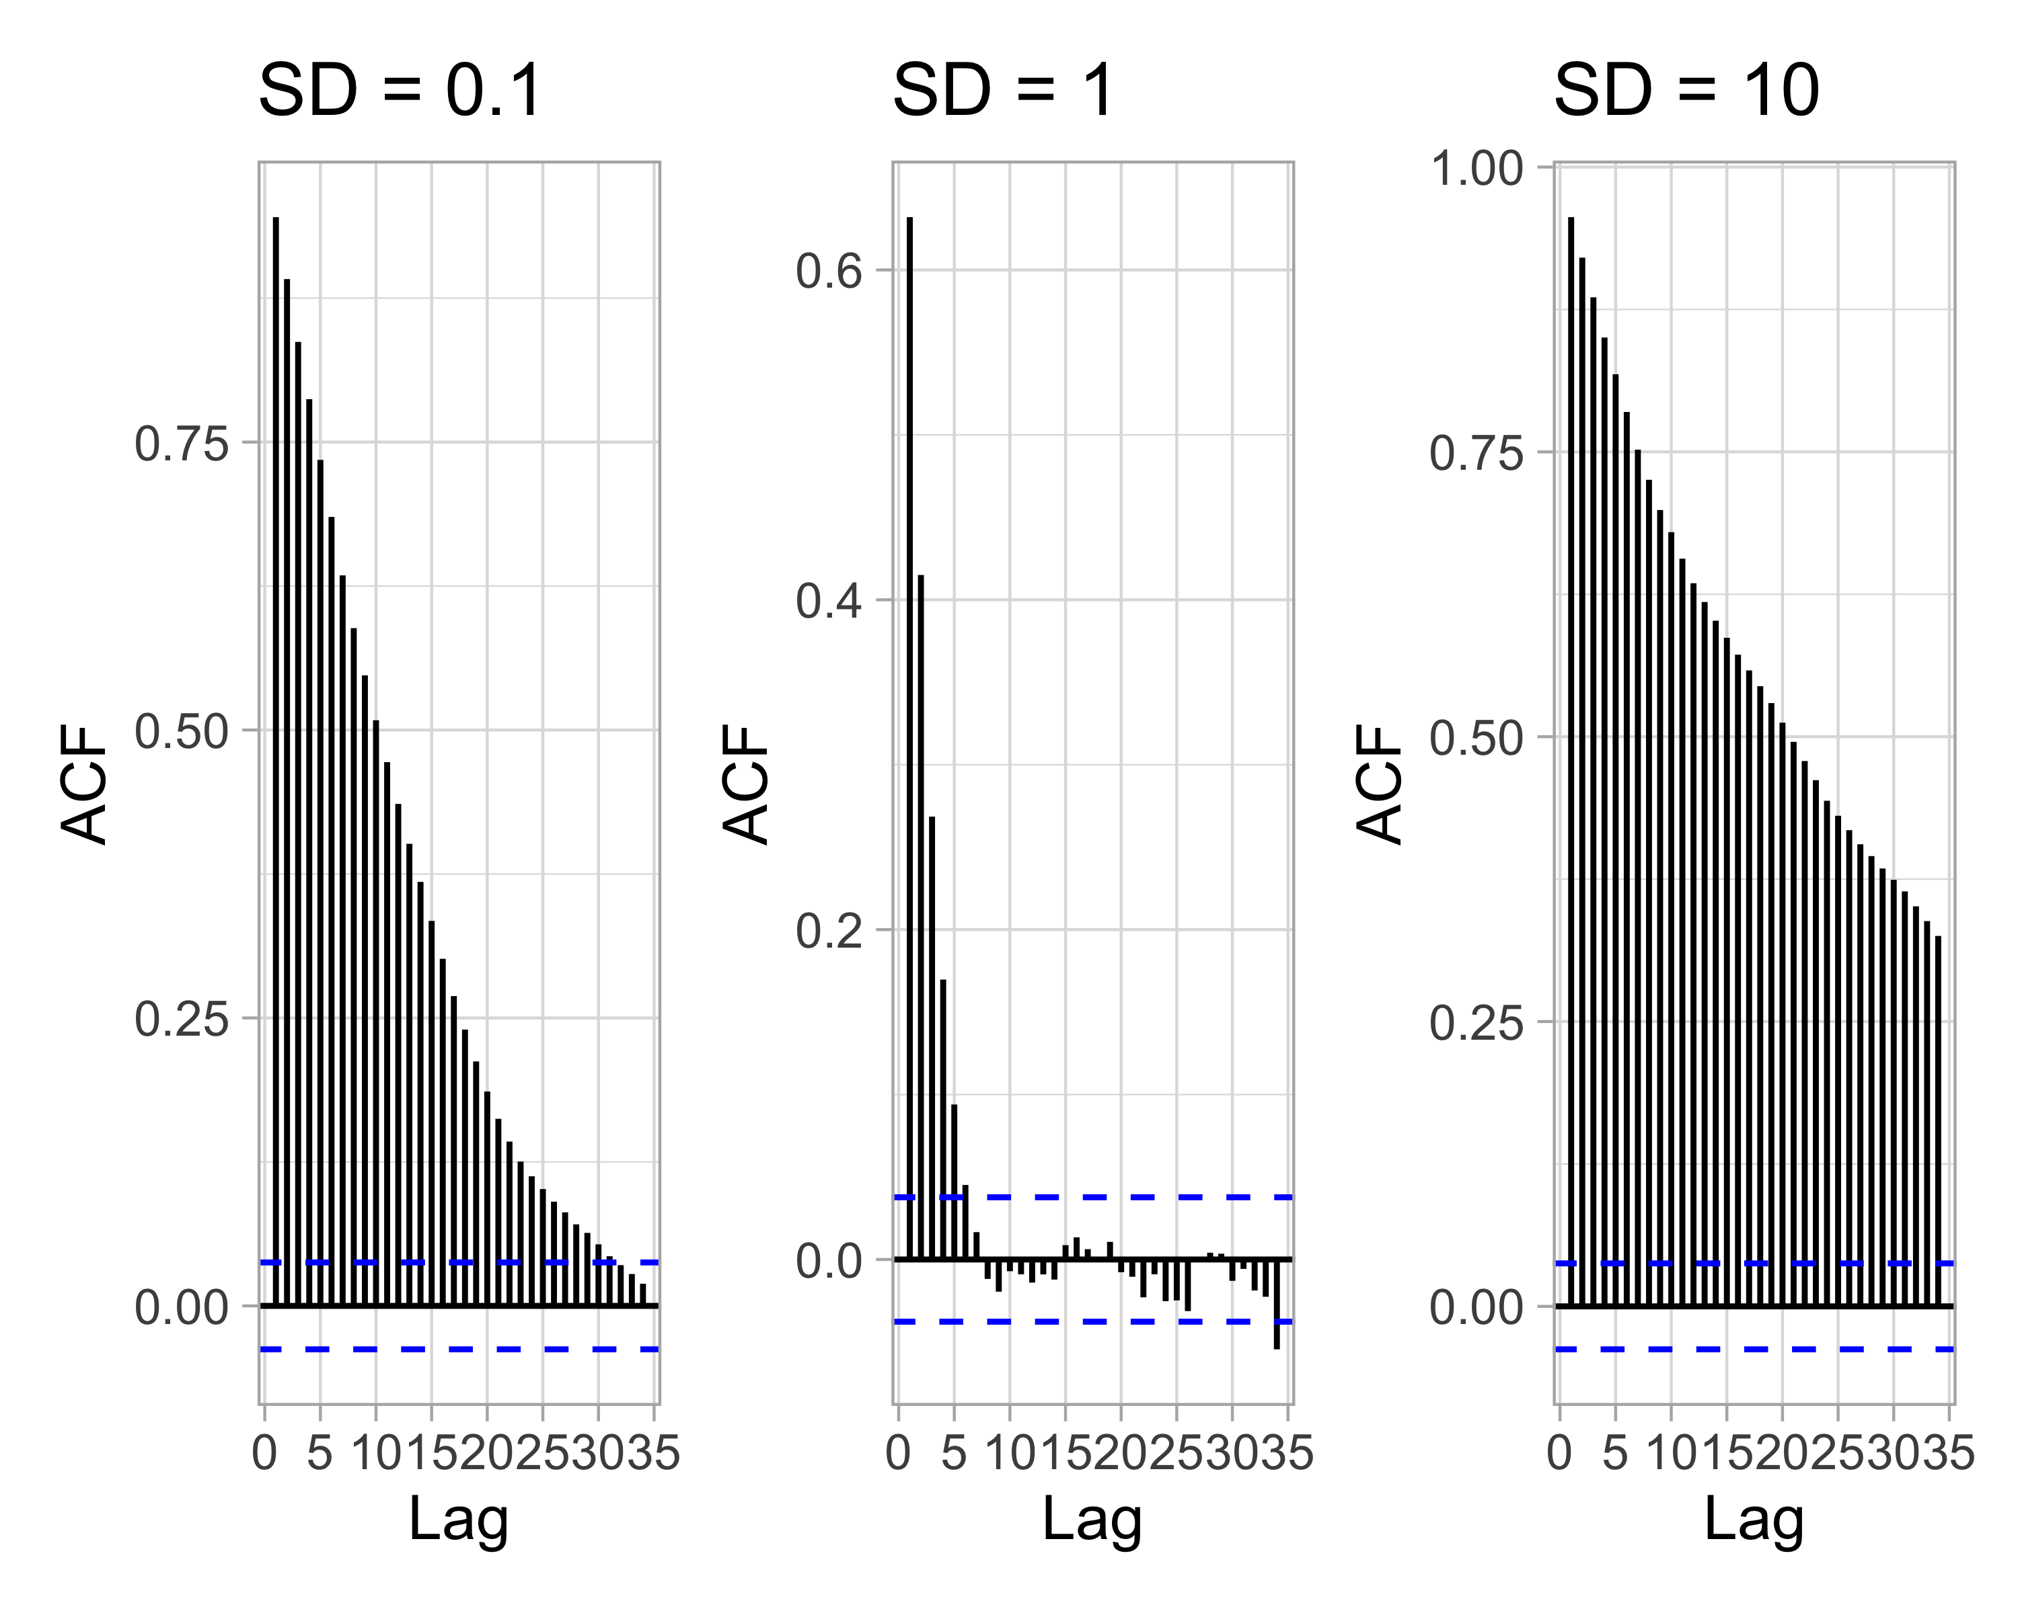

Figure 14: Autocorrelation functions (ACF) for different proposal standard deviations. Low autocorrelation is a sign of good mixing. A burn-in of 300 iterations is applied.

In the left and right panels, autocorrelation is strong and decreases slowly with lag, and mixing is poor. In the central panel, autocorrelation is weak and decreases quickly with lag, and mixing is good.

Autocorrelation is not necessarily a major problem. Highly correlated observations simply require a larger number of samples, and therefore longer simulations. But how many iterations do we need exactly? The effective sample size (n.eff) measures the useful length of the chain while accounting for autocorrelation. It is recommended to check n.eff for each parameter of interest, as well as for any relevant combination of parameters. In general, we consider that we need at least $\text{n.eff}≥400$ independent observations to obtain reliable Monte Carlo estimates of model parameters. In the animal survival example, n.eff can be computed using the effectiveSize() function from the coda package:

# Generate chains for three proposal standard deviations  
d <- tibble(away = c(0.1, 1, 10)) %>%  
 mutate(accepted_traj = map(away,  
 metropolis,  
 steps = n_steps,  
 inits = 0.1)) %>%  
 unnest(accepted_traj) %>%  
 mutate(proposal_sd = str_c("SD = ", away),  
 iter = rep(1:n_steps, times = 3))  
  
# Compute effective sample size  
neff1 <- coda::effectiveSize(d$accepted_traj[d$proposal_sd=="SD = 0.1"][-c(1:300)])  
neff2 <- coda::effectiveSize(d$accepted_traj[d$proposal_sd=="SD = 1"][-c(1:300)])  
neff3 <- coda::effectiveSize(d$accepted_traj[d$proposal_sd=="SD = 10"][-c(1:300)])  
tibble("SD" = c(0.1, 1, 10),  
 "n.eff" = round(c(neff1, neff2, neff3)))  
#> # A tibble: 3 × 2  
#> SD n.eff  
#> <dbl> <dbl>  
#> 1 0.1 81  
#> 2 1 524  
#> 3 10 77

As expected, n.eff is smaller than the total number of MCMC iterations (3000) because of autocorrelation. Only when the proposal standard deviation equals 1 is mixing good (n.eff $≥400$), yielding a satisfactory effective sample size.

### What if you have convergence problems?

When diagnosing the convergence of an MCMC chain, you will (very) often encounter difficulties. This section offers a few practical tips that I hope will be useful.

When mixing is poor and the effective sample size is low, it may be enough to increase the burn-in period and/or increase the number of simulations. Using more informative priors can also facilitate the convergence of Markov chains by helping the MCMC algorithm explore the parameter space more efficiently (Chapter 4). In the same spirit, choosing better initial values to start the chain can also help. A useful strategy is to use estimates from a simpler model for which your MCMC chains already converge.

If convergence problems persist, there is often an issue with the model itself. A bug in the code? A typo? An error in the equations? As is often the case in programming, the best way to identify the problem is to reduce the model’s complexity and start again from a simpler model until you find what is wrong.

Another piece of advice is to think of your model first and foremost as a data generator. Simulate data from this model using realistic parameter values, and then try to recover those parameters by fitting the model to the simulated data. This approach will help you better understand how the model works, what it does not do, and how much data are needed to obtain reliable parameter estimates. We will return to this technique in Chapters 5 and 6.

## In summary

* The idea of Markov chain Monte Carlo (MCMC) methods is to simulate values from a Markov chain whose stationary distribution is precisely the posterior distribution of the parameters we want to estimate.
* In practice, we run several Markov chains starting from dispersed initial values.
* We discard the first iterations (warm-up or burn-in phase) and consider that convergence is reached when all chains converge to the same regime.
* From that point on, we run the chains long enough and then compute Monte Carlo estimates of numerical summaries (for example, posterior means or credible intervals) of the parameters.
* Of course, we do not want to build and implement MCMC methods by hand for every new analysis, and in Chapter 3 we will see how to make this easier.

# Practical implementation

## Introduction

In this chapter, we will explore two very practical tools for performing Bayesian statistics with minimal effort: NIMBLE and brms. NIMBLE and brms are two R packages that implement MCMC algorithms for you. In practice, you only need to specify a likelihood and priors for Bayes’ theorem to be applied automatically. Thanks to a syntax close to that of R, both packages make this step relatively straightforward, even for complex models.

## NIMBLE

NIMBLE stands for **N**umerical **I**nference for statistical **M**odels using **B**ayesian and **L**ikelihood **E**stimation. The originality of NIMBLE is that it separates the model-building step from the model-fitting step, which allows great flexibility in modeling. The package is developed by a team of scientists who continuously improve its capabilities based on community feedback. The NIMBLE community is active on <https://groups.google.com/g/nimble-users>, a forum where the developers respond to questions quickly and helpfully.

To use NIMBLE, you can follow these steps:

1. Build a model (likelihood and priors).
2. Read in the data.
3. Specify the parameters for which you want to make inferences.
4. Provide initial values for these parameters (per chain).
5. Define the MCMC settings: number of chains, burn-in, number of post-burn-in iterations.
6. Assess convergence.
7. Interpret the results.

But first, don’t forget to load the package (to install NIMBLE, see <https://r-nimble.org/download>):

library(nimble)

Let’s return to our running example on coypu survival. First step: define the binomial likelihood and a uniform prior on the survival probability $θ$ using the nimbleCode() function:

model <- nimbleCode({  
 # likelihood  
 y ~ dbinom(theta, n)  
 # prior  
 theta ~ dbeta(1, 1) # or dunif(0,1)  
})

We can check that the model object indeed contains this code:

model  
#> {  
#> y ~ dbinom(theta, n)  
#> theta ~ dbeta(1, 1)  
#> }

In the code, y and n are known, and only $θ$ needs to be estimated. The line y ~ dbinom(theta, n) indicates that the number of survivors follows a binomial distribution. The prior is a beta distribution with parameters 1 and 1 (dbeta()), i.e. a uniform distribution between 0 and 1 (dunif()). Standard distributions are available in NIMBLE (dnorm, dpois, dmultinom, etc.). Note that the order of the lines does not matter: NIMBLE uses a declarative language (you specify *what*, not *how*).

In a second step, we enter the data in a list:

dat <- list(n = 57, y = 19)

NIMBLE distinguishes data (known values on the left of ~) from constants (e.g. loop indices). Declaring some values as constants can improve computational efficiency, although this is not always intuitive. Fortunately, NIMBLE largely handles this automatically and may suggest moving some objects to constants if it improves performance. We ignore this distinction here, but we will use it later in Chapter 6.

The third step is to tell NIMBLE which parameters you want to monitor. Here, we are interested in the survival probability $θ$:

par <- c("theta")

In general, your model contains many quantities, some of which are not very informative and do not need to be monitored. Having full control over what is tracked is therefore very useful.

The fourth step consists in specifying initial values for all model parameters. At a minimum, you must provide initial values for all quantities that appear only on the left side of ~ in your code and are not supplied as data.

To ensure that the MCMC algorithm properly explores the posterior distribution, we run multiple chains with different initial values. You can specify initial values for each chain (here three chains) in a list, which is itself placed inside another list:

init1 <- list(theta = 0.1)  
init2 <- list(theta = 0.5)  
init3 <- list(theta = 0.9)  
inits <- list(init1, init2, init3)  
inits  
#> [[1]]  
#> [[1]]$theta  
#> [1] 0.1  
#>   
#>   
#> [[2]]  
#> [[2]]$theta  
#> [1] 0.5  
#>   
#>   
#> [[3]]  
#> [[3]]$theta  
#> [1] 0.9

Alternatively, you can write an R function that generates random initial values:

inits <- function() list(theta = runif(1,0,1))  
inits()  
#> $theta  
#> [1] 0.0873152

I prefer using functions because the code is more compact and automatically adapts to the number of chains. If you use a function to generate initial values, it is always good practice to set a random seed beforehand so that you can reproduce the results:

seed <- 666  
set.seed(seed)

Fifth and final step: you need to tell NIMBLE the number of chains (n.chains), the burn-in length (n.burnin), and the total number of iterations (n.iter):

n.iter <- 2000  
n.burnin <- 300  
n.chains <- 3

In NIMBLE, you specify the total number of iterations, so the number of posterior samples per chain will be equal to n.iter - n.burnin.

As a side note, to determine the length of the warm-up period (burn-in), you can run NIMBLE with n.burnin <- 0 for a few hundred or thousand iterations and inspect the parameter trace to decide how many iterations are needed to reach convergence.

NIMBLE also allows you to discard samples after the burn-in phase, which is called thinning. By default, thinning = 1 (no samples are removed), meaning that all simulations are used to summarize the posterior distributions.

We now have all the ingredients to run our model, i.e. to generate samples from the posterior distribution of the parameters via MCMC simulations. We use the nimbleMCMC() function for this:

mcmc.output <- nimbleMCMC(code = model, # model  
 data = dat, # data  
 inits = inits, # initial values  
 monitors = par, # parameters to monitor  
 niter = n.iter, # total number of iterations  
 nburnin = n.burnin, # burn-in iterations  
 nchains = n.chains) # number of chains  
#> |-------------|-------------|-------------|-------------|  
#> |-------------------------------------------------------|  
#> |-------------|-------------|-------------|-------------|  
#> |-------------------------------------------------------|  
#> |-------------|-------------|-------------|-------------|  
#> |-------------------------------------------------------|

NIMBLE performs several internal steps that we will not detail here. The nimbleMCMC() function accepts other useful arguments. For example, setSeed lets you fix the random seed inside the MCMC call, ensuring you obtain exactly the same chains at each run—very useful for reproducibility and debugging. You can also request a summary of the output with summary = TRUE, or retrieve MCMC samples in the coda::mcmc() format with samplesAsCodaMCMC = TRUE. Finally, you can remove the progress bar with progressBar = FALSE if you find it too depressing during long simulations. See ?nimbleMCMC for details.

Let’s take a look at the results, starting by examining what the mcmc.output object contains:

str(mcmc.output)  
#> List of 3  
#> $ chain1: num [1:1700, 1] 0.341 0.383 0.409 0.395 0.301 ...  
#> ..- attr(*, "dimnames")=List of 2  
#> .. ..$ : NULL  
#> .. ..$ : chr "theta"  
#> $ chain2: num [1:1700, 1] 0.452 0.337 0.279 0.392 0.394 ...  
#> ..- attr(*, "dimnames")=List of 2  
#> .. ..$ : NULL  
#> .. ..$ : chr "theta"  
#> $ chain3: num [1:1700, 1] 0.32 0.349 0.345 0.443 0.377 ...  
#> ..- attr(*, "dimnames")=List of 2  
#> .. ..$ : NULL  
#> .. ..$ : chr "theta"

The R object mcmc.output is a list with three elements, one for each MCMC chain. Let’s look, for example, at the first chain:

dim(mcmc.output$chain1)  
#> [1] 1700 1  
head(mcmc.output$chain1)  
#> theta  
#> [1,] 0.3406710  
#> [2,] 0.3828351  
#> [3,] 0.4092987  
#> [4,] 0.3952632  
#> [5,] 0.3009713  
#> [6,] 0.3080546

Each element of the list is a matrix. The rows correspond to the 1700 samples from the posterior distribution of $θ$ (which corresponds to n.iter - n.burnin iterations). The columns represent the parameters we monitor, here theta.

From there, we can compute the posterior mean of $θ$:

mean(mcmc.output$chain1[,"theta"])  
#> [1] 0.3372946

And the 95% credible interval:

quantile(mcmc.output$chain1[,"theta"], probs = c(2.5, 97.5)/100)  
#> 2.5% 97.5%   
#> 0.2265435 0.4531473

Let us now visualize the posterior distribution of $θ$ as a histogram:

mcmc.output$chain1[,"theta"] %>%  
 as_tibble() %>%  
 ggplot() +  
 geom_histogram(aes(x = value), color = "white") +  
 labs(x = "Survival probability")

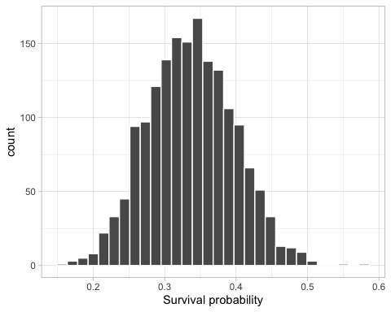

Figure 15: Histogram of the posterior distribution of the survival probability ($θ$).

There are more convenient ways to perform these Bayesian inferences. We will use the R package MCMCvis to summarize and visualize MCMC output, but you can also use ggmcmc, bayesplot, or basicMCMCplots.

Let’s load MCMCvis:

library(MCMCvis)

To obtain the most common numerical summaries, we use MCMCsummary():

MCMCsummary(object = mcmc.output, round = 2)  
#> mean sd 2.5% 50% 97.5% Rhat n.eff  
#> theta 0.34 0.06 0.23 0.34 0.46 1 5072

We can also draw a caterpillar plot with MCMCplot() to visualize posterior distributions:

MCMCplot(object = mcmc.output, params = 'theta')

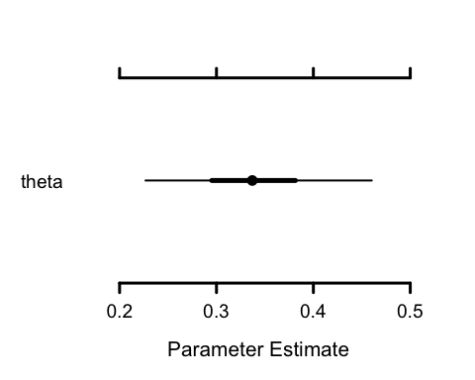

Figure 16: Caterpillar plot of the posterior distribution of the survival probability ($θ$).

The point represents the posterior median, the thick bar the 50% credible interval, and the thin bar the 95% credible interval.

We can plot the MCMC chain (trace plot) and the associated posterior density with MCMCtrace():

MCMCtrace(object = mcmc.output,  
 pdf = FALSE,  
 ind = TRUE,  
 params = "theta")

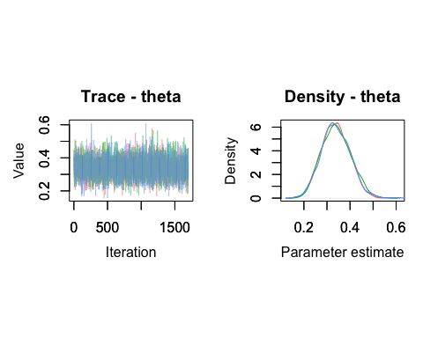

Figure 17: Trace plot and posterior density of the survival probability ($θ$).

These plots are used to assess chain convergence and to detect potential estimation issues (see Chapter 2). We can also add the diagnostics discussed earlier:

MCMCtrace(object = mcmc.output,  
 pdf = FALSE,  
 ind = TRUE,  
 Rhat = TRUE,  
 n.eff = TRUE,  
 params = "theta")

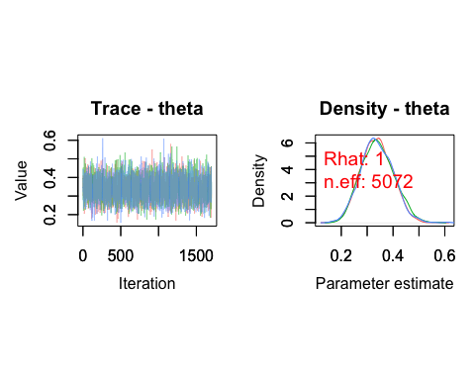

Figure 18: Trace plot and posterior density of the survival probability ($θ$) with convergence diagnostics.

A major advantage of MCMC methods is that they provide the posterior distribution of any function of the parameters by applying that function to draws from the posterior distributions of those parameters. For example, suppose we want to compute the life expectancy of coypus, given by $λ=-1/log\left(θ\right)$.

In our example, we simply combine the theta samples from the three chains:

theta_samples <- c(mcmc.output$chain1[,"theta"],  
 mcmc.output$chain2[,"theta"],  
 mcmc.output$chain3[,"theta"])

Then compute the corresponding life expectancy:

lambda <- -1/log(theta_samples)

We thus obtain 5100 simulated values from the posterior distribution of $λ$, whose first values are:

head(lambda)  
#> [1] 0.9286447 1.0415030 1.1194321 1.0773501 0.8328195 0.8492726

We can then extract the usual summaries:

mean(lambda)  
#> [1] 0.9370169  
quantile(lambda, probs = c(2.5, 97.5)/100)  
#> 2.5% 97.5%   
#> 0.6739012 1.2887118

Life expectancy is approximately one year. We can also visualize the posterior distribution of life expectancy:

lambda %>%  
 as_tibble() %>%  
 ggplot() +  
 geom_histogram(aes(x = value), color = "white") +  
 labs(x = "Life expectancy")

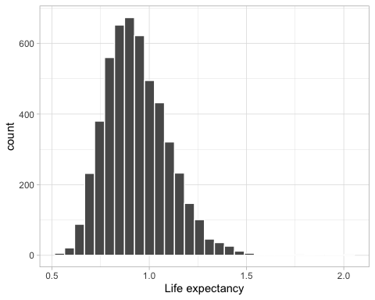

Figure 19: Histogram of the posterior distribution of life expectancy.

We could also compute life expectancy by inserting it directly into the NIMBLE model with a line lambda <- -1/log(theta) and adding lambda to the monitored outputs. The approach presented here is particularly useful with large models and/or large datasets, because it reduces memory usage.

Now you can get started. For convenience, the steps above are summarized below. The workflow provided by nimbleMCMC() allows you to build models and perform Bayesian inference:

model <- nimbleCode({  
 y ~ dbinom(theta, n)  
 theta ~ dbeta(1, 1)  
 lambda <- -1/log(theta)  
})  
dat <- list(n = 57, y = 19)  
par <- c("theta", "lambda")  
inits <- function() list(theta = runif(1,0,1))  
n.iter <- 5000  
n.burnin <- 1000  
n.chains <- 3  
mcmc.output <- nimbleMCMC(code = model,  
 data = dat,  
 inits = inits,  
 monitors = par,  
 niter = n.iter,  
 nburnin = n.burnin,  
 nchains = n.chains)  
MCMCsummary(object = mcmc.output, round = 2)  
MCMCplot(object = mcmc.output)  
MCMCtrace(object = mcmc.output, pdf = FALSE, ind = TRUE)

In this section, we introduced the bare minimum to get started with NIMBLE. But NIMBLE is much more than a simple MCMC engine: it is a programming environment that gives you full control over model construction and parameter estimation. You can write your own functions and distributions, choose MCMC methods yourself, or even code your own algorithms. See the manual <https://r-nimble.org/html_manual/cha-welcome-nimble.html> for more details.

## brms

brms stands for **B**ayesian **R**egression **M**odels using **S**tan. This package makes it possible to formulate and estimate regression models (see the next section and Chapters 5 and 6) in an intuitive way thanks to a syntax close to that of the lme4 package (the R reference for mixed models), while relying on Stan, a reference software in Bayesian statistics. The package is under constant development; see <https://paul-buerkner.github.io/brms/>. You can get help via <https://discourse.mc-stan.org/>.

To use brms, we start by preparing the data:

dat <- data.frame(y = 19, n = 57)

Without forgetting to load brms:

library(brms)

The likelihood is binomial in our running example. In brms, we can express this simply:

bayes.brms <- brm(  
 y | trials(n) ~ 1, # the number of successes is a function of an intercept  
 family = binomial("logit"), # binomial family with logit link function  
 data = dat, # data used  
 chains = 3, # number of MCMC chains  
 iter = 2000, # total number of iterations per chain  
 warmup = 300, # number of burn-in iterations  
 thin = 1 # no thinning (each iteration is kept)  
)

The syntax is relatively simple but requires a few explanations. The argument y | trials(n) ~ 1 makes it possible to specify a model in which we have $y$ successes among $n$ trials, and we estimate only an intercept, the 1 after ~. Why an intercept here? Why not directly the survival $θ$? Because we use family = binomial("logit") on the next line to specify to brms that the response variable follows a binomial distribution. In other words, we have a generalized linear model (see Chapter 6) with $\text{logit}\left(θ\right)=β$ and we estimate $β$, the intercept. The arguments iter = 2000, warmup = 300, and chains = 3 tell brms to use 300 iterations for adaptation (burn-in), and the following 1700 for inference, with 3 chains.

Let’s take a look at the results:

summary(bayes.brms)  
#> Family: binomial   
#> Links: mu = logit   
#> Formula: y | trials(n) ~ 1   
#> Data: dat (Number of observations: 1)   
#> Draws: 3 chains, each with iter = 2000; warmup = 300; thin = 1;  
#> total post-warmup draws = 5100  
#>   
#> Regression Coefficients:  
#> Estimate Est.Error l-95% CI u-95% CI Rhat Bulk_ESS Tail_ESS  
#> Intercept -0.70 0.29 -1.28 -0.14 1.00 1606 2083  
#>   
#> Draws were sampled using sampling(NUTS). For each parameter, Bulk_ESS  
#> and Tail_ESS are effective sample size measures, and Rhat is the potential  
#> scale reduction factor on split chains (at convergence, Rhat = 1).

This command displays a summary table of posterior estimates for each parameter of the model. We find there:

* Estimate is the posterior mean.
* Est.Error is the standard deviation of the posterior distribution.
* l-95% CI and u-95% CI are the bounds of the 95% credible interval.
* The convergence diagnostic Rhat.
* Bulk_ESS is the effective sample size (Tail_ESS is another measure of effective sample size that we will not use here).

The posterior mean is -0.7 far from the proportion of coypus that survived the winter ($19/57≈0.33$). As always in R and in the implementation of generalized linear models (see Chapter 6), parameter estimates are given on the scale of the link function. Here, the estimated intercept is expressed on the logit scale. To convert it to a survival probability (between 0 and 1), we first extract the values generated in the posterior distribution of the intercept $β$ with the function brms::as_draws_matrix():

draws_fit <- as_draws_matrix(bayes.brms)

Then we apply the inverse logistic function plogis() to each of these values to obtain a whole bunch of simulated values from the posterior distribution of survival $θ$:

beta <- draws_fit[,'Intercept'] # selects the intercept column  
theta <- plogis(beta) # logit -> [0,1] conversion

We thus obtain a direct estimate of the posterior mean of the survival probability, along with its 95% credible interval:

mean(theta)  
#> [1] 0.3344732  
quantile(theta, probas = c(2.5,97.5)/100)  
#> 0% 25% 50% 75% 100%   
#> 0.1333564 0.2902688 0.3328735 0.3754111 0.5736192

Or more directly with the function posterior::summarise_draws():

summarise_draws(theta)  
#> # A tibble: 1 × 10  
#> variable mean median sd mad q5 q95 rhat ess_bulk ess_tail  
#> <chr> <dbl> <dbl> <dbl> <dbl> <dbl> <dbl> <dbl> <dbl> <dbl>  
#> 1 Intercept 0.334 0.333 0.0627 0.0631 0.235 0.440 1.00 1606. 2083.

To visualize the posterior distribution of survival probability, we just need to use (Figure 20):

draws_fit %>%  
 ggplot(aes(x = theta)) +  
 geom_histogram(color = "white", fill = "steelblue", bins = 30) +  
 labs(x = "Survival probability", y = "Frequency")

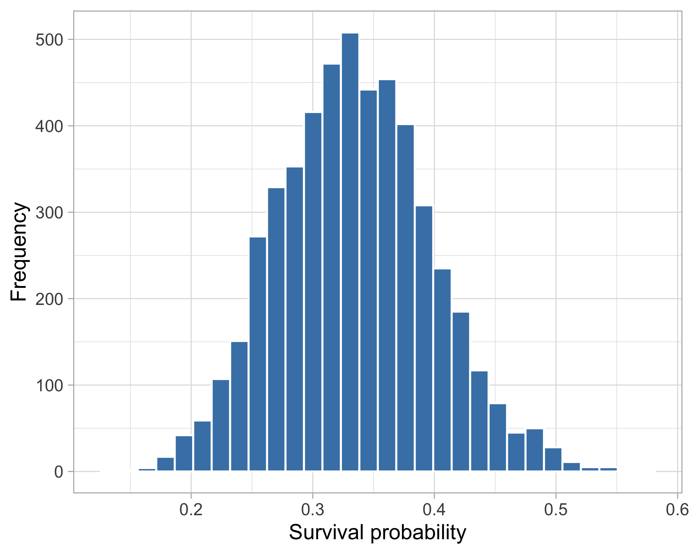

Figure 20: Histogram of the posterior distribution of the survival probability ($θ$).

In brms, we can assess the convergence of the MCMC chains (Figure 21):

plot(bayes.brms)

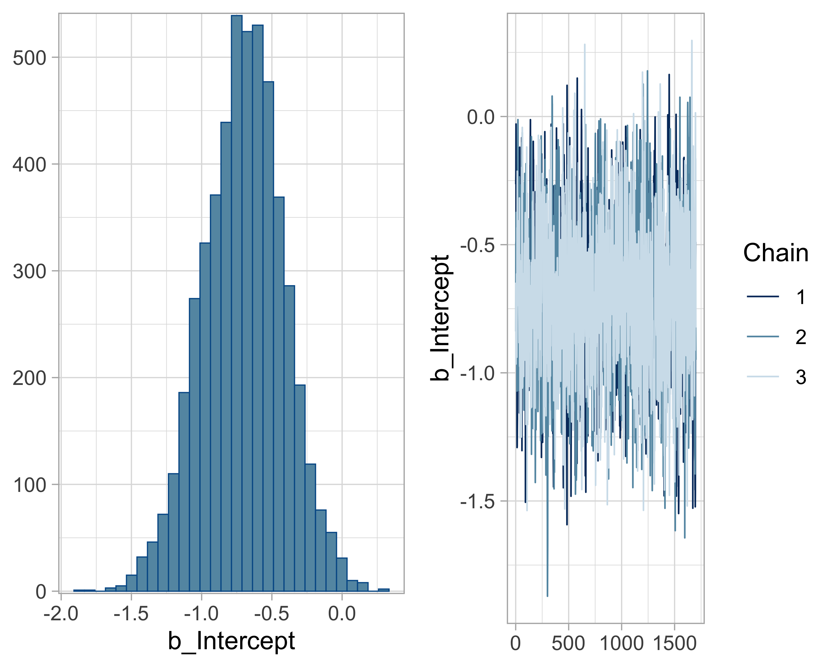

Figure 21: Histogram of the posterior distribution and trace plot of the survival probability on the logit scale (b). In the histogram, the x-axis represents the possible values of the intercept (logit scale) and the y-axis the frequency of the simulated values. In the trace plot, the x-axis corresponds to the MCMC iteration number and the y-axis to the simulated values of the intercept (logit scale).

This graph displays trace plots (right) as well as posterior densities (left).

As a side note, to determine the length of the warm-up period (burn-in), it is enough to run brms with warmup = 0 for a few hundred or thousand iterations and inspect the parameter trace to decide the number of iterations needed to reach convergence.

A major advantage of MCMC methods is that they allow obtaining the posterior distribution of any function of the parameters by applying this function to the values drawn from the posterior distributions of these parameters. Note that here we estimate the intercept $β$ and we have therefore already used this idea to obtain the posterior distribution of the survival probability by applying the inverse logit function. As another example, suppose I would like to compute the life expectancy of coypus, which is given by $λ=-1/log\left(θ\right)$:

beta <- draws_fit[,'Intercept'] # selects the intercept column  
theta <- plogis(beta) # logit -> [0,1] conversion  
lambda <- -1 / log(theta) # transforms survival into life expectancy  
summarize_draws(lambda) # summary of draws: mean, median, intervals  
#> # A tibble: 1 × 10  
#> variable mean median sd mad q5 q95 rhat ess_bulk ess_tail  
#> <chr> <dbl> <dbl> <dbl> <dbl> <dbl> <dbl> <dbl> <dbl> <dbl>  
#> 1 Intercept 0.926 0.909 0.164 0.157 0.691 1.22 1.00 1606. 2083.

Life expectancy is approximately one year. We can also visualize the posterior distribution of life expectancy (Figure 22):

lambda %>%  
 as_tibble() %>%  
 ggplot() +  
 geom_histogram(aes(x = Intercept), color = "white") +  
 labs(x = "Life expectancy")

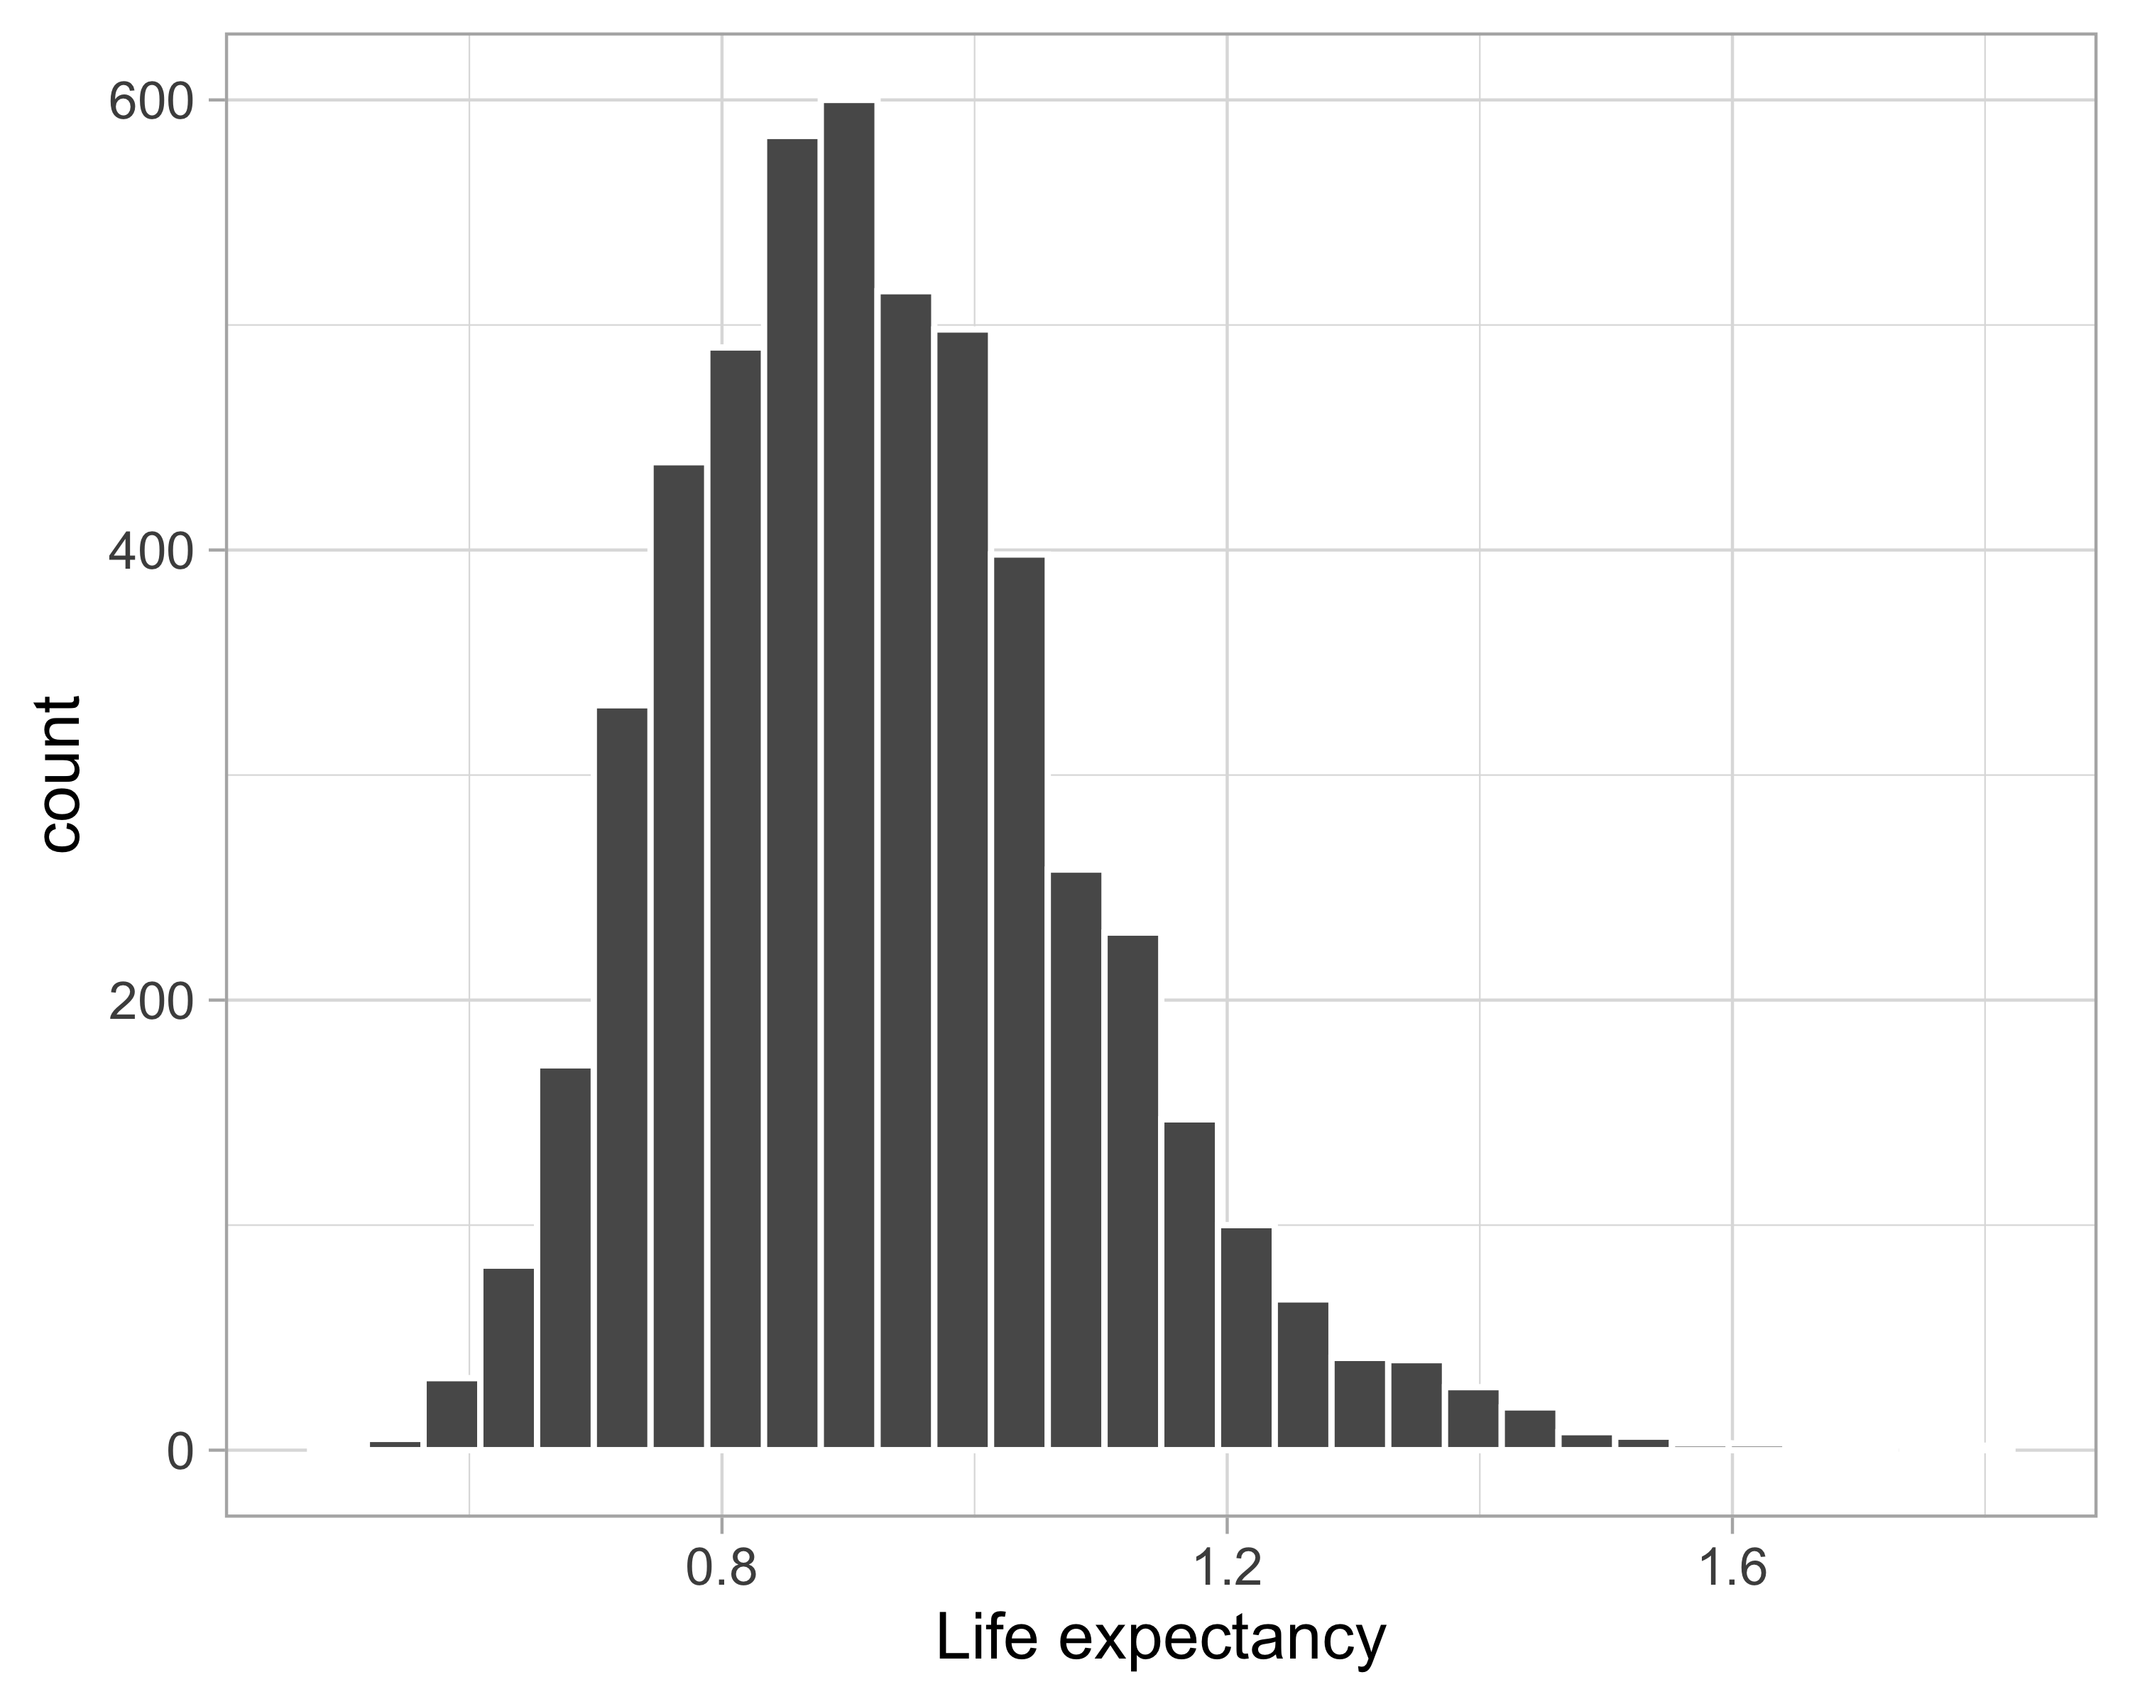

Figure 22: Histogram of the posterior distribution of life expectancy. The x-axis represents the different possible values of life expectancy. The vertical axis indicates the number of simulated draws (Count) for each value.

There are a whole bunch of parameters that are set by default in brms; it is important to be aware of them. This concerns priors in particular. In brms, default priors are often non-informative or weakly informative, but it is always good to examine them explicitly. The following command displays a summary of the priors used in an already fitted model:

prior_summary(bayes.brms)  
#> Intercept ~ student_t(3, 0, 2.5)

The brms package uses as a weakly informative prior a Student distribution with 3 degrees of freedom, centered at 0, with a standard deviation of 2.5. The 3 degrees of freedom give a distribution with heavier tails than a normal, which provides some robustness to extreme values. The center at 0 reflects an absence of strong prior on the value of the intercept. The width 2.5 allows reasonably wide variation of the intercept without being completely non-informative.

In some cases, it is relevant to define your own prior, for example to reflect knowledge from the literature or to further constrain estimation (informative prior). Here, we propose a normal prior centered at 0 with a standard deviation of 1.5 on the intercept; we will come back to this in Chapter 4:

nlprior <- prior(normal(0, 1.5), class = "Intercept")

We can then use it in the model specification:

bayes.brms <- brm(y | trials(n) ~ 1,  
 family = binomial("logit"),  
 data = dat,  
 prior = nlprior, # our own priors  
 chains = 3,  
 iter = 2000,  
 warmup = 300,  
 thin = 1)

You can check that the results are close to those obtained with the default prior:

summary(bayes.brms)  
#> Family: binomial   
#> Links: mu = logit   
#> Formula: y | trials(n) ~ 1   
#> Data: dat (Number of observations: 1)   
#> Draws: 3 chains, each with iter = 2000; warmup = 300; thin = 1;  
#> total post-warmup draws = 5100  
#>   
#> Regression Coefficients:  
#> Estimate Est.Error l-95% CI u-95% CI Rhat Bulk_ESS Tail_ESS  
#> Intercept -0.68 0.28 -1.22 -0.14 1.00 1450 2051  
#>   
#> Draws were sampled using sampling(NUTS). For each parameter, Bulk_ESS  
#> and Tail_ESS are effective sample size measures, and Rhat is the potential  
#> scale reduction factor on split chains (at convergence, Rhat = 1).

## Summary

* NIMBLE makes it possible to model both simple situations and complex models, with great flexibility.
* Its syntax is based on R, which makes it easier to get started if you know the language.
* It offers full control over the model and the algorithms, but assumes you are comfortable with programming.
* Conversely, brms makes it possible to take advantage of MCMC methods without having to write the model yourself (the likelihood in particular).
* Its syntax is simple and close to that of lme4, which makes it particularly suitable for generalized linear models (mixed or not; see Chapter 6).
* In return, brms relies on pre-programmed components (model families, etc.), and it is important to pay attention to default choices, especially regarding prior distributions.
* This chapter thus offers a first concrete approach to implementing Bayesian models, before moving on to richer models, such as mixed models.

# Prior distributions

## Introduction

In this chapter, we will explore a fundamental aspect of Bayesian statistics: the role of prior distributions, or priors. We will see how these priors interact with the data via Bayes’ theorem to produce the posterior distribution, and how this influence varies depending on how much information the data provide. We will also learn how to incorporate relevant external information from expert knowledge or previous studies, and how to critically assess our prior choices using simulations.

## The role of the prior

In Bayesian statistics, the prior plays an essential role: it expresses our knowledge, our uncertainties, or, conversely, our lack of information about the parameters of a model. Choosing priors well is therefore a key step in any Bayesian analysis. Why use a prior?

* To incorporate existing knowledge: we often have information from previous studies, meta-analyses, or expert opinion. The prior makes it possible to formalize and include this prior knowledge, rather than ignoring it and acting as if we were starting from nothing. We will see an example in Section 4.4.
* To deal with a lack of data: when data are scarce or not very informative, frequentist methods can fail to estimate certain parameters correctly (boundary estimates for a probability, or a random-effect variance estimated as zero). In these situations, a well-chosen prior can help stabilize inference by providing complementary information.
* To constrain complex models: in mixed models, or in the presence of parameters that are difficult to estimate, priors make it possible to bound the solution space to plausible values and avoid aberrant estimates. For example, in a mixed model (see Chapter 6) where we estimate the variance between groups or levels of an effect, the absence of a prior can lead to unrealistic values or numerical instabilities. A weakly informative prior can help in this situation.
* To prevent overfitting: in models with many explanatory variables, priors play a regularization role by penalizing unimportant effects. For example, in a regression that includes many covariates, a prior of the form $N\left(0,{1.5}^{2}\right)$ prevents the model from assigning overly strong effects to weakly informative variables, thereby reducing the risk of overfitting.

The choice of a prior depends directly on the context and the scientific question.

* A non-informative prior aims to express a lack of knowledge: it is often used when one does not want to introduce strong assumptions. In practice, this translates into wide or uniform distributions. But beware: even a seemingly vague prior can be informative once transformed to the model scale, as we will see in Section 4.5.
* An informative prior reflects credible knowledge external to the dataset being analyzed: it may come from a literature synthesis, past experience, or expert opinion. Its advantage is to reduce uncertainty on parameters, especially with little data. We will see an example in Section 4.4.
* A weakly informative prior is somewhat a compromise between non-informative and informative priors. The idea is to rule out values that are clearly aberrant or incompatible with what we know about the phenomenon being studied, while still leaving enough freedom for the model to learn from the data. This type of prior is used notably in brms. We will see an example in Chapter 6.

In practice, a cautious strategy is to start with a weakly informative prior, such as a centered normal distribution with moderate variance, then to test more informative (or more vague) alternatives to examine the impact on posterior results. This is the idea of sensitivity analysis developed in Section 4.3.

## Sensitivity to the prior

Let us return to our running example on coypu survival. Let us examine how different choices of priors influence the posterior distribution of this survival probability. In Figure 23, we have three increasingly informative priors (in columns), and two sample sizes (in rows).

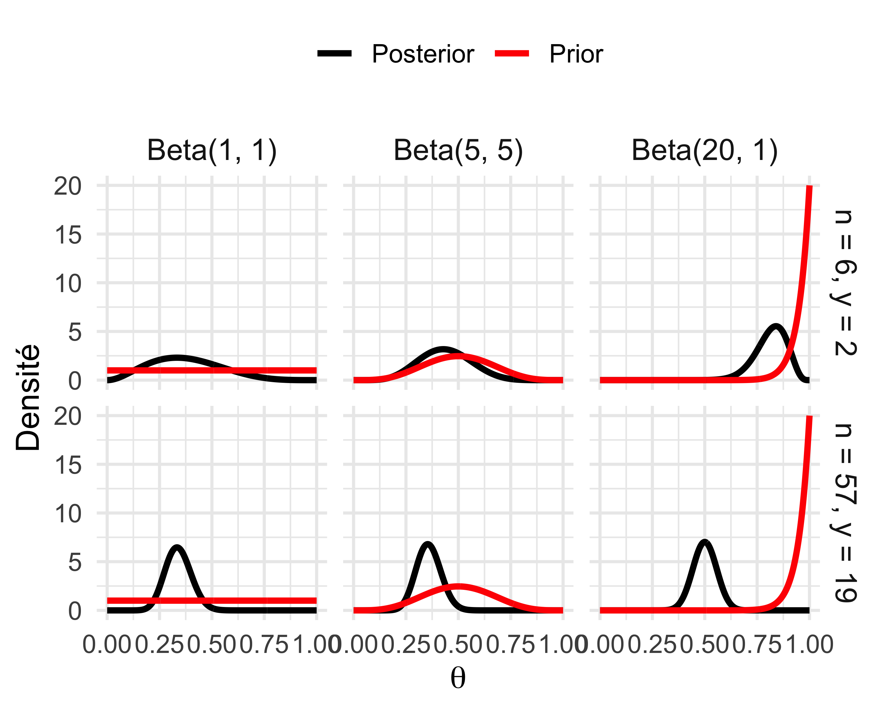

Figure 23: Combined effect of the prior and sample size on the posterior distribution with a binomial likelihood. Columns: three beta priors Beta(1,1), Beta(5,5) and Beta(20,1). Rows: small (n = 6, y = 2) and large (n = 57, y = 19) sample (factor 10). The red line represents the prior, the black line the posterior distribution.

With little data (top row), the effect of the prior is visible: the posterior distribution of survival remains close to the prior, especially with the $\text{Beta}\left(20,1\right)$ which pulls the estimate toward high values. With more data (bottom row), the posterior distribution is dominated by the likelihood: it concentrates around the observed proportion, except for the prior $\text{Beta}\left(20,1\right)$ for which the posterior distribution is centered on 0.5. We thus observe a fundamental principle of Bayesian inference: the more numerous and informative the data are, the less the prior influences the results.

We can formalize the observations made in Figure 23. Recall that when the likelihood is $\text{Bin}\left(n,θ\right)$ with $y$ successes, and the prior is a $\text{Beta}\left(a,b\right)$ distribution, the posterior distribution is also beta (conjugacy), and more precisely $\text{Beta}\left(a+y, b+n-y\right)$. Now, the mean of a $\text{Beta}\left(a,b\right)$ is $\frac{a}{a+b}$, and therefore the mean of the posterior distribution $\text{Beta}\left(a+y, b+n-y\right)$ is $\frac{a+y}{a+b+n}$, which can be rewritten as a weighted average between the mean of the prior distribution $μ_{prior}=\frac{a}{a+b}$ and the observed proportion $y/n$, which is none other than the maximum likelihood estimator $\hat{θ}$, with weight $w=\frac{n}{a+b+n}$. Note: this is a weight in the statistical sense of the term, a weighting factor, not in the sense of “kilograms of coypu”. In other words, the mean of the posterior distribution is $\left(1-w\right)μ_{prior}+w\hat{θ}$. Thus, when the sample size $n$ is large, $w$ tends to 1, and the posterior mean approaches the maximum likelihood estimator. Conversely, for a small sample or a very informative prior (the sum $a+b$ is large; see Figure 4), $w$ is small, and the prior pulls the estimate. In short, when data are limited, we rely more on the prior; when they are rich, we let the likelihood speak.

In conclusion, it is always a good idea to carry out this kind of sensitivity analysis. By comparing results obtained with different priors (non-informative, weakly informative, informative), we can ensure that conclusions do not depend excessively on prior choices. If they do, do not panic: it simply means we have little information about the parameter in question, and we must be extra cautious and think carefully about the prior used. We will return to this later.

## How to incorporate prior information?

### Meta-analysis

Let us go back to our running example on estimating a survival probability, but making it slightly more complex to account for a common issue when studying animal populations: imperfect detection of individuals. Indeed, depending on behavior or field conditions, an animal may very well be alive and present, but not detected at the time of sampling. To correct this bias, capture–recapture protocols are often used, which rely on individual identification of animals, via a ring, a coat pattern, a genetic profile, etc.

An individual can thus be detected (1) or not (0), and we code for example 101 which means: seen the first year, missed the second, then seen again the third. In the simplest model, we assume a constant survival probability $θ$ and a constant detection probability $p$. The likelihood for history 101 is therefore: $Pr\left(101\right)=θ \left(1-p\right) θ p$. To obtain the full likelihood, we perform this calculation for each individual and assume that all share the same $θ$ and $p$, and that they are independent.

To take a break from coypus, let us look at the White-throated Dipper (*Cinclus cinclus*), a bird studied for more than 40 years by Gilbert Marzolin, a mathematics teacher passionate about ornithology with whom I had the chance to work. We have capture–recapture data here over 7 years (1981–1987) for more than 200 birds.

We will start with a non-informative prior on survival probability, say a $\text{Beta}\left(1,1\right)$. This will be our model A. As an alternative prior, we can draw on accumulated knowledge for similar species. In passerines, for instance, there is a relationship between body mass and survival probability: on average, heavier birds live longer. This allometric relationship was quantified by McCarthy (2007) via a linear regression (see Chapter 5), based on survival and mass data for 27 European passerine species. Using this regression for passerines in the specific case of the dipper, and knowing that the dipper weighs on average 59.8 grams, we can predict its annual survival probability. The model thus provides an estimate of 0.57 with a standard error of 0.075. These values allow us to define an informative prior, in the form of a normal distribution centered at 0.57 with variance ${0.075}^{2}$. This will be our model B.

We thus obtain the following results for the dipper:

| Model | Prior for $θ$ | Posterior mean survival | 95% credible interval |
| --- | --- | --- | --- |
| A | Beta(1,1) | 0.56 | [0.51 ; 0.61] |
| B | N(0.57, 0.075²) | 0.56 | [0.52 ; 0.61] |

With a rich dataset (7 years), the information contained in the likelihood dominates; the informative prior adds almost no information, and the two models produce very similar results.

Now imagine that we have limited data. What happens if we only have the first three years, for example? We redo the analysis, and the results are now:

| Model | Prior for $θ$ | Posterior mean survival | 95% credible interval |
| --- | --- | --- | --- |
| A | Beta(1,1) | 0.70 | [0.47 ; 0.95] |
| B | N(0.57, 0.075²) | 0.60 | [0.48 ; 0.72] |

This time, the informative prior makes a real difference. The width of the interval is reduced by nearly 50%, while bringing the mean estimate back toward a more realistic value for a passerine. We also note that the posterior estimate of model B with 3 years of data is close to that obtained with 7 years (Figure 24).

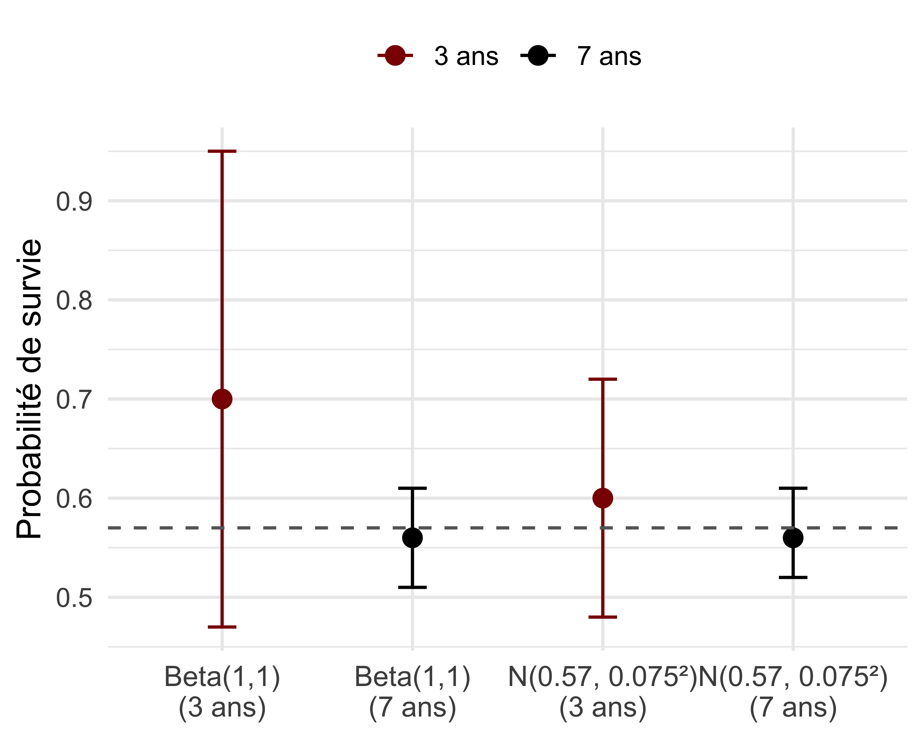

Figure 24: Comparison of posterior estimates of dipper survival according to the type of prior and study duration. Each point represents the posterior mean, with its 95% credible interval. The grey line indicates the survival value from the meta-analysis for passerines (0.57).

This example shows that information from the literature (here an allometric mass–survival relationship obtained via a meta-analysis) can be used to build a relevant informative prior, capable of substantially improving the precision of estimates, especially when data are limited. This approach offers a low-cost alternative to lengthening field protocols, provided of course that the (relatively simple) question remains the estimation of a single survival.

### Moment-matching method

In the dipper example, we used a normal distribution as an informative prior for a parameter that happens to be a probability. However, the normal distribution can take negative values or values greater than 1, which is not desirable for a probability. In the example, the informative prior $N\left(0.57,{0.075}^{2}\right)$ is on average between 0 and 1 with a small variance, so there is little chance that this goes wrong. You can see this by simulating values in R with the command summary(rnorm(n = 100, mean = 0.57, sd = 0.075)). Still, it is not very satisfying.

The good news is that we can construct a more appropriate informative prior for a probability using the so‑called “moment-matching” method. The moment-matching method consists in choosing the parameters of a prior distribution by matching the moments (often the mean and the variance) that represent the prior information we have (before seeing the data).

When the prior information is available in the form of a mean $μ$ and a standard deviation $σ$, we can transform these moments into parameters $a,b$ of a beta distribution. As a reminder, the mean and the variance of a beta distribution with parameters $a$ and $b$ are $μ=\frac{a}{a+b}$ and $σ^{2}=\frac{ab}{{\left(a+b\right)}^{2}\left(a+b+1\right)}$. By inverting these relationships, we obtain: $a=\displaystyle \Bigl(\frac{1-\mu}{\sigma^2}-\frac{1}{\mu}\Bigr)\mu^2$ and $b=\displaystyle a\Bigl(\frac{1}{\mu}-1\Bigr)$. In our example, we have $μ=0.57$ and $σ=0.075$, from which we can deduce $a=24.3$ and $b=18.3$ with a few lines of code:

# desired mean and standard deviation for the beta distribution  
mu <- 0.57 # mean probability  
sigma <- 0.075 # standard deviation on that probability  
# inverse formulas to obtain the parameters a and b of a beta distribution  
a <- ((1 - mu) / (sigma^2) - 1 / mu) * mu^2  
b <- a * (1 / mu - 1)  
# display a and b rounded  
c(a = round(a, 1), b = round(b, 1))  
#> a b   
#> 24.3 18.3

We can check that this beta distribution indeed has the mean and standard deviation given by the meta-analysis:

# generate 10,000 values from a Beta distribution with parameters a = 24.3 and b = 18.3  
ech_prior <- rbeta(n = 10000, shape1 = 24.3, shape2 = 18.3)  
# empirical mean of the draws (should be close to 0.57)  
mean(ech_prior)  
#> [1] 0.5699991  
# empirical standard deviation of the draws (should be close to 0.075)  
sd(ech_prior)  
#> [1] 0.0750291

We can therefore adopt a prior $\text{Beta}\left(a=24.3, b=18.3\right)$ to incorporate the mean information and its variability obtained from the allometric survival–mass relationship.

The moment-matching method does not apply only to probabilities. It can also be used to construct a prior for a real-valued parameter, for example the effect of coypu body mass on survival (see Chapter 5). Suppose an expert says: “I am 80% sure that parameter $θ$ lies between –0.15 and 0.25.” This sentence defines an 80% credible interval: $Pr\left(θ∈\left[-0.15,0.25\right]\right)=0.80$. We seek a normal prior $θ∼N\left(μ,σ^{2}\right)$ that reflects exactly this information.

We can start with the mean $μ$. The interval is symmetric, so we can directly deduce that the mean $μ$ of the prior is the midpoint of the interval: $μ=\frac{-0.15+0.25}{2}=0.05$.

Now let us move to the standard deviation $σ$. The expert states that 80% of the values of $θ$ are between –0.15 and 0.25. For a normal distribution, this proportion can be written as $Pr\left(μ-z σ≤θ≤μ+z σ\right)=0.80$. This means that 80% of the mass of the distribution is contained in an interval centered on $μ$ and of width $2zσ$. For a level of 80%, the value of $z$ is about 1.2816 (obtained via qnorm(0.90), where 0.90 is the upper quantile $1-α/2=1-20/2$ with $\left(1-α\right)\%=80\%$ and thus $α=0.20$). Finally, we obtain $σ=\frac{0.25-\left(-0.15\right)}{2×1.2816}≈0.156$. Here is the calculation in R:

# lower and upper bounds given by the expert  
a <- -0.15  
b <- 0.25  
  
# stated confidence level  
level <- 0.80  
alpha <- 1 - level  
  
# z value corresponding to an 80% credible interval  
z <- qnorm(1 - alpha / 2) # ≈ 1.2816  
  
# mean = center of the interval  
mu <- (a + b) / 2  
  
# standard deviation deduced from the interval width  
sigma <- (b - a) / (2 * z)  
  
mu  
#> [1] 0.05  
sigma  
#> [1] 0.1560608

We conclude that the desired informative prior is $N\left(μ=0.05,σ=0.156\right)$. We can check that everything went well:

mu <- 0.05  
sigma <- 0.1560608  
pnorm(c(-0.15, 0.25), mean = mu, sd = sigma)  
#> [1] 0.09999996 0.90000004  
#> 0.10 0.90 # OK: 10% on the left, 90% on the right → 80% in the center

Visually, Figure 25 shows the density of a normal distribution with mean $μ=0.05$ and standard deviation $σ=0.156$. The light-blue interval corresponds to the central 80% credible interval, that is, the interval [−0.15; 0.25] which contains 80% of the probability mass. The grey dotted lines indicate the bounds of this interval, while the black dashed line marks the position of the mean. We see that, thanks to the symmetry of the normal distribution, the interval is centered around the mean, and that 10% of the mass lies on each side outside this interval.

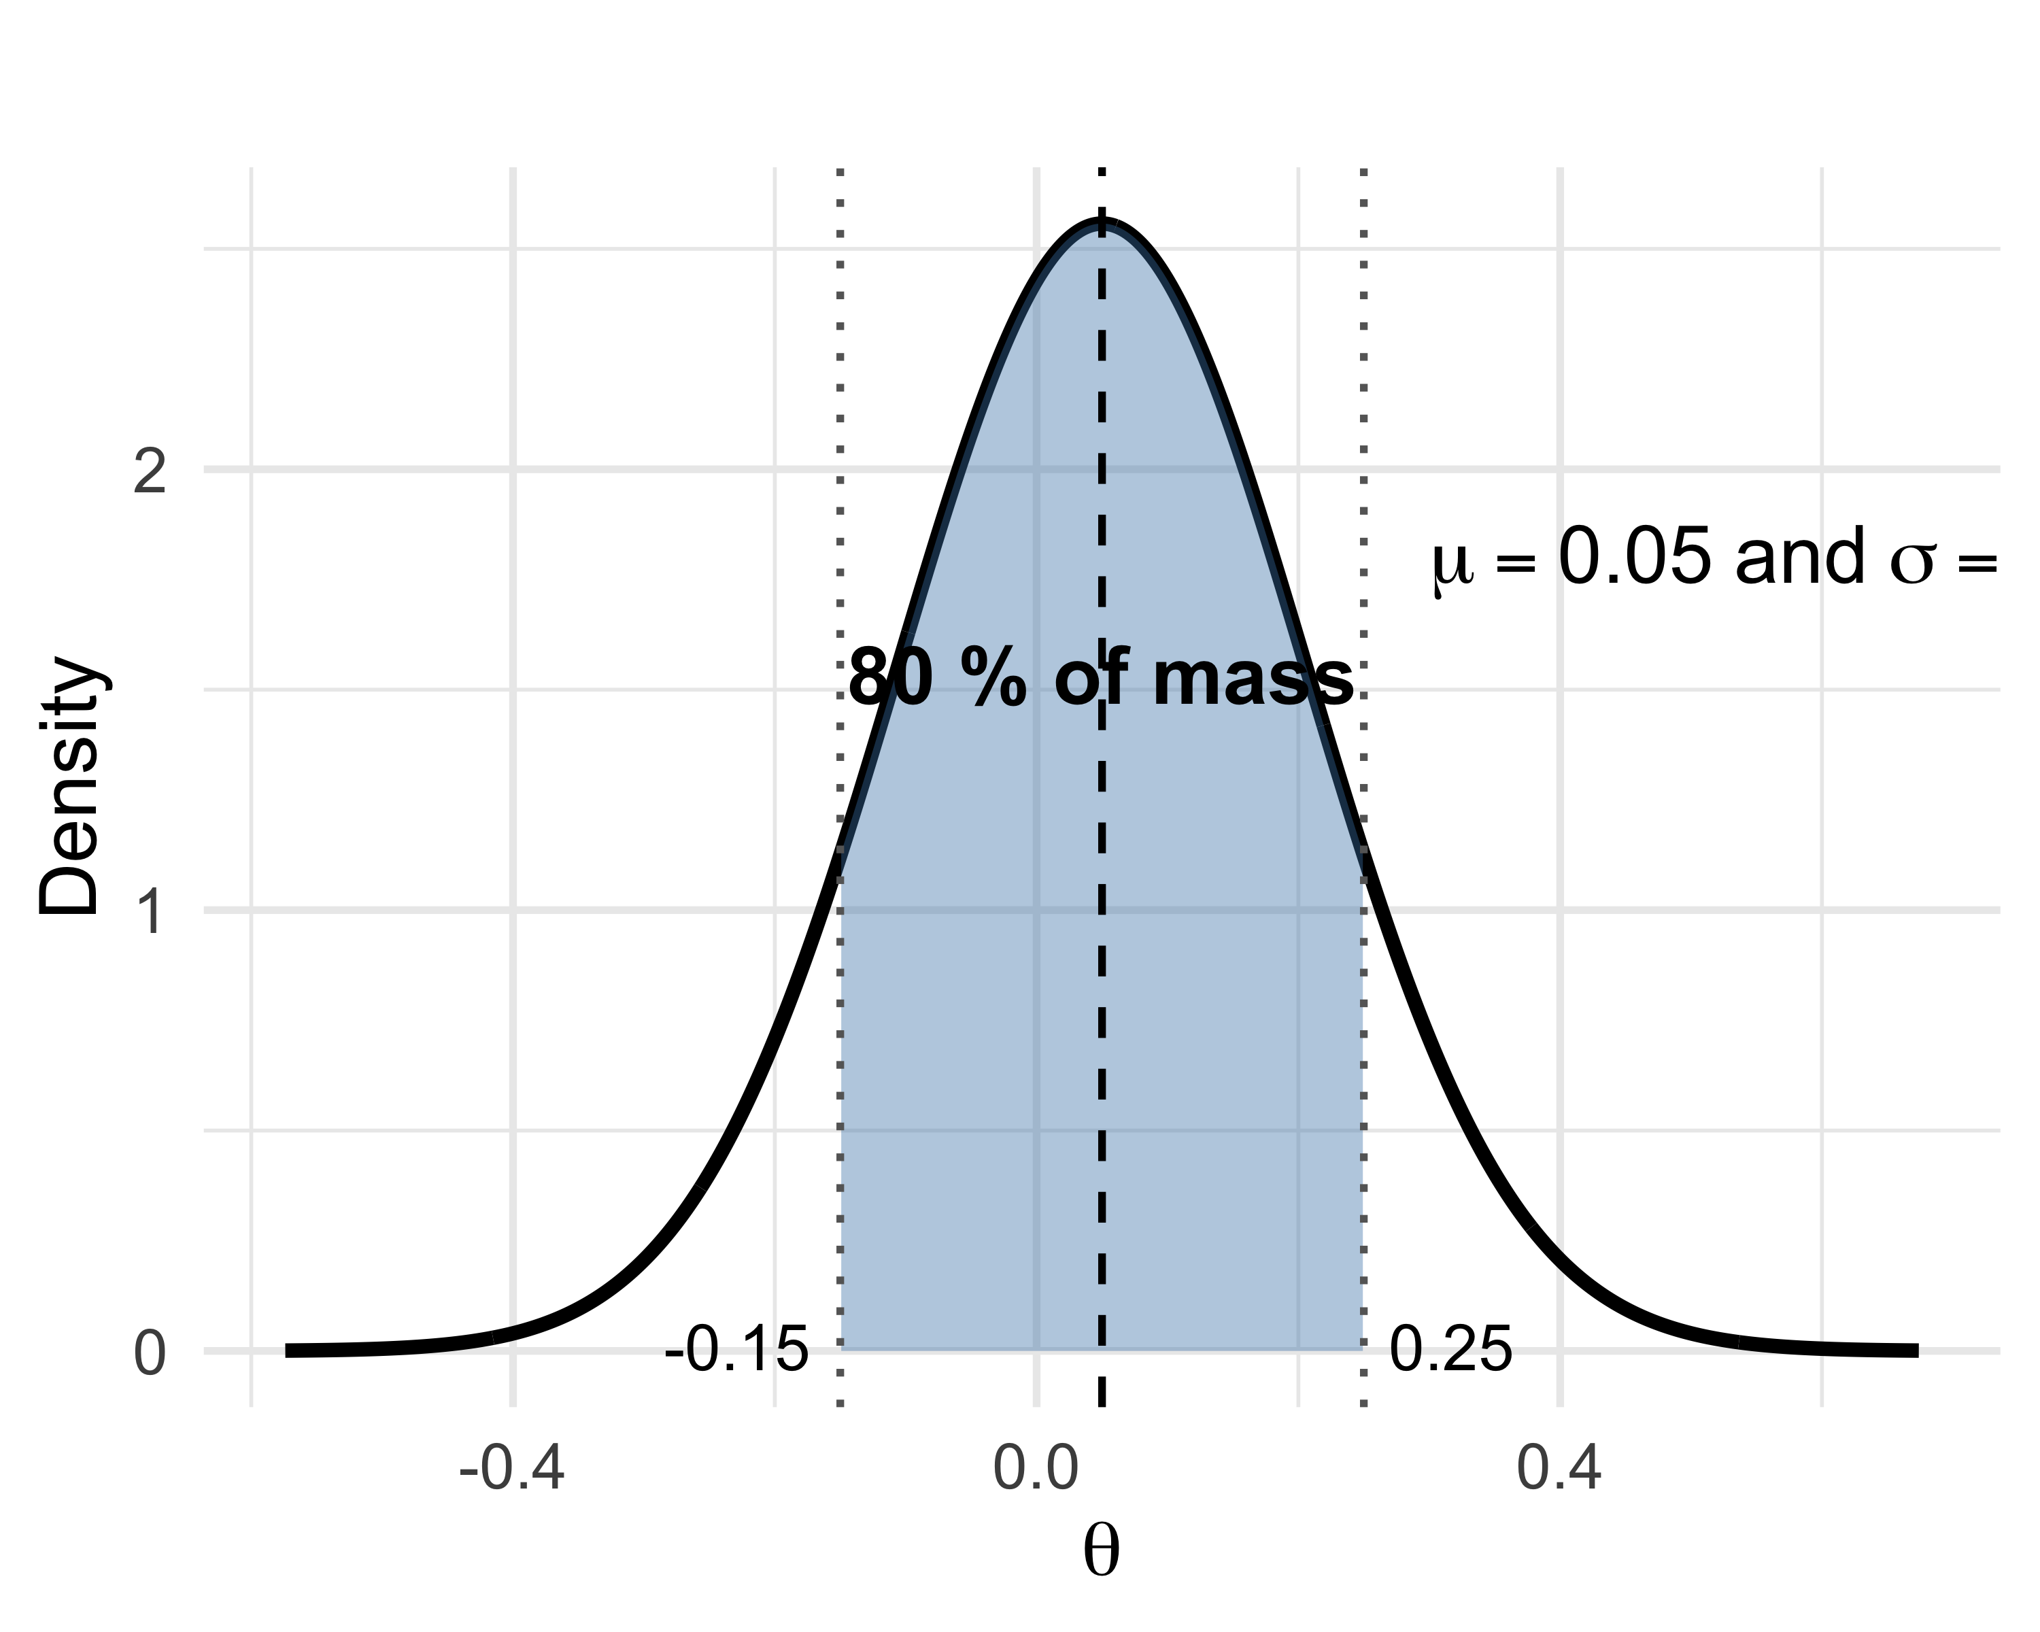

Figure 25: Normal distribution with mean 0.05 and standard deviation 0.156. The shaded interval corresponds to the 80% credible interval, between –0.15 and 0.25.

## Beware of so-called non-informative priors

In Bayesian statistics, we often use non-informative priors. But be careful: appearances can be misleading, especially when working with parameters defined on transformed scales, such as the logit or the log in generalized linear models (Chapter 6). Let us take a common example where we model a probability $θ$ on the logit scale via a parameter $β$ such that $\text{logit}\left(θ\right)=β$.

In practice, we can use simulations to check that priors do not bring unpleasant surprises after transformation; this is what we call prior predictive checks. This happens even before fitting a model, and to do so we will:

1. simulate values from the prior of $β$ on the logit scale;
2. apply the inverse logit transformation to obtain $θ$;
3. inspect the induced prior distribution on $θ$ and judge whether it seems realistic.

A first choice is to take as a prior a normal distribution with a large variance, for example $β∼N\left(0,{10}^{2}\right)$. Steps 1 and 2 are obtained via:

logit_prior <- rnorm(n = 1000, mean = 0, sd = 10) # simulation  
prior <- plogis(logit_prior) # transformation

The problem is that after transformation with the inverse logit function, most simulated values—and thus the probability $θ$—are close to 0 or 1 as we see in Figure 26 (left panel), which implicitly favors extreme values. We go from a non-informative prior on the logit scale to a very informative prior (without meaning to) on the natural scale of the probability.

Another choice is to take $β∼N\left(0,{1.5}^{2}\right)$. The first two steps of the simulation can be summarized as:

logit_prior2 <- rnorm(n = 1000, mean = 0, sd = 1.5)  
prior2 <- plogis(logit_prior2)

Here the induced distribution on $θ$ is uniform, covering mainly the range of values between 0.05 and 0.95 as we can see in Figure 26 (right panel), which better reflects a lack of information about $θ$. This second choice is the right one; we speak of weakly informative priors.

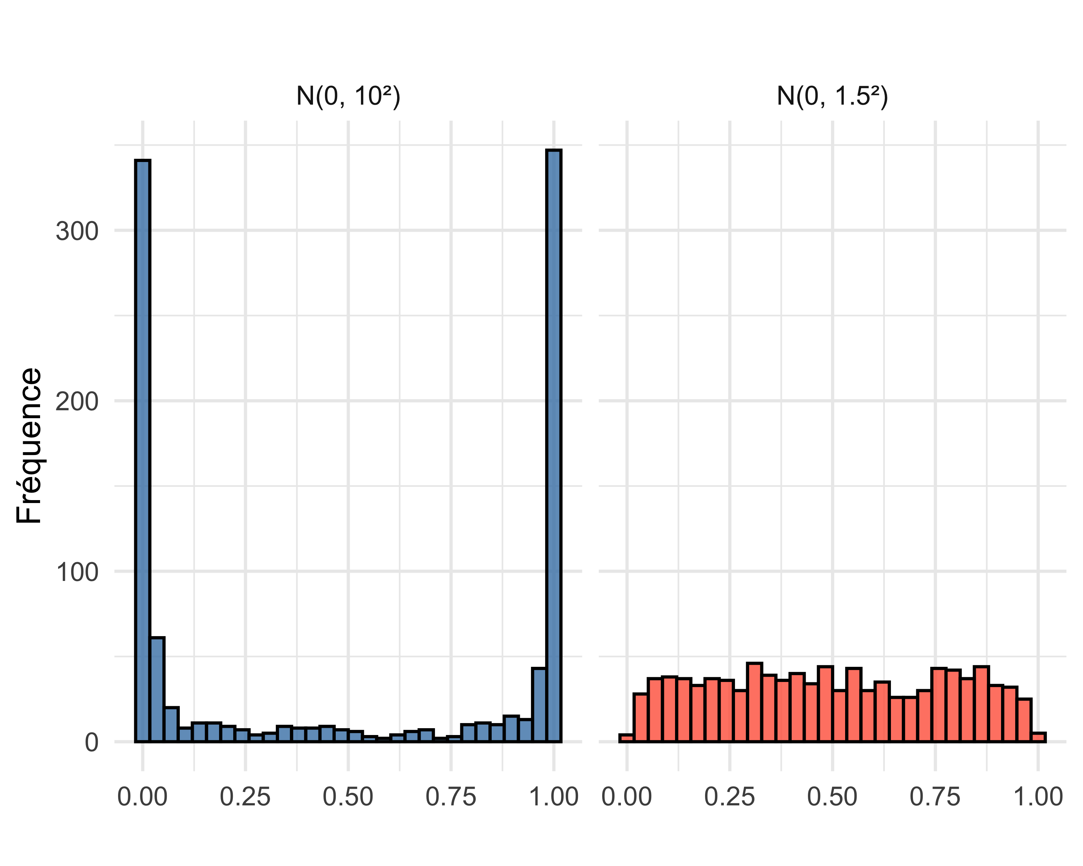

Figure 26: Comparison of two priors obtained for the probability $θ={\text{logit}}^{-1}\left(β\right)$ after transformation by the inverse logit function of $β∼N\left(0,{10}^{2}\right)$ and $β∼N\left(0,{1.5}^{2}\right)$. The x-axis represents the different possible values of the probability $θ$ obtained after transformation by the inverse logit. The y-axis indicates the frequency of simulated draws for each value.

There are also invariant priors, that is, priors whose shape accounts for the scale of the parameter. Jeffreys’ prior is an example: it maximizes the information brought by the data, while remaining invariant under reparameterization. For example, for a probability $θ$, Jeffreys’ prior is $\text{Beta}\left(0.5,0.5\right)$. This prior is less flat than a uniform $\text{Beta}\left(1,1\right)$. It is often used when one wants an objective approach, without introducing subjective information. In practice, however, Jeffreys’ prior is difficult to compute, and we will prefer the simulation-based approach to ensure that transformed parameters have reasonable priors.

## Summary

* The richer the data are, the less the prior influences the posterior estimate.
* Do not hesitate to take the time to visualize your priors on the natural scale of the parameters using simulations.
* Moment-matching methods offer a practical way to transform and encode knowledge into the parameters of distributions that can serve as priors (beta or normal, for example).
* When should you use which type of prior?

| Type of prior | Recommended use | Advantages | Precautions |
| --- | --- | --- | --- |
| Informative | When one has solid information (expertise, meta-analysis, etc.) | Incorporates available knowledge, useful with little data | Risk of bias if poorly calibrated |
| Weakly informative | By default if one wants to guide inference without constraining it | Protects against implausible values, improves numerical stability | Must be adapted to the scale of the parameter |
| Non-informative | Exploratory cases, or to let the data speak | Does not a priori favor any particular value | Can be misleading on transformed scales (logit, log) |
| Reference / Jeffreys | When one seeks an invariant approach (a $\text{Beta}\left(0.5,0.5\right)$ in the running example) | Invariant under changes of parameterization | Sometimes difficult to compute or to interpret |

# Regression

## Introduction

This chapter presents the application of Bayesian statistics to linear regression. We will use an example that allows us to go a bit further than our running example on survival. This will be an opportunity to discuss how and why to use a model to simulate data. We will also illustrate model comparison and validation. We will use NIMBLE and brms and compare with the frequentist approach.

## Linear regression

### The model

To change things a bit, I suggest using NIMBLE and brms on an example different from survival estimation. Let us focus on linear regression.

Let us start by laying out the foundations of our linear model. We have $n$ measurements of a response variable $y_{i}$ with $i$ ranging from 1 to $n$. Think for example of the mass (in kilograms) of our coypus in the running example. We associate each measurement with an explanatory variable $x_{i}$, for example the average outdoor temperature in winter (in degrees Celsius) for our coypus. We want to study the effect of temperature on mass. The simplest assumption is a linear relationship between the two, so we use a linear regression model. The model includes an intercept $β_{0}$, and a slope $β_{1}$ that describes the effect of $x_{i}$ on $y_{i}$, or of temperature on coypu mass. We also need a parameter to describe residual variability represented by a variance parameter $σ^{2}$, which captures the part of variation in the $y_{i}$ not explained by the $x_{i}$. You have probably already encountered this model in the form: $y_{i}=β_{0}+β_{1}x_{i}+ε_{i}$ where the errors $ε_{i}$ are assumed independent and normally distributed with mean 0 and variance $σ^{2}$.

The intercept $β_{0}$ gives us the mass when the temperature is 0 degrees ($x_{i}=0$). The parameter $β_{1}$ tells us the change in the response variable for a one‑unit increase (here 1 degree Celsius) in the explanatory variable (hence the term “slope” for this parameter). In general, it is (strongly) recommended to center (subtract the mean) and scale (divide by the standard deviation) the values of the explanatory variable for numerical and interpretational reasons. Numerical first, because it allows algorithms, whether frequentist or Bayesian, not to get lost in corners of the parameter space. Interpretation next, because the intercept $β_{0}$ is then interpreted as the value of the response variable for an average value of the explanatory variable.

In this section, rather than analyzing “real” data, we will, from the parameters $β_{0}$, $β_{1}$ and $σ$, simulate artificial data, as if they came from a real underlying process.

### Simulating data

What do I mean by simulating data? Data analysis and data simulation are two sides of the same model. In analysis, we use the data to estimate the parameters of a model. In simulation, we fix the parameters and use the model to generate data. One reason to use simulations is that this exercise forces us to really understand the model; if I cannot simulate data from a model, it means I have not fully understood how it works. There are many other good reasons to use simulations. Since the truth (the parameters and the model) is known, we can check that the model is correctly coded. We can evaluate bias and precision of our parameter estimates, assess the effects of violating model assumptions, plan a data collection protocol, or evaluate the power of a statistical test. In short, it is a very useful technique to have in your toolbox!

Let us return to our example. To simulate data according to the linear regression model, we start by fixing our parameters: $β_{0}=0.1$, $β_{1}=1$ and $σ^{2}=0.5$:

beta0 <- 0.1 # true value of the intercept  
beta1 <- 1 # true value of the coefficient of x  
sigma <- 0.5 # standard deviation of the errors

Then we simulate $n=100$ values $x_{i}$ of our explanatory variable from a normal distribution with mean 0 and standard deviation 1, that is $N\left(0,1\right)$:

set.seed(666) # to make the simulation reproducible  
n <- 100 # number of observations  
x <- rnorm(n = n, mean = 0, sd = 1) # covariate x simulated from a standard normal distribution

Finally, we simulate the values of the response variable by adding a normal error epsilon to the linear relationship beta0 + beta1 * x :

epsilon <- rnorm(n, mean = 0, sd = sigma) # generate normal errors  
y <- beta0 + beta1 * x + epsilon # add errors to the linear relationship  
data <- data.frame(y = y, x = x)

Figure 27 below shows the simulated data, as well as the regression line corresponding to the model used to generate them : 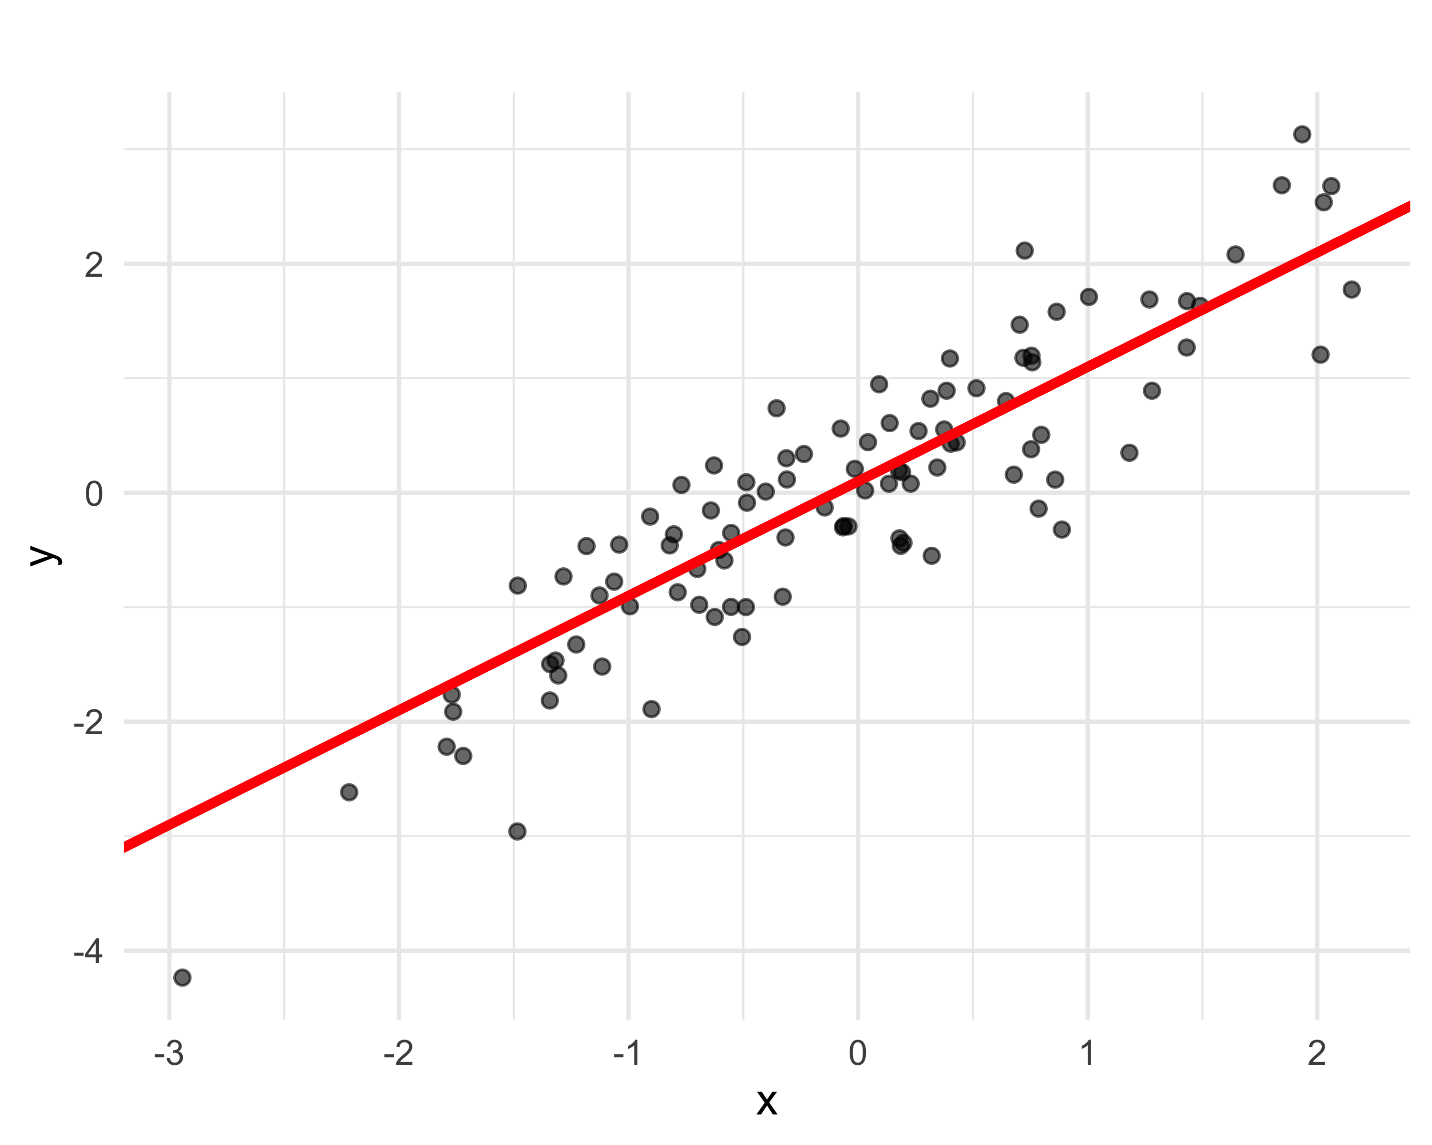

### Fitting with brms

In this section, we use brms to fit the linear regression model to the data we have just generated. If everything goes well, the estimated parameters should be close to the values used to generate the data. I will go relatively quickly here since we covered the different steps in Chapter 3. The syntax is very close to what we would use to fit the model by maximum likelihood with the lm() function in R:

lm.brms <- brm(y ~ x, # formula: y as a function of x  
 data = data, # dataset  
 family = gaussian) # normal distribution

Let’s take a look at the numerical summaries and the convergence diagnostics:

summary(lm.brms)  
#> Family: gaussian   
#> Links: mu = identity; sigma = identity   
#> Formula: y ~ x   
#> Data: data (Number of observations: 100)   
#> Draws: 4 chains, each with iter = 2000; warmup = 1000; thin = 1;  
#> total post-warmup draws = 4000  
#>   
#> Regression Coefficients:  
#> Estimate Est.Error l-95% CI u-95% CI Rhat Bulk_ESS Tail_ESS  
#> Intercept 0.06 0.06 -0.05 0.17 1.00 4366 3028  
#> x 1.10 0.06 0.99 1.21 1.00 4188 3147  
#>   
#> Further Distributional Parameters:  
#> Estimate Est.Error l-95% CI u-95% CI Rhat Bulk_ESS Tail_ESS  
#> sigma 0.57 0.04 0.49 0.65 1.00 4090 3050  
#>   
#> Draws were sampled using sampling(NUTS). For each parameter, Bulk_ESS  
#> and Tail_ESS are effective sample size measures, and Rhat is the potential  
#> scale reduction factor on split chains (at convergence, Rhat = 1).

By default, brms used four chains that each ran for 2000 iterations with 1000 iterations used as burn-in, for a total of 4000 iterations for posterior inference. In the output, Intercept, x and sigma correspond respectively to the parameters $β_{0}$, $β_{1}$ and $σ$ of the model. The $\hat{R}$ for the 3 parameters is 1, and the effective sample sizes are satisfactory. The credible intervals contain the true parameter value used to simulate the data.

We check that the mixing is good (Figure 28):

plot(lm.brms)

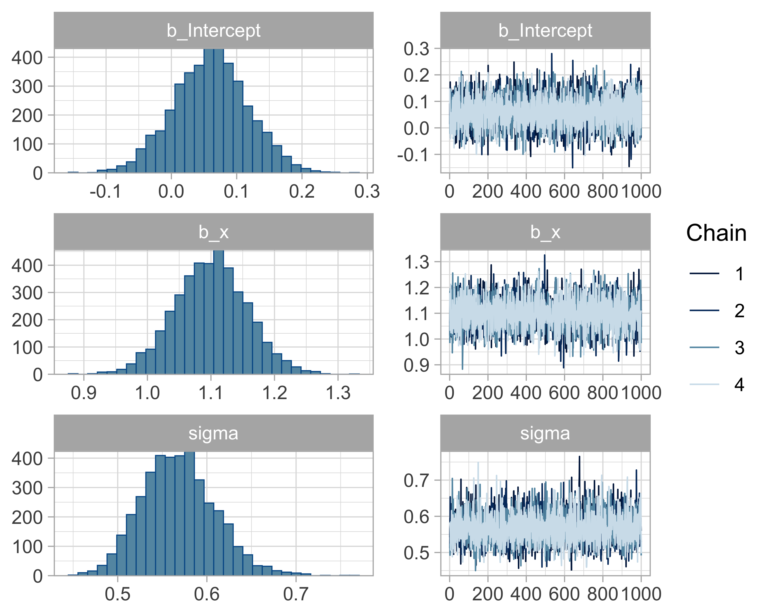

Figure 28: Histograms of the posterior distributions (left column) and traces (right column) of the linear regression parameters. In the histograms, the x-axis represents the possible values of the estimated parameter (intercept, slope, or standard deviation) and the y-axis corresponds to their frequency in the posterior sample. In the trace plots, the x-axis indicates the MCMC iteration number, while the y-axis represents the simulated value of the parameter at each iteration.

### Weakly informative priors

Rather than using the default priors in brms, let’s choose other priors. We will use weakly informative priors, and more specifically a normal with mean 0 and standard deviation 1.5, or $N\left(0,1.5\right)$, for the regression parameters $β_{0}$ and $β_{1}$. We already discussed weakly informative priors in Chapter 4. The idea is close to that of vague or non-informative priors, in the sense that we try, through weakly informative priors, to reflect the fact that we do not really have information on the model parameters. The difference is that non-informative priors can induce aberrant values as we saw in Chapter 4. This is still the case here. Take for example $N\left(0,100\right)$ for the parameters of the linear relationship that links the mass of coypus to temperature, and simulate a whole bunch of values from these priors, then form the linear relationship:

# number of lines to simulate  
n_lines <- 100  
  
# draws of intercepts and slopes from the priors  
intercepts <- rnorm(n_lines, mean = 0, sd = 100)  
slopes <- rnorm(n_lines, mean = 0, sd = 100)  
  
# create a data frame  
lines_df <- data.frame()  
for (i in 1:n_lines) {  
 y_vals <- intercepts[i] + slopes[i] * x  
 temp_df <- data.frame(x = x, y = y_vals, line = as.factor(i))  
 lines_df <- rbind(lines_df, temp_df)  
}  
  
# plot with ggplot2  
ggplot(lines_df, aes(x = x, y = y, group = line)) +  
 geom_line(alpha = 0.3) +  
 theme_minimal() +  
 labs(x = "x", y = "y")

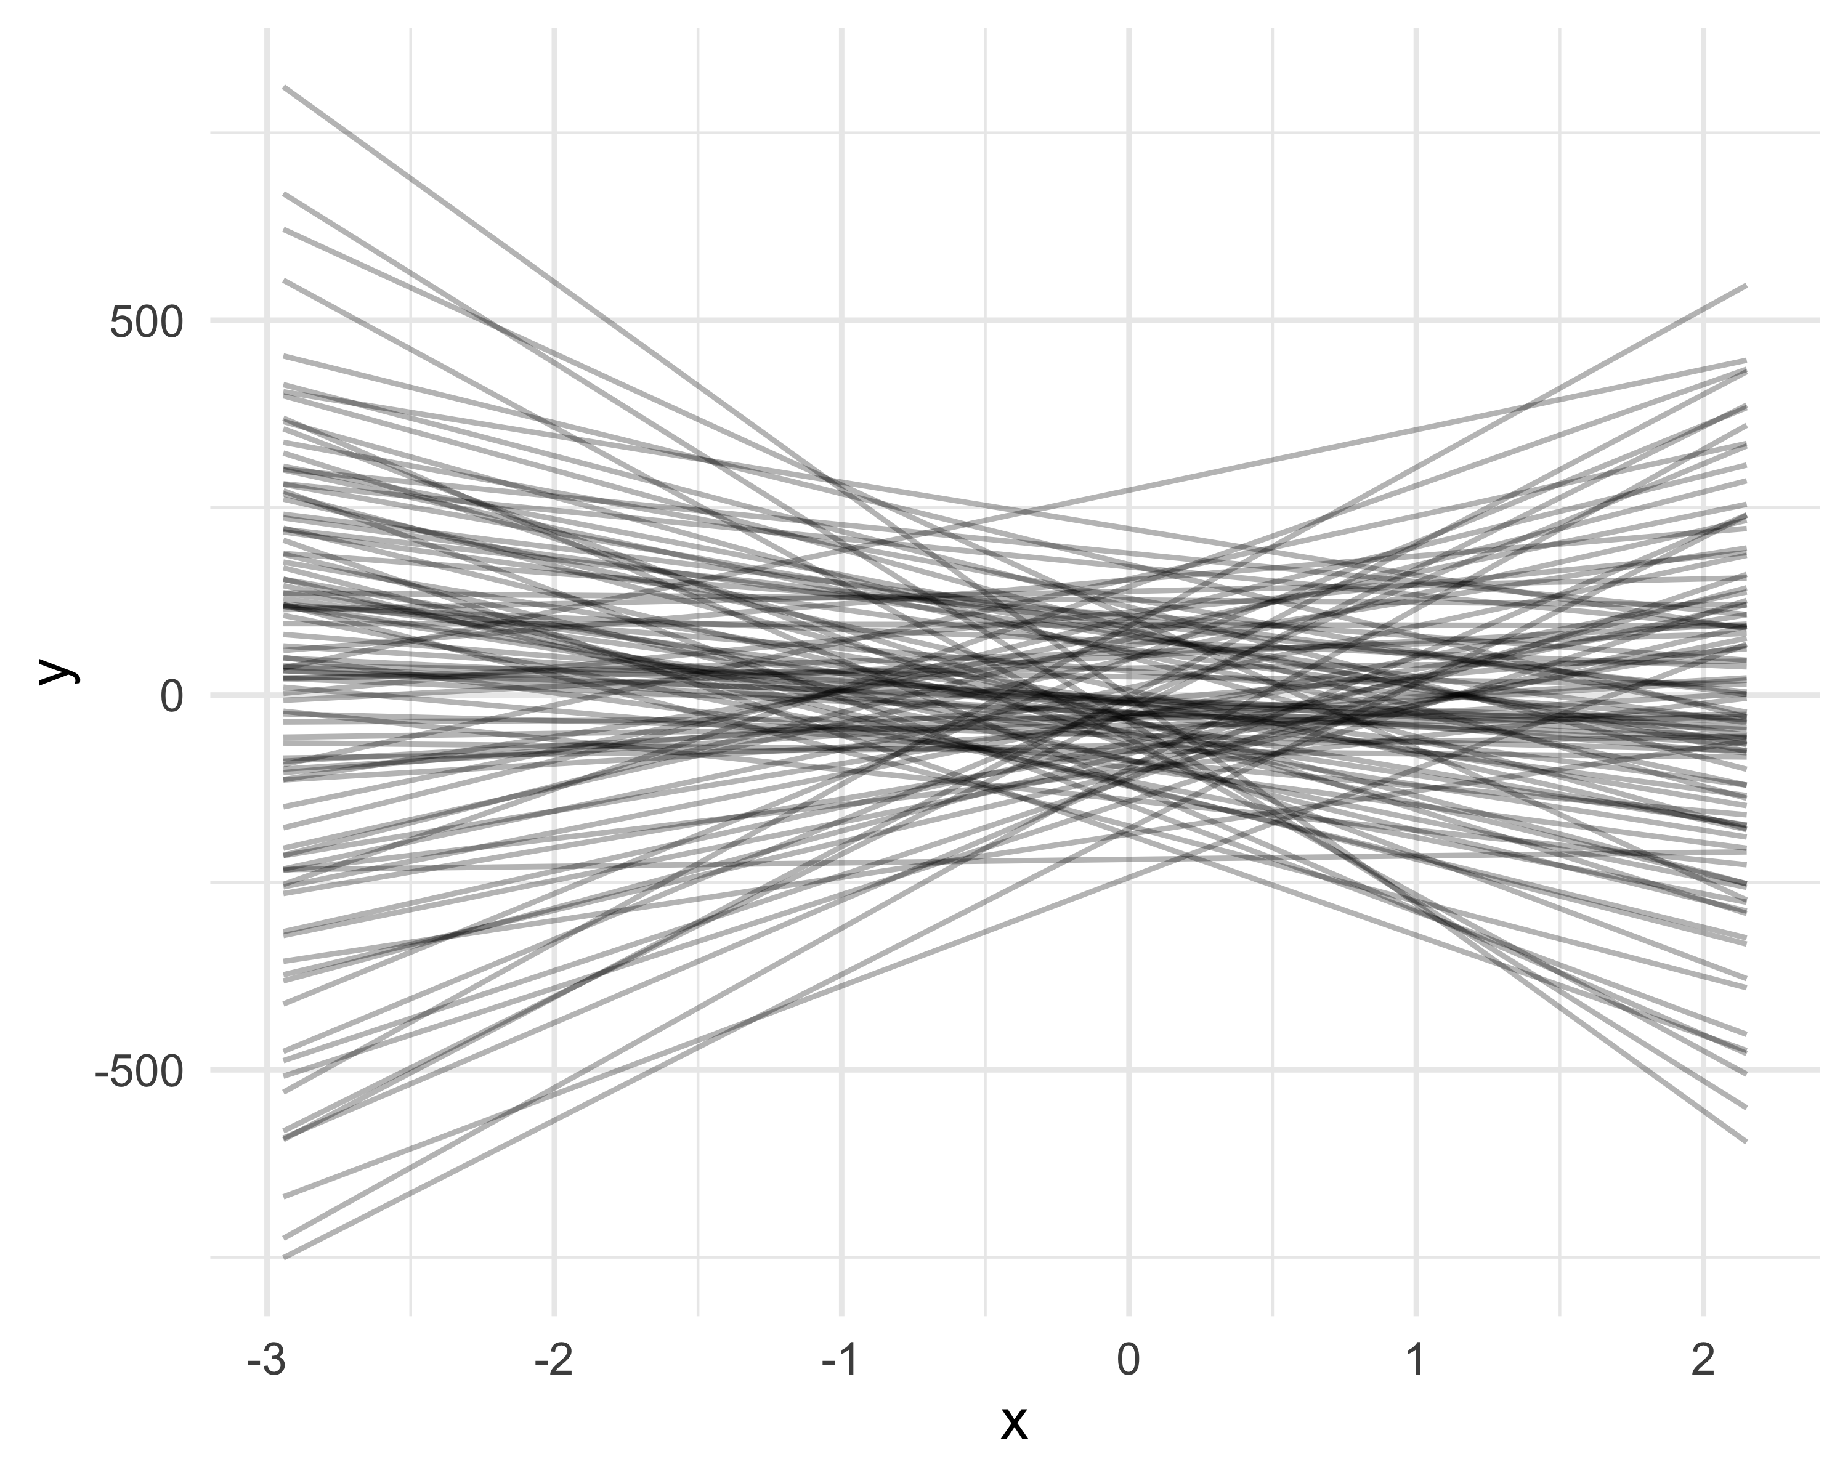

Figure 29: Simulation of regression lines drawn from the prior distributions. Each line corresponds to a draw of the parameters: intercept and slope ~ N(0, 100).

In Figure 29, we see that we obtain aberrant values for the $y_{i}$, with coypus weighing more than 400 kilograms, and (very) negative values for the mass. We have just done a “prior predictive check”, as in Chapter 4. In Figure 30, we do the same thing with our weakly informative prior $N\left(0,1.5\right)$: 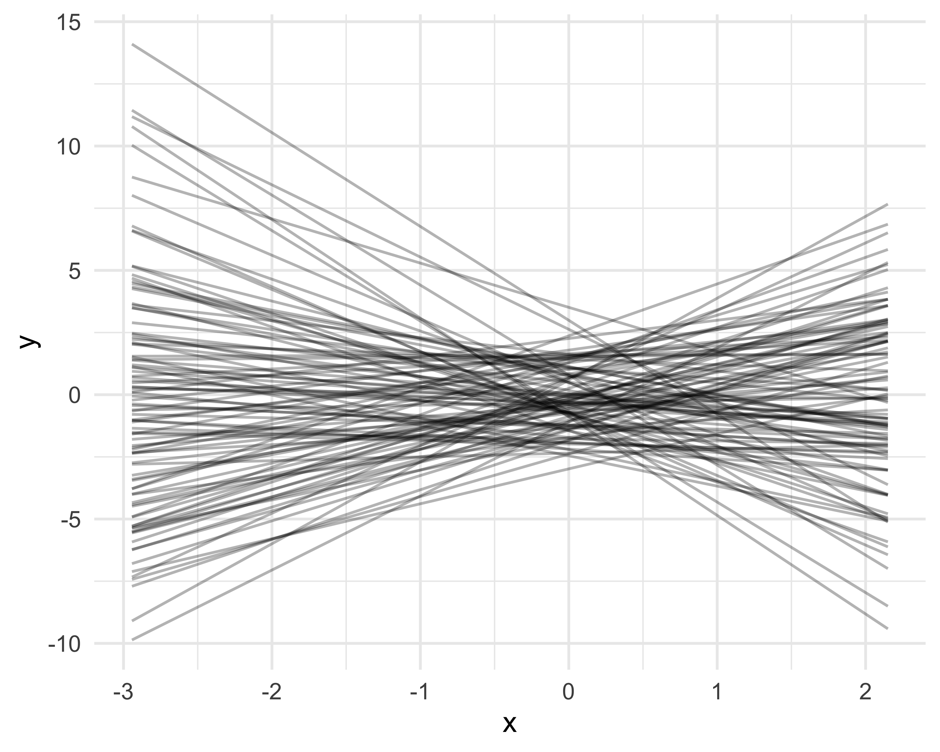

We obtain more reasonable values for the mass of coypus, which rarely exceeds 10 kilograms. We still have negative values, but smaller ones, and the MCMC algorithm should cope. There is also a numerical advantage to using weakly informative priors: they help MCMC methods not to get lost in the space of all possible values for the parameters to be estimated, and allow them to focus on realistic values of these parameters. By doing this, you may have the impression that we are using the data to construct the priors, whereas we said that the prior should reflect the information available before seeing the data. This is an opportunity to clarify this point a bit. The important thing is above all that the prior represents information independent of the data that are used in the likelihood.

So far we have focused on the regression parameters, the intercept $β_{0}$ and the slope $β_{1}$. But what about the standard deviation, $σ$? This parameter is just as important: it reflects how much the observations deviate from the average trend described by the regression line.

One option often considered is to assign it a uniform distribution, for example $σ∼U\left(0,B\right)$, with a natural lower bound (0, since $σ$ is always positive), but an upper bound $B$ that is difficult to choose. What maximum value should one give to a standard deviation? In some cases, an apparently reasonable value can turn out to be too wide. For example, if we model human heights and set $σ∼U\left(0,50\right)$ (in cm), this amounts to assuming that 95% of heights are spread over a 100 cm range around the mean—which is very unlikely.

A more flexible and more realistic alternative is to use an exponential distribution $σ∼exp\left(λ\right)$ where $λ>0$ is a rate parameter. This distribution is defined only for positive values, which is consistent with the nature of $σ$, and it favors small values of the standard deviation while leaving the possibility for $σ$ to be larger if the data justify it.

By default, one often takes $λ=1$. With $λ=1$, the mean and the standard deviation of this distribution are both equal to $1$, which induces a modest but non-restrictive prior (Figure 31).

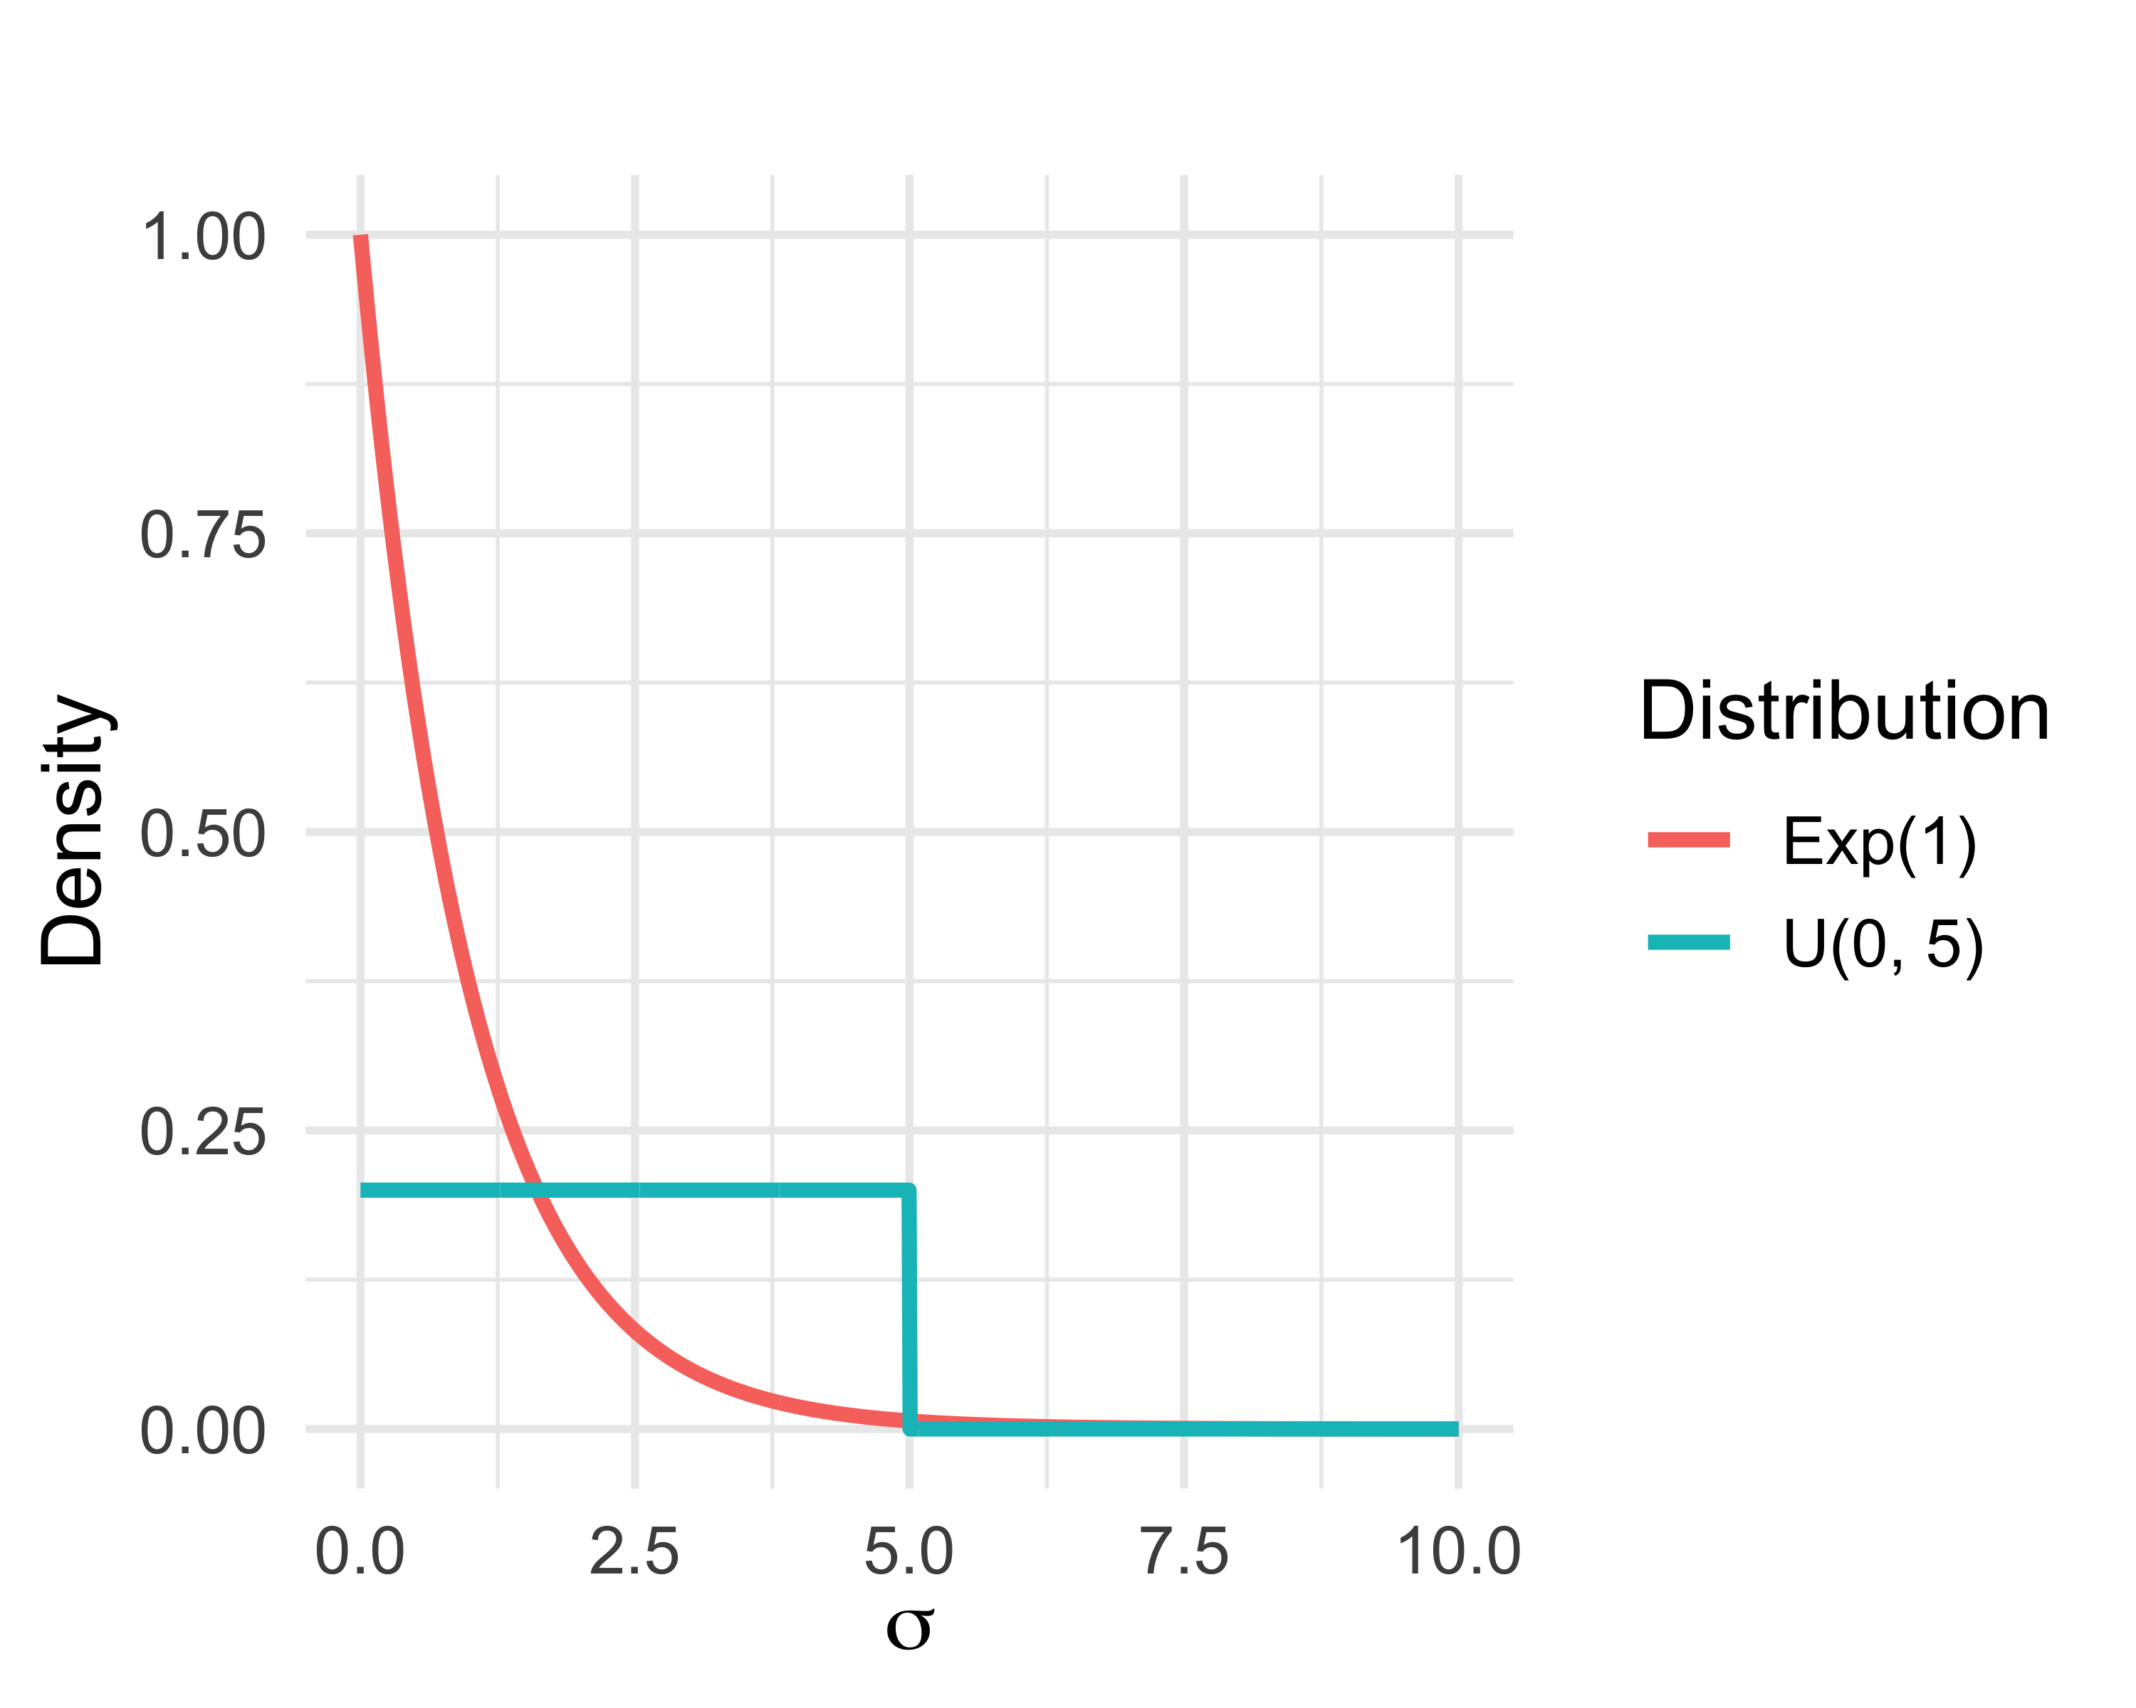

Figure 31: Comparison between two prior distributions for the standard deviation $σ$: a uniform distribution $\text{U}\left(0,5\right)$, which gives the same density between 0 and 5, and an exponential distribution $\text{Exp}\left(1\right)$, which favors small values while retaining a heavier tail.

We can formalize this model as follows:

$$\begin{matrix}y_{i} & ∼\text{Normal}\left(μ_{i},σ^{2}\right) & \text{[likelihood]} \\ μ_{i} & =β_{0}+β_{1} x_{i} & \text{[linear relationship]} \\ β_{0},β_{1} & ∼\text{Normal}\left(0,1.5\right) & \text{[prior on parameters]} \\ σ & ∼\text{Exp}\left(1\right) & \text{[prior on parameters]} \\ & & \end{matrix}$$

Let us specify these priors:

myprior <- c(  
 prior(normal(0, 1.5), class = b), # prior on the coefficient of x  
 prior(normal(0, 1.5), class = Intercept), # prior on the intercept  
 prior(exponential(1), class = sigma) # prior on the standard deviation of the error  
)

Then let’s refit with brms:

lm.brms <- brm(y ~ x,   
 data = data,   
 family = gaussian,   
 prior = myprior)

We check that the numerical summaries obtained are close to those obtained with the default priors, and above all close to the values used to simulate the data:

summary(lm.brms)  
#> Family: gaussian   
#> Links: mu = identity; sigma = identity   
#> Formula: y ~ x   
#> Data: data (Number of observations: 100)   
#> Draws: 4 chains, each with iter = 2000; warmup = 1000; thin = 1;  
#> total post-warmup draws = 4000  
#>   
#> Regression Coefficients:  
#> Estimate Est.Error l-95% CI u-95% CI Rhat Bulk_ESS Tail_ESS  
#> Intercept 0.06 0.06 -0.05 0.18 1.00 3562 2765  
#> x 1.10 0.06 0.99 1.21 1.00 3870 2731  
#>   
#> Further Distributional Parameters:  
#> Estimate Est.Error l-95% CI u-95% CI Rhat Bulk_ESS Tail_ESS  
#> sigma 0.57 0.04 0.49 0.66 1.00 3540 2633  
#>   
#> Draws were sampled using sampling(NUTS). For each parameter, Bulk_ESS  
#> and Tail_ESS are effective sample size measures, and Rhat is the potential  
#> scale reduction factor on split chains (at convergence, Rhat = 1).

Here, the two models give almost the same thing, which is not surprising because the data are informative enough for them to “take over from” the prior. The interest of weakly informative priors is not so much seen in this small example as in other situations: they avoid aberrant values, stabilize the MCMC computations, and remain useful when we have fewer data or more complex models.

### Fitting with NIMBLE

We start by writing the model:

model <- nimbleCode({  
 # priors  
 beta0 ~ dnorm(0, sd = 1.5) # normal prior on intercept  
 beta1 ~ dnorm(0, sd = 1.5) # normal prior on coefficient  
 sigma ~ dexp(1) # exponential prior on standard deviation  
 # likelihood  
 for(i in 1:n) {  
 y[i] ~ dnorm(beta0 + beta1 * x[i], sd = sigma) # equiv of yi = beta0 + beta1 * xi + epsiloni  
 }  
})

In this code block, we start by specifying priors on the three model parameters: a normal prior centered on 0 with standard deviation 1.5 for the intercept $β_{0}$ and for the slope $β_{1}$, as well as an exponential prior for the standard deviation $σ$ of the errors. The next part is a for(i in 1:n) loop that defines the likelihood. We specify the likelihood observation by observation, and NIMBLE automatically deduces the product of likelihoods over all individuals, which corresponds to the likelihood of the dataset. For each observation $i$, we have a normal distribution centered at beta0 + beta1 * x[i], with standard deviation sigma. We recover the relationship $y_{i}=β_{0}+β_{1}x_{i}+ε_{i}$ where $ε_{i}∼N\left(0,σ^{2}\right)$, which is strictly equivalent to $y_{i}∼N\left(β_{0}+β_{1}x_{i},σ^{2}\right)$.

The next steps are to put the data into a list, specify initial values, and indicate the parameters for which we want output:

dat <- list(x = x, y = y, n = n) # data  
inits <- list(list(beta0 = -0.5, beta1 = -0.5, sigma = 0.1), # inits chain 1  
 list(beta0 = 0, beta1 = 0, sigma = 1), # inits chain 2  
 list(beta0 = 0.5, beta1 = 0.5, sigma = 0.5)) # inits chain 3  
par <- c("beta0", "beta1", "sigma")

We then have all the ingredients to run NIMBLE:

lm.nimble <- nimbleMCMC(  
 code = model,  
 data = dat,  
 inits = inits,  
 monitors = par,  
 niter = 2000,  
 nburnin = 1000,  
 nchains = 3  
)

Let’s inspect the results:

MCMCsummary(lm.nimble, round = 2)  
#> mean sd 2.5% 50% 97.5% Rhat n.eff  
#> beta0 0.06 0.06 -0.05 0.06 0.17 1.00 3000  
#> beta1 1.10 0.06 0.99 1.10 1.21 1.00 3000  
#> sigma 0.57 0.04 0.49 0.56 0.65 1.01 772

We obtain numerical summaries that are close to those obtained with brms, and close to the true parameter values used to simulate the data.

For convergence, we can inspect the trace plots:

MCMCtrace(object = lm.nimble,  
 pdf = FALSE,  
 ind = TRUE,  
 Rhat = TRUE,  
 n.eff = TRUE)

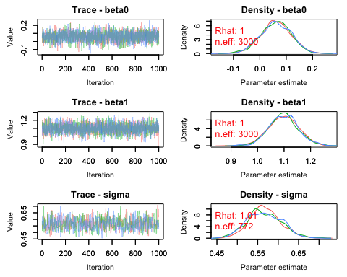

Everything looks good. Mixing is correct, and the convergence diagnostics are in the green.

### Maximum likelihood fitting

Finally, we can compare with maximum likelihood fitting, obtained simply with the command lm(y ~ x, data = data). Everything is in Figure 32:

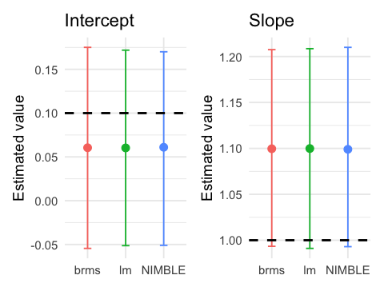

Figure 32: Comparison of parameter estimates (intercept and slope) across methods (brms, lm, and NIMBLE). Points show posterior means for brms and NIMBLE, and the maximum likelihood estimate for lm. We also show 95% credible intervals (brms and NIMBLE) and the 95% confidence interval (lm). The dashed black line indicates the true value used to simulate the data.

The posterior means obtained with NIMBLE and brms are close to the maximum likelihood estimates for the intercept and the slope, to a lesser extent. The credible intervals obtained with NIMBLE and brms and the confidence interval obtained by maximum likelihood all include the true parameter values used to simulate the data. Keep in mind that this is a single simulation; the exercise would need to be repeated many times to formally assess the distance between the true values and the parameter estimates (bias).

## Model evaluation

The quality of a model fit to data is essential to assess how much confidence we can place in parameter estimates. Goodness-of-fit tests are well established in frequentist statistics, and many of them can also be used in simple Bayesian models. This is the case, for example, for residual analysis.

In the case of linear regression, the model rests on several assumptions. These are the assumptions of independence, normality, linearity, and homoscedasticity ( $σ$ does not vary with the explanatory variable). In general, we can evaluate the first two with context. For the other two, we can visualize the fit by overlaying the estimated regression line on the observed scatter plot. With the brms package, this gives Figure 33:

# extract values from posteriors  
post <- as_draws_df(lm.brms)  
  
# create grid of x values  
grille_x <- tibble(x = seq(min(data$x), max(data$x), length.out = 100))  
  
# for each x, simulate y values  
pred <- post %>%  
 select(b_Intercept, b_x) %>%  
 expand_grid(grille_x) %>%  
 mutate(y = b_Intercept + b_x * x) %>%  
 group_by(x) %>%  
 summarise(  
 mean = mean(y),  
 lower = quantile(y, 0.025),  
 upper = quantile(y, 0.975),  
 .groups = "drop"  
 )  
  
# extract post means  
intercept <- summary(lm.brms)$fixed[1,1]  
slope <- summary(lm.brms)$fixed[2,1]  
  
# dataviz  
ggplot(data, aes(x = x, y = y)) +  
 geom_point(alpha = 0.6) +  
 geom_ribbon(data = pred, aes(x = x, ymin = lower, ymax = upper), fill = "blue", alpha = 0.2, inherit.aes = FALSE) +  
 geom_line(data = pred, aes(x = x, y = mean), color = "blue", size = 1.2) +  
 labs(x = "x", y = "y") +  
 coord_cartesian(xlim = range(grille_x$x)) +  
 theme_minimal()

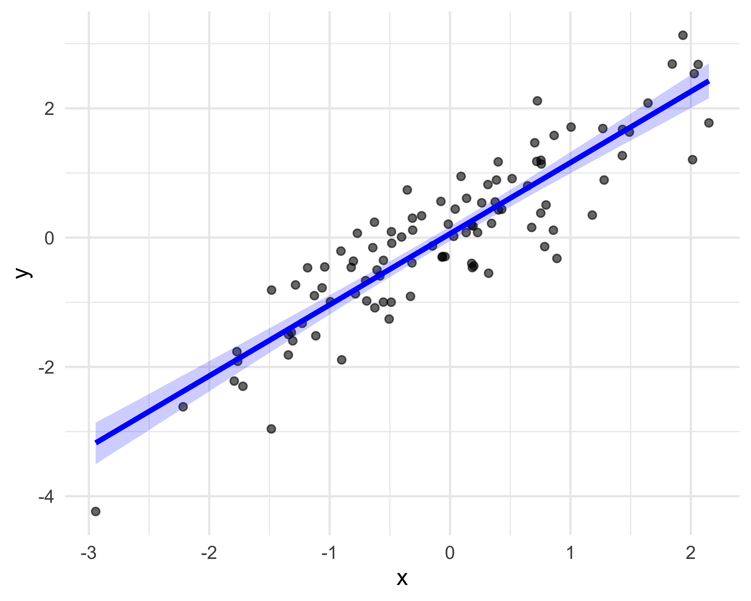

Figure 33: Linear model fit with brms. The blue line is the estimated regression, obtained by setting the intercept and slope to their posterior means, surrounded by its 95% credible interval.

With NIMBLE, this is Figure 34:

x <- data$x  
y <- data$y  
  
posterior <- rbind(lm.nimble$chain1, lm.nimble$chain2, lm.nimble$chain3)  
beta0 <- posterior[,'beta0']  
beta1 <- posterior[,'beta1']  
  
x_seq <- seq(min(data$x), max(data$x), length.out = 100)  
  
pred_matrix <- sapply(x_seq, function(xi) beta0 + beta1 * xi)  
  
pred_df <- tibble(  
 x = x_seq,  
 y_mean = colMeans(pred_matrix),  
 y_lower = apply(pred_matrix, 2, quantile, probs = 0.025),  
 y_upper = apply(pred_matrix, 2, quantile, probs = 0.975)  
)  
  
true_df <- tibble(x = x_seq, y_true = 0.1 + 1 * x_seq)  
  
ggplot() +  
 geom_point(data = data, aes(x = x, y = y), alpha = 0.6) +  
 geom_ribbon(data = pred_df, aes(x = x, ymin = y_lower, ymax = y_upper), fill = "blue", alpha = 0.2) +  
 geom_line(data = pred_df, aes(x = x, y = y_mean), color = "blue", size = 1.2) +  
 # geom_line(data = true_df, aes(x = x, y = y_true), color = "red", size = 1.2) +  
 labs(x = "x", y = "y") +  
 theme_minimal()

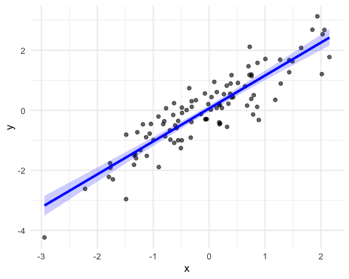

Figure 34: Linear model fit with NIMBLE. The blue line is the estimated regression, obtained by setting the intercept and slope to their posterior means, surrounded by its 95% credible interval.

Bayesian methods are often used for more complex models than linear regression (such as mixed models; see Chapter 6), for which there are no standard turnkey goodness-of-fit tests. In these situations, we commonly use what are called posterior predictive checks. The idea is to simulate new datasets from the posterior distribution of the model parameters, and then compare them to the observed data. The more the simulated data resemble the real data, the more it suggests that the model fits well. This comparison can be done visually or using a Bayesian p-value that quantifies the discrepancy between simulated and observed data.

In brms, you just do:

pp_check(lm.brms)

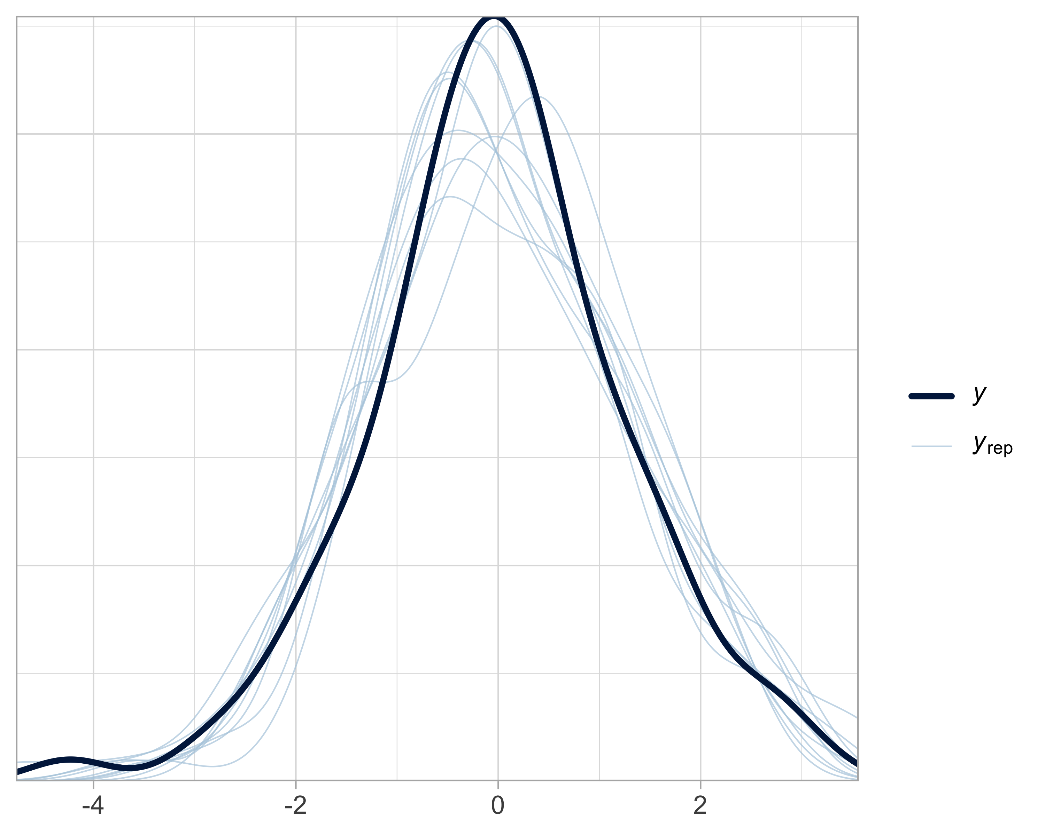

Figure 35: Posterior predictive checks produced with brms. The black curve corresponds to the observed data; the blue curves to data simulated under the model. The x-axis shows the possible values of the simulated or observed response. The y-axis shows their estimated density.

The pp_check() function generates posterior predictive check plots (Figure 35). It compares observed data to data simulated from the fitted model. If the model fits the data well, then we should be able to use it to generate data that resemble the observed data. Therefore, if the simulated curves overlap the observations well, this indicates that the model captures the structure of the data correctly. Otherwise, this may suggest a model misspecification, for example an inappropriate link or distribution family (see Chapter 6).

There is no dedicated function in NIMBLE, so we will need to simulate data under the model with the estimated parameters. We could do it by hand as with life expectancy, but the simplest approach is to include an additional line in the NIMBLE code:

model <- nimbleCode({  
 beta0 ~ dnorm(0, sd = 1.5) # normal prior on intercept  
 beta1 ~ dnorm(0, sd = 1.5) # normal prior on coefficient  
 sigma ~ dexp(1) # exponential prior on standard deviation  
 for(i in 1:n) {  
 y[i] ~ dnorm(beta0 + beta1 * x[i], sd = sigma) # model for observed data  
 y_sim[i] ~ dnorm(beta0 + beta1 * x[i], sd = sigma) # model for simulated data  
 }  
})

This is the line y_sim[i] ~ dnorm(beta0 + beta1 * x[i], sd = sigma) that I added to simulate under the fitted model. The data and initial values do not change; we just need to add y_sim to the list of parameters we want to retrieve in the output:

par <- c("beta0", "beta1", "sigma", "y_sim")

Then we rerun NIMBLE:

lm.nimble <- nimbleMCMC(  
 code = model,  
 data = dat,  
 inits = inits,  
 monitors = par,  
 niter = 2000,  
 nburnin = 1000,  
 nchains = 3  
)  
#> |-------------|-------------|-------------|-------------|  
#> |-------------------------------------------------------|  
#> |-------------|-------------|-------------|-------------|  
#> |-------------------------------------------------------|  
#> |-------------|-------------|-------------|-------------|  
#> |-------------------------------------------------------|

We then merge the 3 chains, and select only the columns corresponding to y_sim:

# merge  
y_sim_mcmc <- rbind(lm.nimble$chain1, lm.nimble$chain2, lm.nimble$chain3)  
# get columns corresponding to simulated y (y_sim[i])  
y_sim_cols <- grep("^y_sim\\[", colnames(y_sim_mcmc))  
# extract  
y_sim_matrix <- y_sim_mcmc[, y_sim_cols]

We then take 10 draws, as brms does by default, and format the results:

# set seed for reproducibility  
set.seed(123)  
# select at random 10 values  
sim_indices <- sample(1:nrow(y_sim_matrix), 10)  
# format simulated data  
simulations_df <- data.frame(  
 y_sim = as.vector(t(y_sim_matrix[sim_indices, ])), # sim values  
 Replicate = rep(1:length(sim_indices), each = n), # id draw  
 Observation = rep(1:n, times = length(sim_indices)) # id obs  
)

Finally, we obtain the posterior predictive checks plot in Figure 36:

ggplot() +  
 geom_density(aes(x = y_sim, group = Replicate), color = "lightblue", alpha = 0.2, data = simulations_df) +  
 geom_density(aes(x = y), color = "black", alpha = 0.5, size = 1.2, data = data.frame(y = y)) +  
 labs(x = "",  
 y = "") +  
 theme_minimal(base_size = 14)

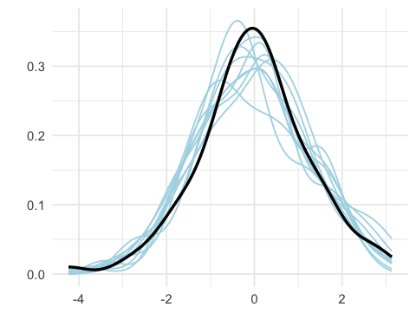

Figure 36: Posterior predictive checks produced with NIMBLE. The black curve corresponds to the observed data; the blue curves to data simulated under the model. The x-axis shows the possible values of the simulated or observed response. The y-axis shows their estimated density.

We can also compute a Bayesian p-value, which represents the proportion of datasets simulated under the model for which the chosen statistic (here the mean) is as large as or larger than the observed one. A value close to 0 or 1 can indicate a poor fit of the model for that particular statistic, whereas a value close to 0.5 suggests a good fit. This Bayesian p-value is obtained as follows:

# Observed test stat  
T_obs <- mean(y)  
  
# Simulated test stat  
T_sim <- apply(y_sim_matrix, 1, mean)  
  
# Bayesian p-value: proportion of simulations where T_sim is more extreme than T_obs  
bayes_pval <- mean(T_sim >= T_obs)  
bayes_pval  
#> [1] 0.512

With brms, we can also obtain this Bayesian p-value:

# extract simulations  
y_rep <- posterior_predict(lm.brms)  
  
# compute test stat on sim data  
T_sim <- rowMeans(y_rep)  
  
# compute test stat on observed data  
T_obs <- mean(lm.brms$data$y)  
  
# compute Bayesian p-value  
bayes_pval <- mean(T_sim >= T_obs)  
bayes_pval  
#> [1] 0.49075

## Model comparison

As we saw in Chapter 1, Bayesian statistics makes it possible to compare several hypotheses with each other, and to assess how plausible a hypothesis is given the data we have collected.

Before comparing models, it is essential to ask what the goal of the analysis is: is it to better understand a phenomenon (an explanatory approach), or rather to make predictions (a predictive approach)?

One strategy is to build a single model that includes the variables deemed relevant, then fit it, examine it, test it, and improve it progressively. This approach aims less at identifying the best model than at exploring different variants to better understand the system under study.

To evaluate a model’s predictive ability, one can rely on data already used for fitting (internal prediction) or, more reliably, on new data (external prediction). The latter approach, however, requires splitting the data into a training set and a test set. If that is not possible, it is still possible to estimate predictive performance on the training data themselves using tools such as WAIC or LOO-CV.

WAIC (Watanabe–Akaike Information Criterion) and LOO-CV (Leave-One-Out cross-validation) allow models to be compared by estimating their ability to predict new data. They combine the fit to the observed data with a penalization for model complexity. A lower WAIC or LOO-CV value indicates a better model. WAIC is based on a theoretical approximation, whereas LOO-CV relies on cross-validation. LOO-CV is generally more accurate, especially for complex models or limited sample sizes, but it is also more computationally costly. In practice, when models are well specified and the sample is large, WAIC and LOO-CV often give very similar results for a given model.

Let us return to the linear regression example. We would like to test the hypothesis that the variable $x$ does explain an important part of the variation in $y$. This amounts to comparing models with and without this variable.

In brms, we fit these two models using weakly informative priors:

# Model with covariate  
fit1 <- brm(y ~ x, data = data, family = gaussian(),  
 prior = c(  
 prior(normal(0, 1.5), class = Intercept),  
 prior(normal(0, 1.5), class = b),  
 prior(exponential(1), class = sigma)  
 ))  
  
# Model without covariate  
fit0 <- brm(y ~ 1, data = data, family = gaussian(),  
 prior = c(  
 prior(normal(0, 1.5), class = Intercept),  
 prior(exponential(1), class = sigma))

The function waic() can be used to extract the WAIC; the model with the smallest value is preferred. If the model with $x$ is indeed the correct one (which is what we expect since that is how the data were simulated), we should see that it is clearly better than the one without the covariate:

# Compute WAIC  
waic1 <- waic(fit1)  
waic0 <- waic(fit0)  
  
# Compare  
waic1$estimates['waic',]  
#> Estimate SE   
#> 172.50456 13.13435  
waic0$estimates['waic',]  
#> Estimate SE   
#> 333.97491 17.23233

Phew, that is indeed the case. The function loo() can be used to compute the LOO-CV (an approximation, in fact):

# Leave-one-out cross-validation  
loo1 <- loo(fit1)  
loo0 <- loo(fit0)  
  
# Compare  
loo_compare(loo0, loo1)  
#> elpd_diff se_diff  
#> fit1 0.0 0.0   
#> fit0 -80.7 9.1

In this R output, elpd_diff gives the difference in LOO-CV between each model and the one with the largest value. Thus, the best model is on the first line with an elpd_diff equal to zero; here, it is the model with the covariate. We therefore reach the same conclusion as with WAIC.

We can also obtain WAIC values with NIMBLE. To do so, we simply add WAIC = TRUE in the call to the function nimbleMCMC:

# Code of model with covariate  
model_avec <- nimbleCode({  
 # priors  
 beta0 ~ dnorm(0, sd = 1.5)  
 beta1 ~ dnorm(0, sd = 1.5)  
 sigma ~ dexp(1)  
 # likelihood  
 for(i in 1:n) {  
 y[i] ~ dnorm(beta0 + beta1 * x[i], sd = sigma)  
 }  
})  
  
# Code of model without covariate  
model_sans <- nimbleCode({  
 # priors  
 beta0 ~ dnorm(0, sd = 1.5)   
 sigma ~ dexp(1)   
 # likelihood  
 for(i in 1:n) {  
 y[i] ~ dnorm(beta0, sd = sigma)   
 }  
})  
  
# Data, initial values  
dat <- list(x = x, y = y, n = n) # données  
inits_avec <- list(list(beta0 = -0.5, beta1 = -0.5, sigma = 0.1), # inits chain 1  
 list(beta0 = 0, beta1 = 0, sigma = 1), # inits chain 2  
 list(beta0 = 0.5, beta1 = 0.5, sigma = 0.5)) # inits chain 3  
inits_sans <- list(list(beta0 = -0.5, sigma = 0.1), # inits chain 1  
 list(beta0 = 0, sigma = 1), # inits chain 2  
 list(beta0 = 0.5, sigma = 0.5)) # inits chain 3  
  
# Model with covariate  
lm.avec <- nimbleMCMC(  
 code = model_avec,  
 data = dat,  
 inits = inits_avec,  
 niter = 2000,  
 nburnin = 1000,  
 nchains = 3,  
 WAIC = TRUE)  
#> |-------------|-------------|-------------|-------------|  
#> |-------------------------------------------------------|  
#> |-------------|-------------|-------------|-------------|  
#> |-------------------------------------------------------|  
#> |-------------|-------------|-------------|-------------|  
#> |-------------------------------------------------------|  
  
# Model without covariate  
lm.sans <- nimbleMCMC(  
 code = model_sans,  
 data = dat,  
 inits = inits_sans,  
 niter = 2000,  
 nburnin = 1000,  
 nchains = 3,  
 WAIC = TRUE)  
#> |-------------|-------------|-------------|-------------|  
#> |-------------------------------------------------------|  
#> |-------------|-------------|-------------|-------------|  
#> |-------------------------------------------------------|  
#> |-------------|-------------|-------------|-------------|  
#> |-------------------------------------------------------|  
#> [Warning] There are 1 individual pWAIC values that are greater than 0.4. This may indicate that the WAIC estimate is unstable (Vehtari et al., 2017), at least in cases without grouping of data nodes or multivariate data nodes.  
  
# Compute WAIC  
lm.avec$WAIC$WAIC  
#> [1] 172.4424  
lm.sans$WAIC$WAIC  
#> [1] 333.3443

We reach the same conclusion as with brms. Note that NIMBLE does not directly provide a loo() function like brms, even though one could estimate LOO-CV “by hand”.

## In summary

* Linear regression makes it possible to model the relationship between a continuous response variable and one or more explanatory variables, while accounting for residual variability.
* Simulating data from a model is an excellent way to understand how it works and to test your code.
* Weakly informative prior distributions (such as $N\left(0,1.5\right)$ for the coefficients or $\text{Exp}\left(1\right)$ for $σ$) help constrain realistic values while still allowing the model the freedom to learn from the data.
* Model validation and comparison can be performed using posterior predictive checks and criteria such as WAIC. These tools make it possible to evaluate model quality with respect to the data and to arbitrate between competing models.

# Generalized linear models, and generalized linear mixed models

## Introduction

This chapter presents the application of Bayesian statistics to extensions of the linear model seen in the previous chapter: generalized linear models (GLMs) and generalized linear mixed models (GLMMs). We will start with a GLM that will allow us to revisit our running example on coypu (ragondin) survival and binary data. We will then use a GLMM to analyze count data. We will then use a GLMM to analyze count data. We will use NIMBLE and brms and compare with the frequentist approach.

## Generalized linear models (GLMs)

In Chapter 5, we introduced linear regression $y_{i}∼N\left(μ_{i},σ^{2}\right)$ with $μ_{i}=β_{0}+β_{1}x_{i}$, where we model the mean $μ$ of the response variable $y$ as a function of an explanatory variable $x$. This so-called linear model is well suited to a continuous response variable. But what happens when the response variable is discrete? Let us go back to our coypu example in which we study the number of animals that survive. If we apply linear regression to these data, we will obtain a decimal number of coypu, which is a bit annoying for a count that is, by definition, discrete. Moreover, if we introduce an explanatory variable $x_{i}$ such as body mass to explain variation in the number of coypu that survive, we may end up with a negative survival probability, or one greater than one. Why? Because nothing forces the linear model to consider only values that are positive and less than one.

We saw the solution in Chapter 1. We set $z_{i}=1$ when coypu $i$ survived, and $z_{i}=0$ otherwise, and we assume that the survival event is like a coin flip with probability $θ$; in other words, each $z_{i}$ follows a Bernoulli distribution with parameter $θ$. If we assume that individuals are independent and share the same distribution, then the total number of coypu that survive the winter $\sum_{i=1}^{n}{z_{i}}=y$ follows a binomial distribution $y∼\text{Bin}\left(n,θ\right)$, with $θ$ the survival probability.

We also saw in Chapters 2 and 3 that we can use the logit function to force a parameter to be properly estimated between 0 and 1. This amounts to writing $\text{logit}\left(θ_{i}\right)=β_{0}+β_{1}x_{i}$, as explained in Figure 37.

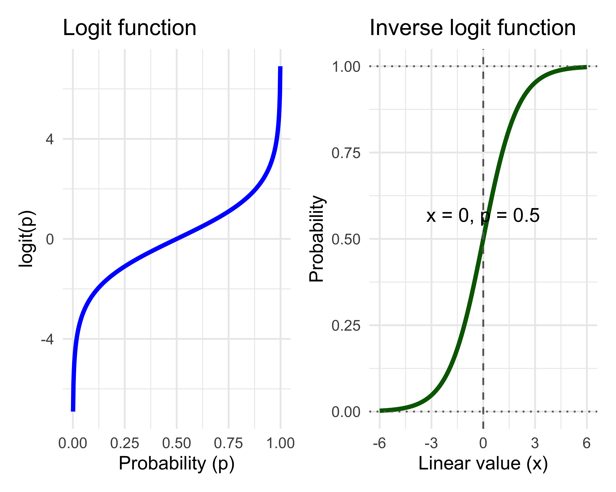

Figure 37: Left: the logit function transforms a probability p into an unbounded continuous value logit(p) that lives between minus infinity and plus infinity. Right: the inverse logit function transforms a linear combination of predictors (linear value on the figure) into a probability that lives between 0 and 1. The logit function is used in logistic regression (a GLM with binomial distribution) to transform a probability (between 0 and 1) into a continuous variable defined on the real line. Then, the inverse logit function allows you to return to the probability scale.

To formalize things a bit, we have:

$$\begin{matrix}z_{i} & ∼\text{Bernoulli}\left(θ_{i}\right) & \text{[likelihood]} \\ \text{logit}\left(θ_{i}\right) & =β_{0}+β_{1} x_{i} & \text{[linear relationship]} \\ θ_{i} & ={\text{logit}}^{-1}\left(β_{0}+β_{1} x_{i}\right)=\frac{e^{β_{0}+β_{1} x_{i}}}{1+e^{β_{0}+β_{1} x_{i}}} & \text{[transformed relationship]} \\ β_{0},β_{1} & ∼\text{Normal}\left(0,1.5\right) & \text{[prior on the parameters]} \\ & & \end{matrix}$$

To illustrate all this, we can go back to the coypu data and add individual body mass data; to do so, we recreate the raw data, i.e. the $z_{i}$:

# Total number of coypus released, and surviving  
n <- 57  
y <- 19  
  
# Create individual data (0 = dead, 1 = alive)  
z <- c(rep(1, y), rep(0, n - y))  
  
# Add a continuous covariate (ex: mass)  
set.seed(123)  
mass <- rnorm(n, mean = 5, sd = 1) # mass in kg  
  
df_bern <- data.frame(survival = z, mass = mass)

We can now fit the two models with brms, for example (we would get the same thing with NIMBLE): linear regression and logistic regression:

# Fit linear regression  
fit_lm <- brm(survival ~ mass,   
 data = df_bern,   
 family = gaussian())  
  
# Fit logistic regression  
fit_logit <- brm(survival ~ mass,   
 data = df_bern,   
 family = bernoulli())

By the way, interpreting the coefficients of logistic regression is not easy. People often introduce the notion of odds ratios to help, but personally it does not speak to me any more than that. I always come back to a graphical representation of the relationship between the probability of success (survival here) and the explanatory variables (body mass here), as in Figure 39. We observe a positive trend here, but it is due only to the randomness of the simulation (since the data were generated without any effect of body mass). Another intuitive way to deal with this is to use the rule of 4 proposed by Andrew Gelman and colleagues. The trick is to divide the slope of the logistic regression by 4. This gives an approximate estimate of the expected change in probability for a one-unit change in the explanatory variable, at the point where the curve is steepest. If the slope is estimated at 0.23, for example, then the maximum slope of the logistic curve (around the inflection point, where it changes shape) is approximately $0.23/4=0.06$. This means that an increase of one unit in the explanatory variable (here, the coypu’s body mass increases by 1 kg) increases the survival probability by about 6% at the point where the slope is strongest (we go from a survival probability of 0.5 to 0.53), as illustrated in Figure 38:

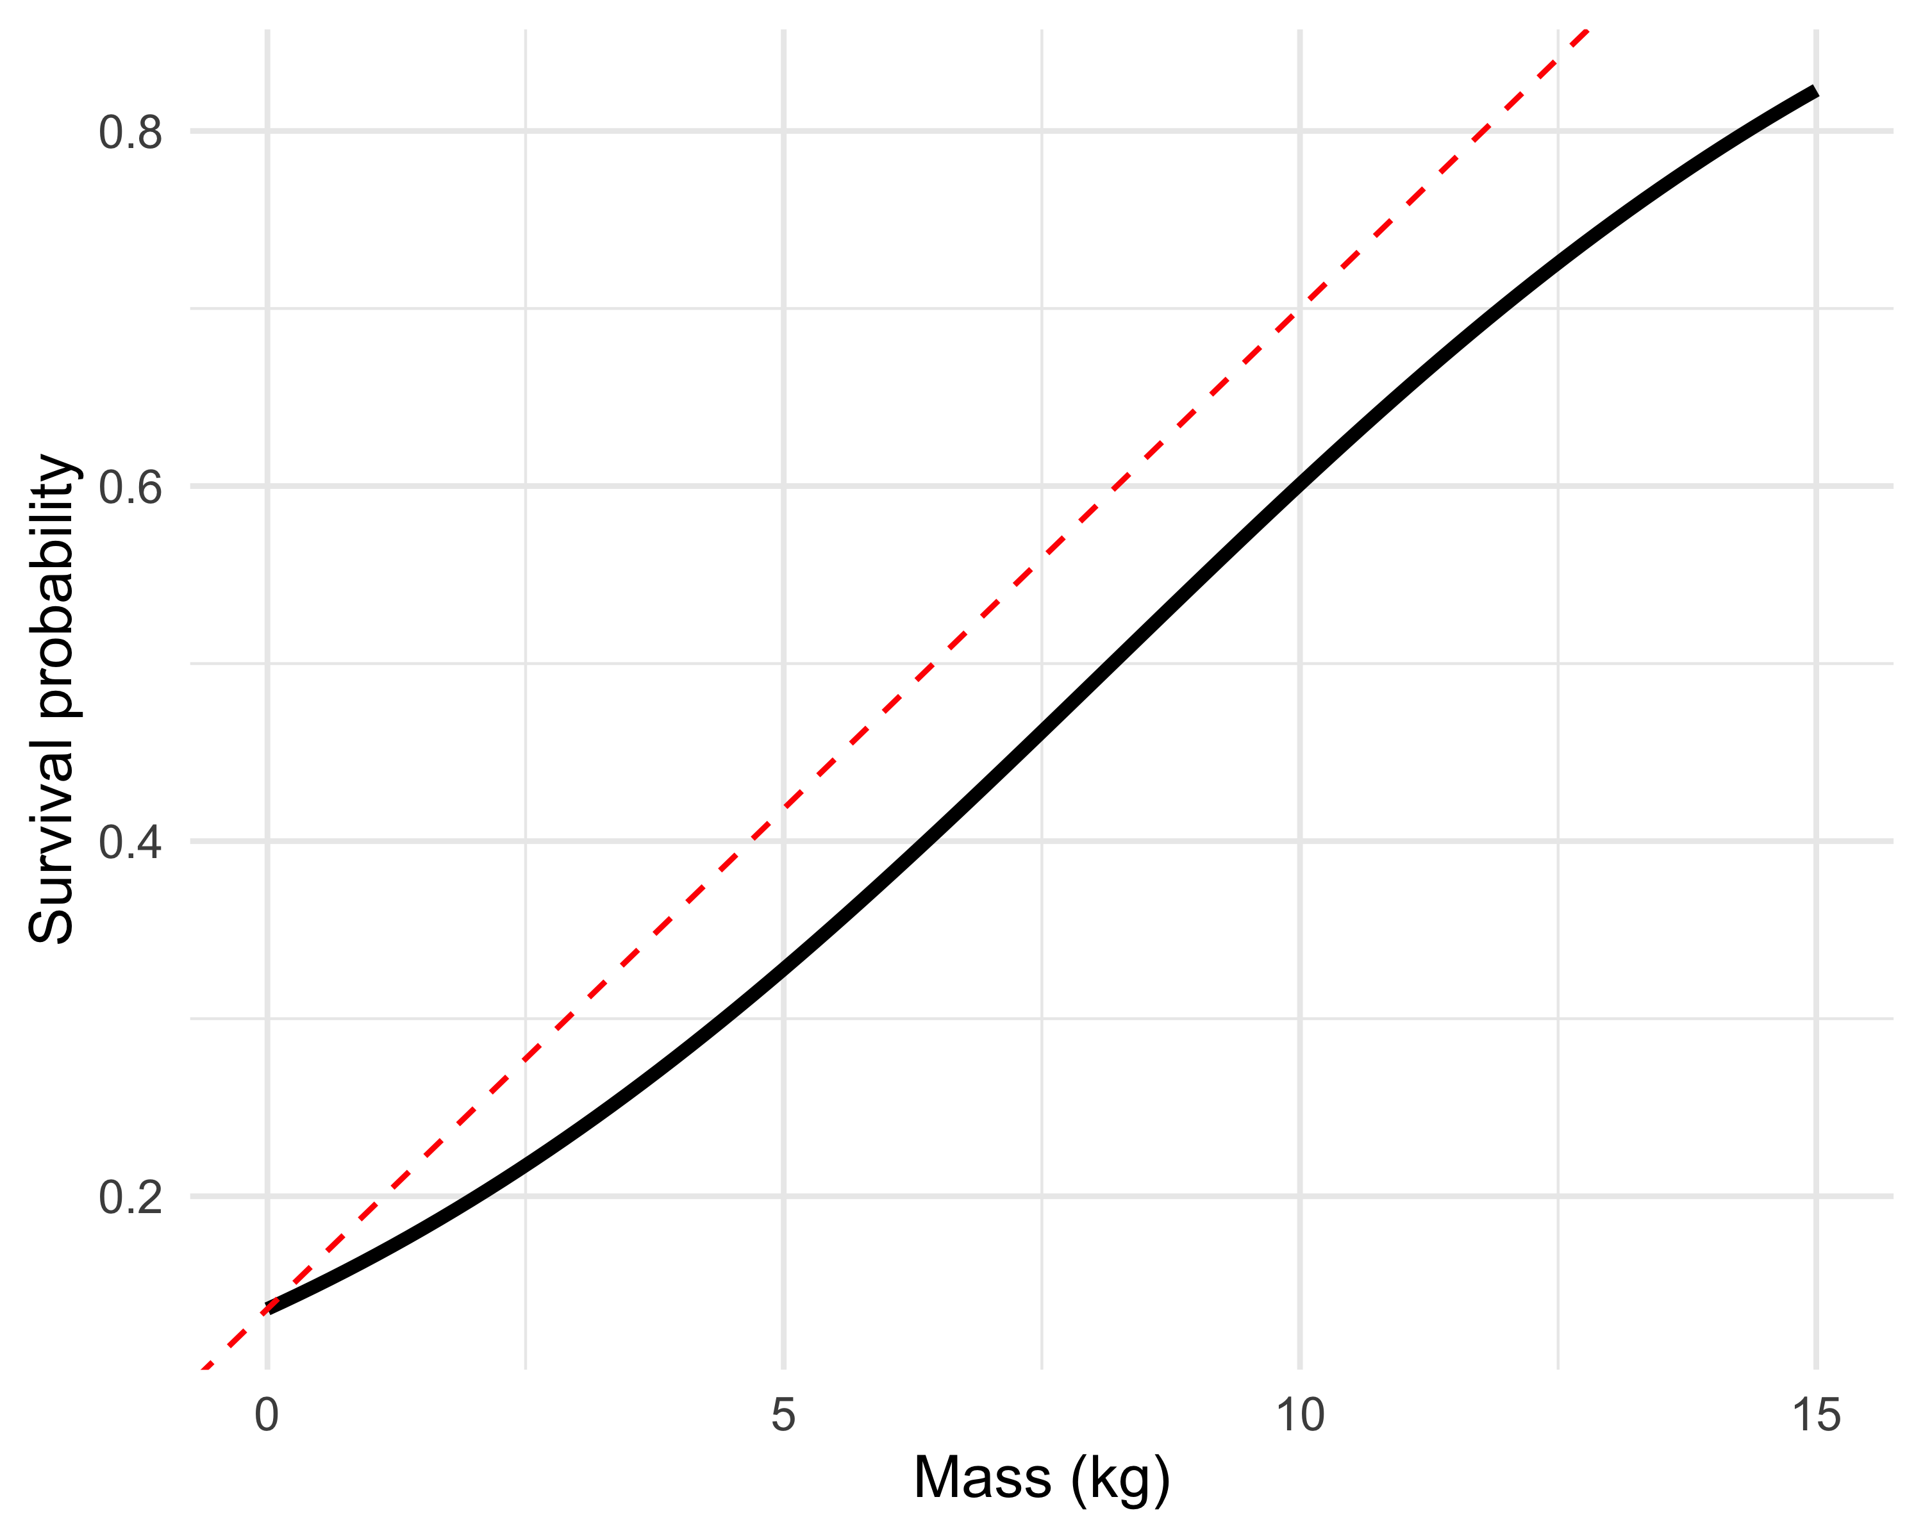

Figure 38: Illustration of Gelman’s rule of 4. Here, we approximate the effect of coypu body mass on survival probability (the black logistic curve) around the inflection point by a straight line whose slope is given by the estimated coefficient divided by 4 (the red dashed line).

But I am digressing—let’s return to the problem of applying linear regression to binary data. As you can see in Figure 39, linear regression amounts to fitting an unbounded straight line to binary data, which can lead to survival probabilities greater than 1 (and/or smaller than 0, even if that is not the case here). Logistic regression, by contrast, naturally constrains predictions between 0 and 1 thanks to the logit transformation, making it a suitable choice for success/failure variables. By the way, I used the Bernoulli formulation to introduce an explanatory variable measured at the individual scale, but if that is not necessary, we can go back to the grouped formulation with the binomial distribution as in the previous chapters.

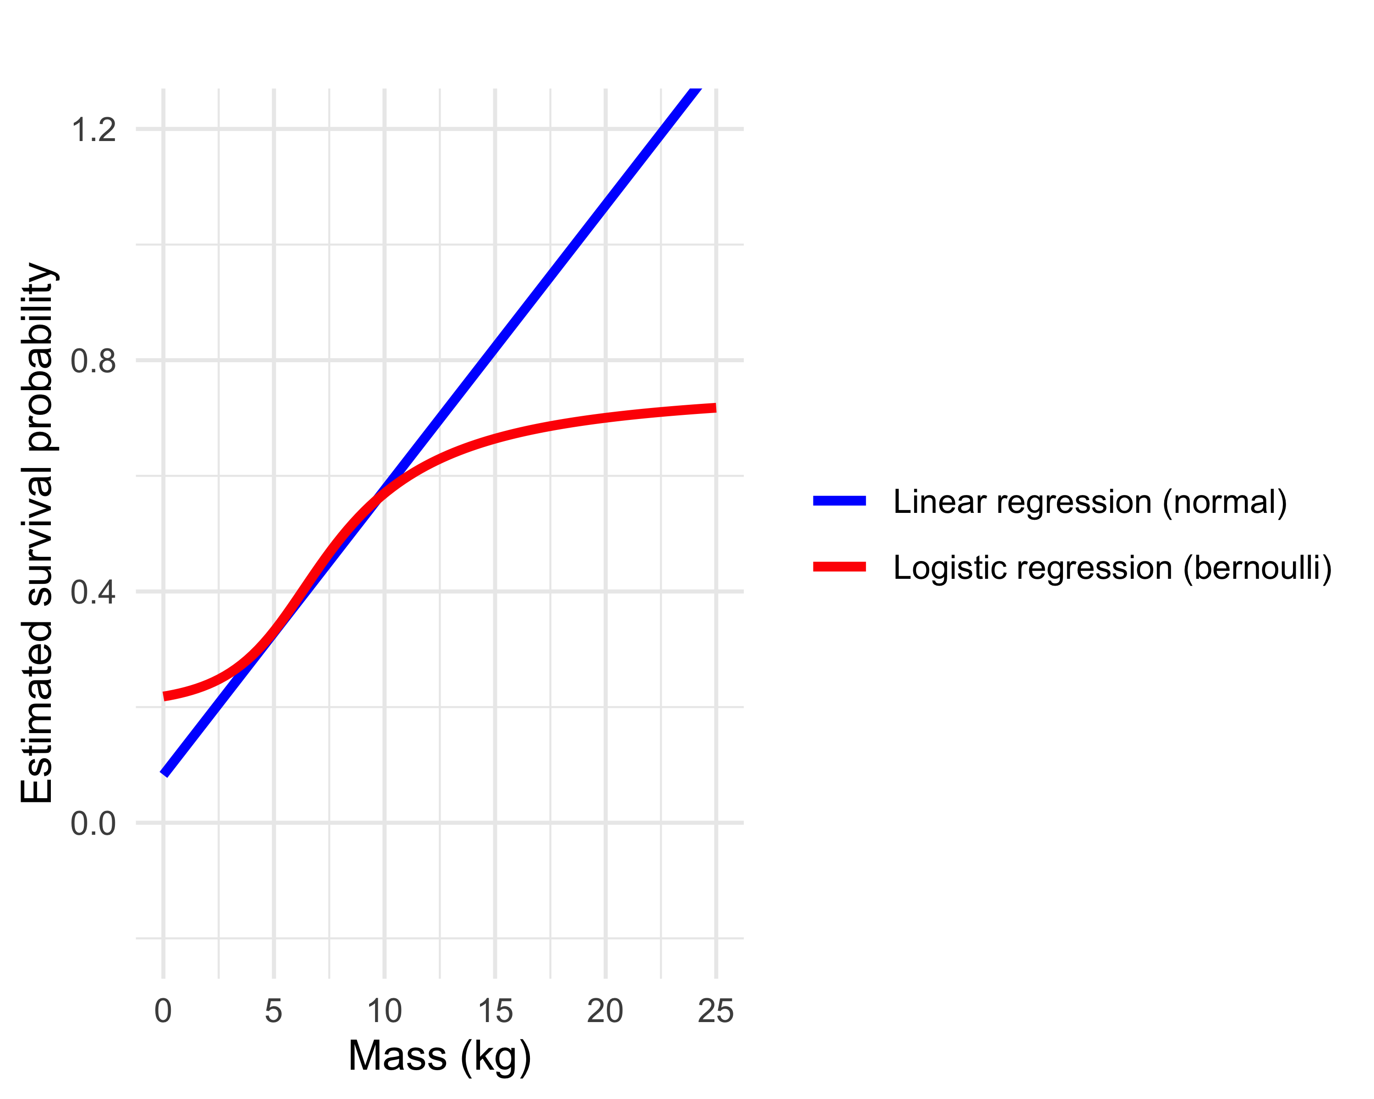

Figure 39: Comparison between a linear regression and a logistic regression fitted to binary data. Linear regression (in blue) produces predictions greater than 1 (a problem for a survival probability), whereas logistic regression (in red) guarantees a valid probability estimate.

## Generalized linear mixed models (GLMMs)

### Introduction

Often, data are collected or measured with some structure: they are hierarchical or grouped—for instance, the relationship between coypu survival and their body mass across different populations from different watersheds. In such cases, it is relevant to model this structure in the data. Doing so helps explain variability in mean survival that is not explained by body mass, and thus yields better estimates. To achieve this, we introduce generalized linear mixed models (GLMMs), which combine fixed effects as in GLMs—representing the average effect of an explanatory variable (body mass in the coypu example)—and random effects representing variability among groups or hierarchical levels.

What is a random effect? An effect is random when it represents a random selection of units from a larger population—for example, sampling sites or individuals; if we were to repeat the experiment, the particular sites or individuals would not matter, and what matters is the ability to generalize the interpretation of effects. In this sense, the sex of coypu, for example, cannot be considered a random effect; if we repeat the experiment, the sex variable still has the same two levels, male and female. By contrast, treating the sites within a study area for our coypu as a fixed effect only allows us to say things about these specific sites, without being able to generalize to the “population” of sites, or to the study area.

Along the way, you will see the terms *hierarchical models*, *multilevel models*, or *random-effects models* used to refer to a GLMM in the scientific literature. Sometimes this is exactly the same thing; sometimes it refers to GLMMs that are slightly modified. To avoid confusion, remember that GLMMs are used to analyze data that come with a grouped structure.

### Example

To illustrate a GLMM concretely, imagine the situation where we want to estimate coypu abundance in the Lez watershed, in Montpellier, where the Lez is a river that runs through the city. We lay out ten transects across the study area. On each transect, we count the number of coypu present at ten regularly spaced points. We are interested in how the number of coypu (counts) responds to temperature. The measurements are clearly hierarchical: we take one count at each of the 10 points within each of the 10 transects. The protocol is illustrated in Figure 40 and is inspired by the book of my colleague Jason Matthiopoulos (Matthiopoulos 2011).

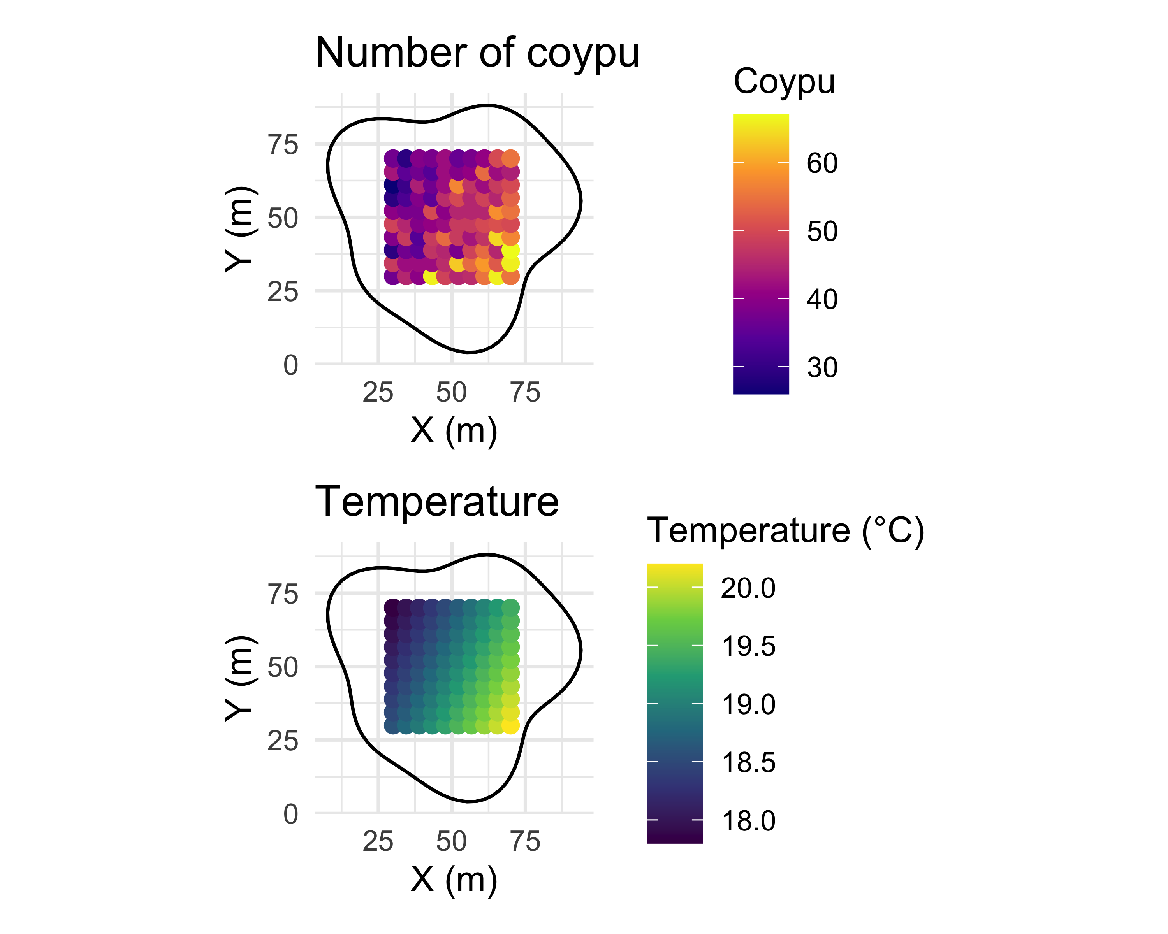

Figure 40: Diagram of the coypu data under a sampling protocol with 10 points in 10 transects. The study area is in black. The top panel shows the number of coypu, and the bottom panel shows temperature.

Starting from this protocol, let us simulate data with the following script. We will make it a bit more challenging by assuming that, among our ten transects, we had sampling issues on three of them, for which we could only sample two or three points:

set.seed(123) # for reproducibility  
transects <- 10 # total number of transects  
nb_points <- c(10, 10, 10, 3, 2, 10, 10, 3, 10, 10) # number of points per transect  
data <- NULL # object that will store the simulated data  
for (tr in 1:transects){  
 ref <- rnorm(1, 0, .3) # transect random effect (N(0, 0.3^2))  
 # temperature simulated along the transect:  
 # random starting point between 18 and 22 °C, then a slight slope per segment  
 t <- runif(1, 18, 22) + runif(1, -0.2, 0.2) * 1:10  
 # expected intensity (log scale): linear relationship with temperature  
 ans <- exp(ref + 0.2 * t)  
 # Poisson counts of coypu at each point  
 an <- rpois(nb_points[tr], ans)  
 # stack the points from the current transect  
 data <- rbind(data, cbind(rep(tr, nb_points[tr]), t[1:nb_points[tr]], an))  
}  
# put everything into a data.frame  
sim_simple <- data.frame(  
 Transect = data[, 1],  
 Temperature = data[, 2],  
 Ragondins = data[, 3]  
)  
head(sim_simple)  
#> Transect Temperature Ragondins  
#> 1 1 19.78911 54  
#> 2 1 19.94232 46  
#> 3 1 20.09553 47  
#> 4 1 20.24874 60  
#> 5 1 20.40194 53  
#> 6 1 20.55515 42

I have commented the code, which should make it easier to read. Nevertheless, a few explanations of the different steps are in order. We begin with a loop for (tr in 1:transects) that simulates the data for each of the ten transects, one by one. Each time, we draw a transect-specific random effect (ref), which slightly shifts the intercept of the relationship between temperature and the number of coypu depending on the transect. Next, we generate a temperature sequence (t) with a randomly drawn starting point and a small slope that changes temperature slightly from one point to the next. From this temperature, we compute the expected intensity of the counting process (ans) by assuming a linear relationship (on the log scale), and then we generate the observed data (an) by drawing values from a Poisson distribution with mean ans. Finally, we gather everything into a table (sim_simple) so we can analyze it. Figure 41 illustrates the data we obtain:

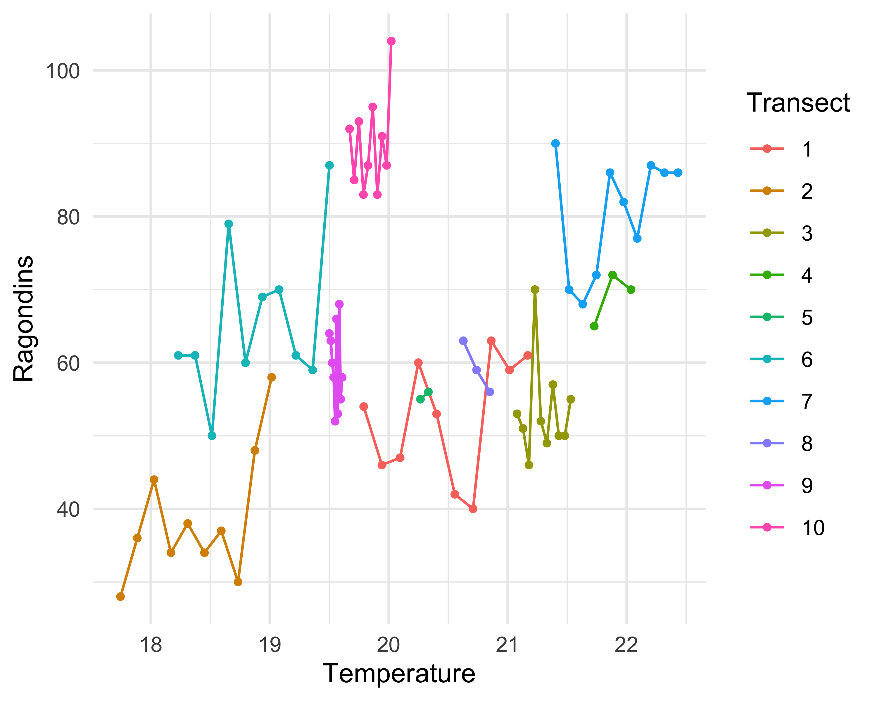

Figure 41: Relationship between the number of coypu and temperature by transect, with multiple count points (10 for all transects, except transects 4, 5, and 8 for which we have 3, 2, and 3 points) per transect.

### The GLM approach

We want to analyse these data. Here we are not dealing with binary data as in the beginning of this chapter, but with **count data**. To model this type of response, we use a **Poisson** distribution with a **log link**, $log\left(θ_{i}\right)=β_{0}+β_{1} {\text{temp}}_{i}$, where ${\text{temp}}_{i}$ is temperature:

$$\begin{matrix}y_{i} & ∼\text{Poisson}\left(θ_{i}\right) & \text{[likelihood]} \\ log\left(θ_{i}\right) & =β_{0}+β_{1} {\text{temp}}_{i} & \text{[linear predictor]} \\ θ_{i} & =exp\left(β_{0}+β_{1} {\text{temp}}_{i}\right) & \text{[transformed mean]} \\ β_{0},β_{1} & ∼\text{Normal}\left(0,1.5\right) & \text{[priors]} \\ & & \end{matrix}$$

This distribution is relatively easy to handle because, among other things, it has a single parameter $\text{theta}$ that gives the rate of occurrence of the event being modelled, and because on average the expected number of coypus here should be equal to that parameter.

In a Poisson GLM, the coefficients $β_{0}$ and $β_{1}$ are interpreted on the **log scale**. More precisely, a one-unit increase in temperature multiplies the mean number of coypus by $exp\left(β_{1}\right)$. For instance, if $β_{1}=0.3$, then a one-degree increase corresponds to an expected increase of about $35\%$ in the mean number of coypus, because $exp\left(0.3\right)≈1.35$. We can also visualise the relationship between coypu counts and temperature, as in Figures 44 and 46 below.

In a first model, let us ignore the grouping / multilevel structure in the data (here: transects). We fit a single curve through the point cloud: this is the **complete pooling** model:

# do not forget to standardise the temperature covariate  
sim_simple$Temp <- scale(sim_simple$Temperature)  
  
# complete pooling model  
fit_complete <- brm(Ragondins ~ Temp,  
 data = sim_simple, # simulated data  
 family = poisson("log")) # Poisson distribution, log link

The results are:

summary(fit_complete)  
#> Family: poisson   
#> Links: mu = log   
#> Formula: Ragondins ~ Temp   
#> Data: sim_simple (Number of observations: 78)   
#> Draws: 2 chains, each with iter = 5000; warmup = 1000; thin = 1;  
#> total post-warmup draws = 8000  
#>   
#> Regression Coefficients:  
#> Estimate Est.Error l-95% CI u-95% CI Rhat Bulk_ESS Tail_ESS  
#> Intercept 4.13 0.01 4.11 4.16 1.00 5374 5177  
#> Temp 0.10 0.01 0.07 0.13 1.00 5936 5368  
#>   
#> Draws were sampled using sampling(NUTS). For each parameter, Bulk_ESS  
#> and Tail_ESS are effective sample size measures, and Rhat is the potential  
#> scale reduction factor on split chains (at convergence, Rhat = 1).

Here we ignore that observations are collected by transect, and we incorrectly assume that all observations are independent. The risk is to draw misleading conclusions: we might think there is a single relationship while differences are actually due to transect-to-transect variation, or conversely we might miss a true trend. A model check shows in Figure 42 that the fit is poor:

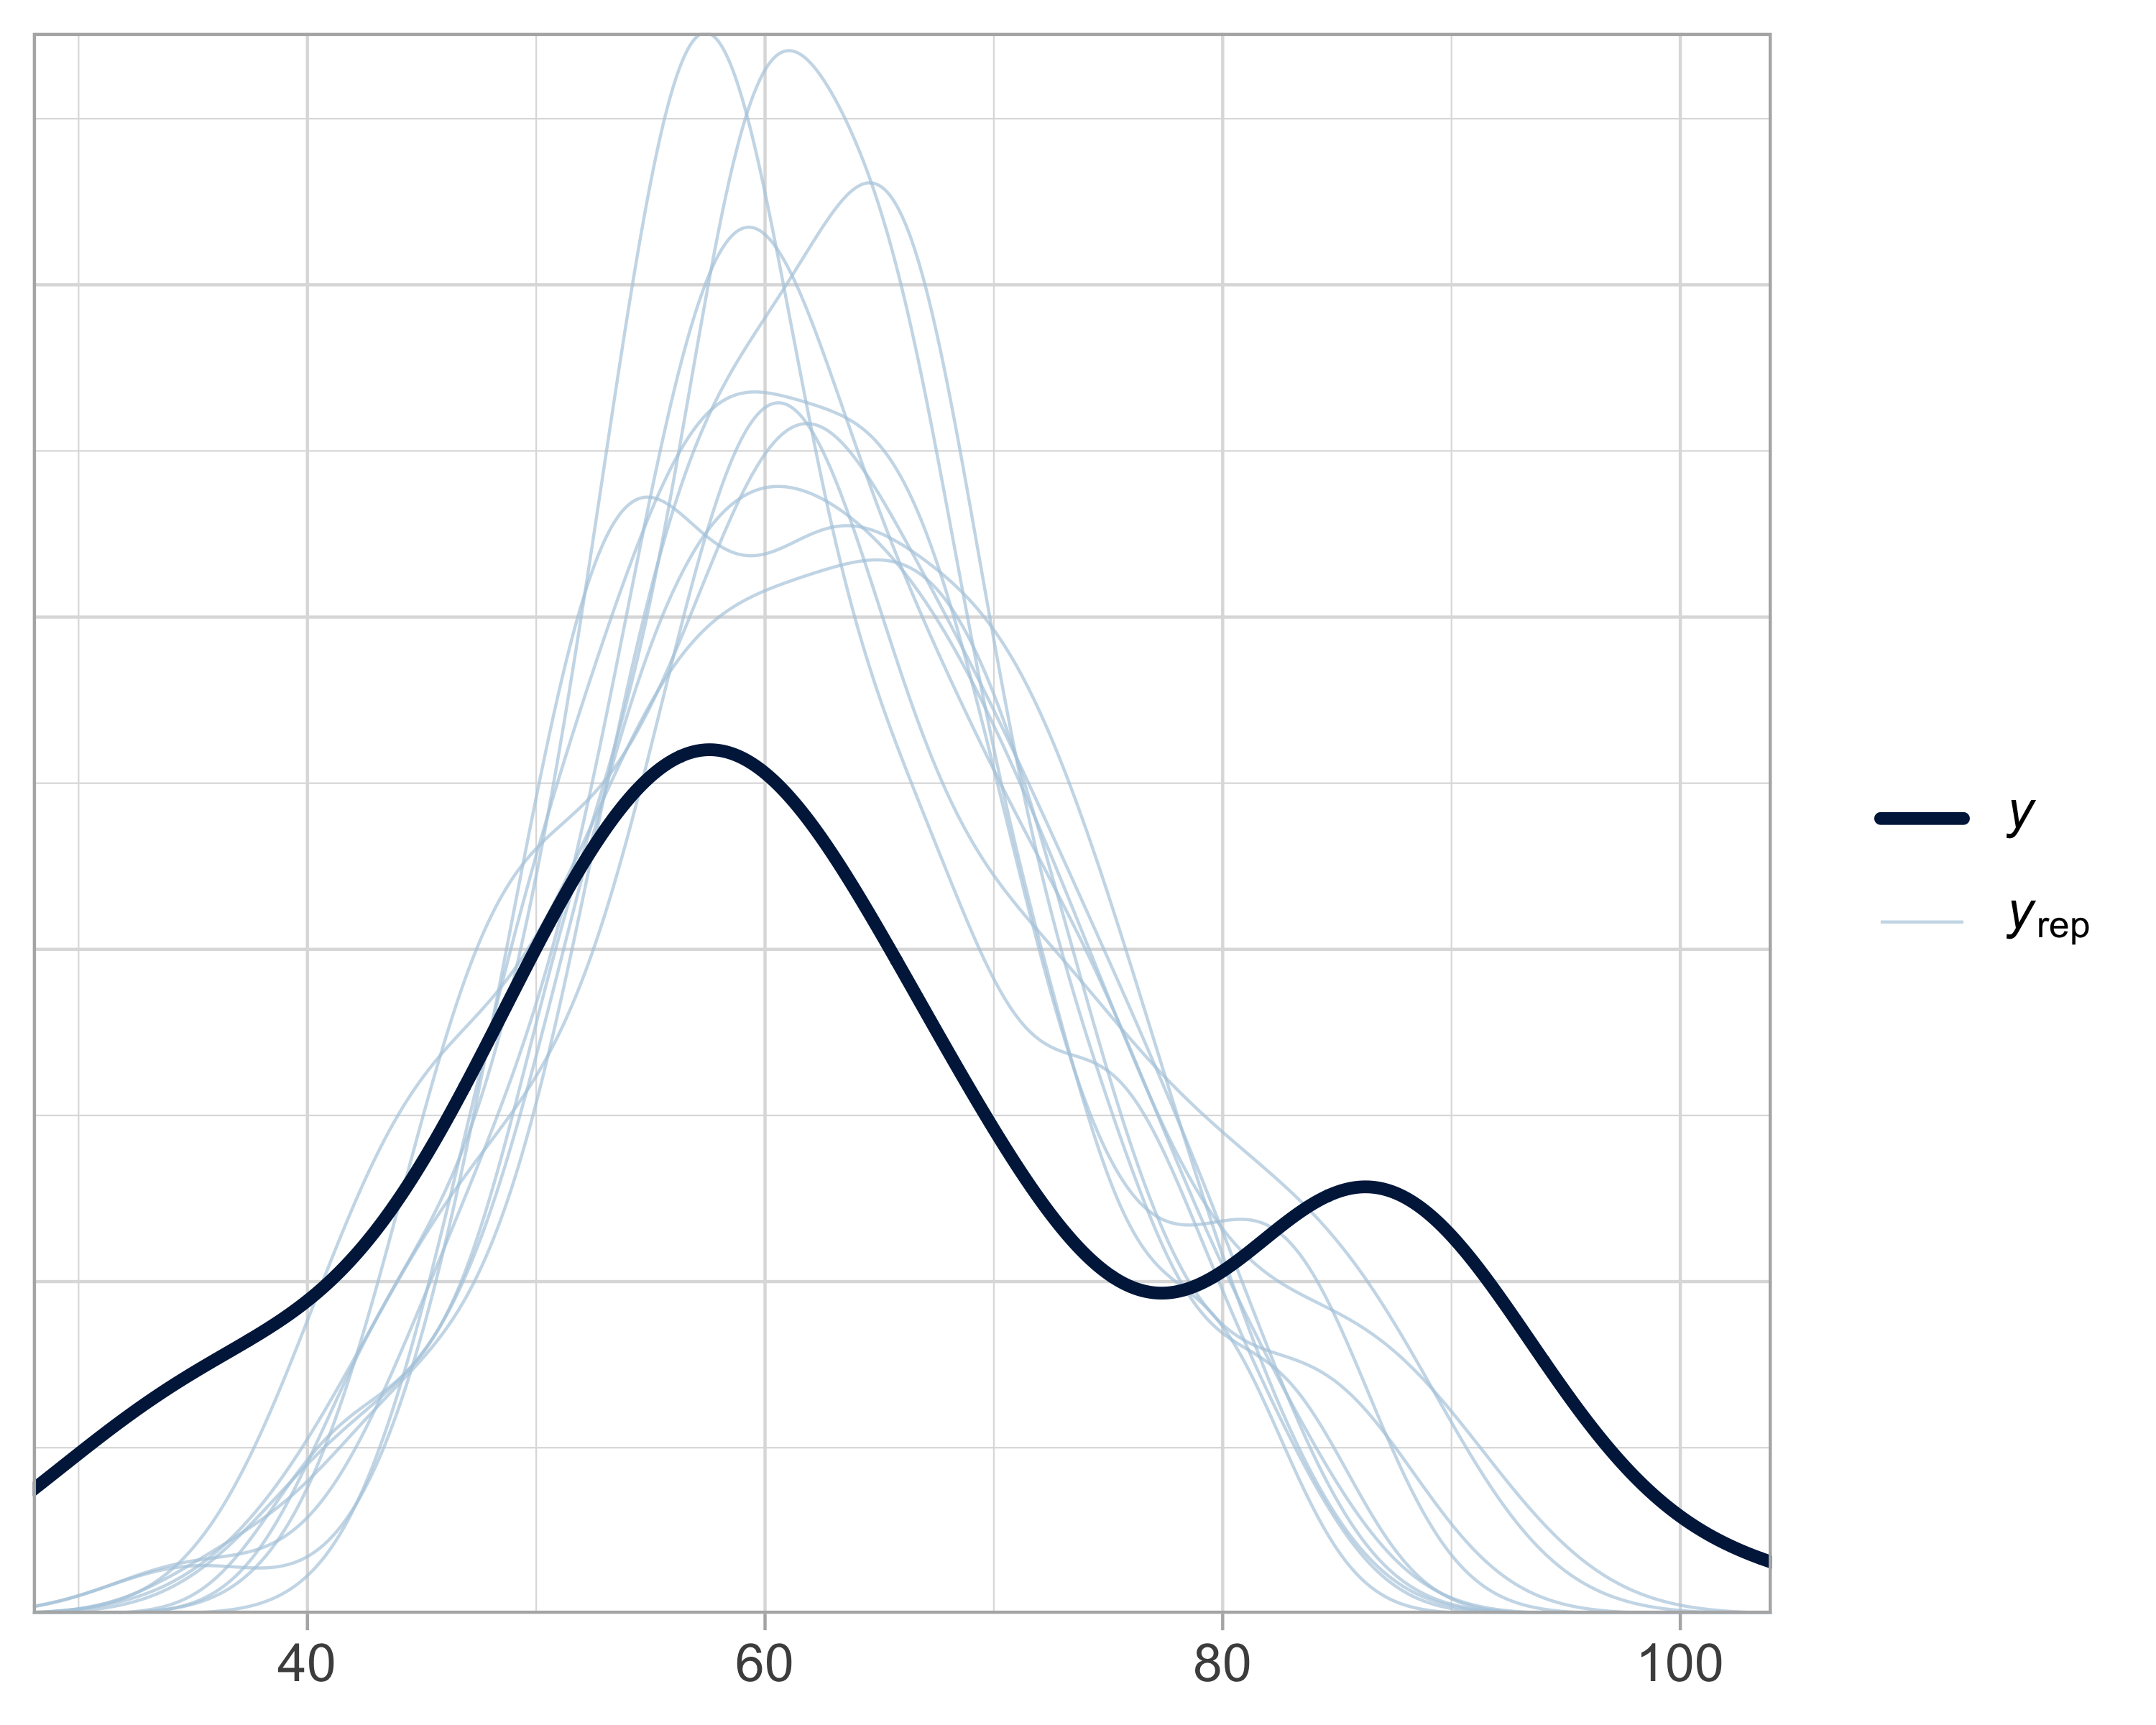

Figure 42: Model-check for the complete pooling model. The x-axis shows possible values of the observed or simulated response. The y-axis shows the estimated density. Simulated distributions (blue) are compared with the observed data (black). Poor overlap indicates a lack of fit.

To account for the structure in the data, we can fit another model in which transect is treated as a **fixed effect**. In other words, we fit a separate curve for each transect, with its own intercept, but a common slope:

# no pooling model (transect as a fixed effect)  
fit_nopool <- brm(Ragondins ~ Temp + as.factor(Transect),  
 data = sim_simple,  
 family = poisson("log"))

The results are:

summary(fit_nopool)  
#> Family: poisson   
#> Links: mu = log   
#> Formula: Ragondins ~ Temp + as.factor(Transect)   
#> Data: sim_simple (Number of observations: 78)   
#> Draws: 2 chains, each with iter = 5000; warmup = 1000; thin = 1;  
#> total post-warmup draws = 8000  
#>   
#> Regression Coefficients:  
#> Estimate Est.Error l-95% CI u-95% CI Rhat Bulk_ESS Tail_ESS  
#> Intercept 3.90 0.05 3.81 3.99 1.00 3659 4650  
#> Temp 0.20 0.06 0.08 0.32 1.00 2684 3611  
#> as.factorTransect2 0.04 0.12 -0.21 0.28 1.00 3001 3973  
#> as.factorTransect3 -0.12 0.07 -0.26 0.03 1.00 4207 5527  
#> as.factorTransect4 0.05 0.11 -0.16 0.26 1.00 3737 4859  
#> as.factorTransect5 0.09 0.10 -0.12 0.29 1.00 5687 5484  
#> as.factorTransect6 0.49 0.10 0.29 0.68 1.00 3009 4224  
#> as.factorTransect7 0.19 0.09 0.02 0.37 1.00 3322 4124  
#> as.factorTransect8 0.08 0.09 -0.09 0.26 1.00 5512 5480  
#> as.factorTransect9 0.28 0.08 0.13 0.43 1.00 3452 4601  
#> as.factorTransect10 0.64 0.06 0.53 0.77 1.00 3729 4715  
#>   
#> Draws were sampled using sampling(NUTS). For each parameter, Bulk_ESS  
#> and Tail_ESS are effective sample size measures, and Rhat is the potential  
#> scale reduction factor on split chains (at convergence, Rhat = 1).

Here I told brms to treat transect as a categorical variable (a factor), via as.factor(Transect) in the call to brm(). By default, the first factor level (here transect 1) is used as the reference. This means that the intercept $β_{0}$ estimated in the model corresponds to transect 1, and the coefficients for other transects represent (on the log scale) deviations relative to transect 1. For example, the intercept for transect 1 is estimated as 3.9. The shift between transect 1 and transect 2 is estimated as 0.04. Therefore, the intercept for transect 2 is: 3.94.

We can repeat this for each transect to obtain transect-specific intercepts, and then exponentiate them to recover the expected mean number of coypus (on the original scale) at **average temperature** (which equals 0 here because temperature has been standardised):

# extract the intercept (reference = Transect 1)  
beta0 <- fixef(fit_nopool)["Intercept", "Estimate"]  
  
# all model coefficients  
coefs <- fixef(fit_nopool)  
  
# effects associated with the other transects  
coefs_transects <- coefs[grep("as.factor", rownames(coefs)), "Estimate"]  
  
# compute intercepts by transect (on the log scale)  
intercepts_log <- c(  
 Transect1 = beta0,  
 beta0 + coefs_transects  
)  
  
# expected mean counts on the original scale  
means <- exp(intercepts_log)  
  
# summary table  
df_intercepts <- data.frame(  
 Transect = names(intercepts_log),  
 Intercept_log = round(intercepts_log, 2),  
 Mean_count = round(means, 2)  
)  
  
# display  
df_intercepts  
#> Transect Intercept_log Mean_count  
#> Transect1 Transect1 3.90 49.60  
#> as.factorTransect2 as.factorTransect2 3.94 51.48  
#> as.factorTransect3 as.factorTransect3 3.79 44.15  
#> as.factorTransect4 as.factorTransect4 3.95 51.94  
#> as.factorTransect5 as.factorTransect5 3.99 54.02  
#> as.factorTransect6 as.factorTransect6 4.39 80.75  
#> as.factorTransect7 as.factorTransect7 4.10 60.22  
#> as.factorTransect8 as.factorTransect8 3.98 53.74  
#> as.factorTransect9 as.factorTransect9 4.19 65.76  
#> as.factorTransect10 as.factorTransect10 4.55 94.53

We indeed estimate one intercept per transect (so 10 intercepts), and a common slope (the temperature effect) shared by all transects. Note that the Mean_count values are Poisson means. They are continuous (possibly non-integer) even though the observed data are integer counts. This is a key feature of Poisson models: the response is discrete, but the model is parameterised through a continuous mean.

The fit is better, as shown in Figure 43:

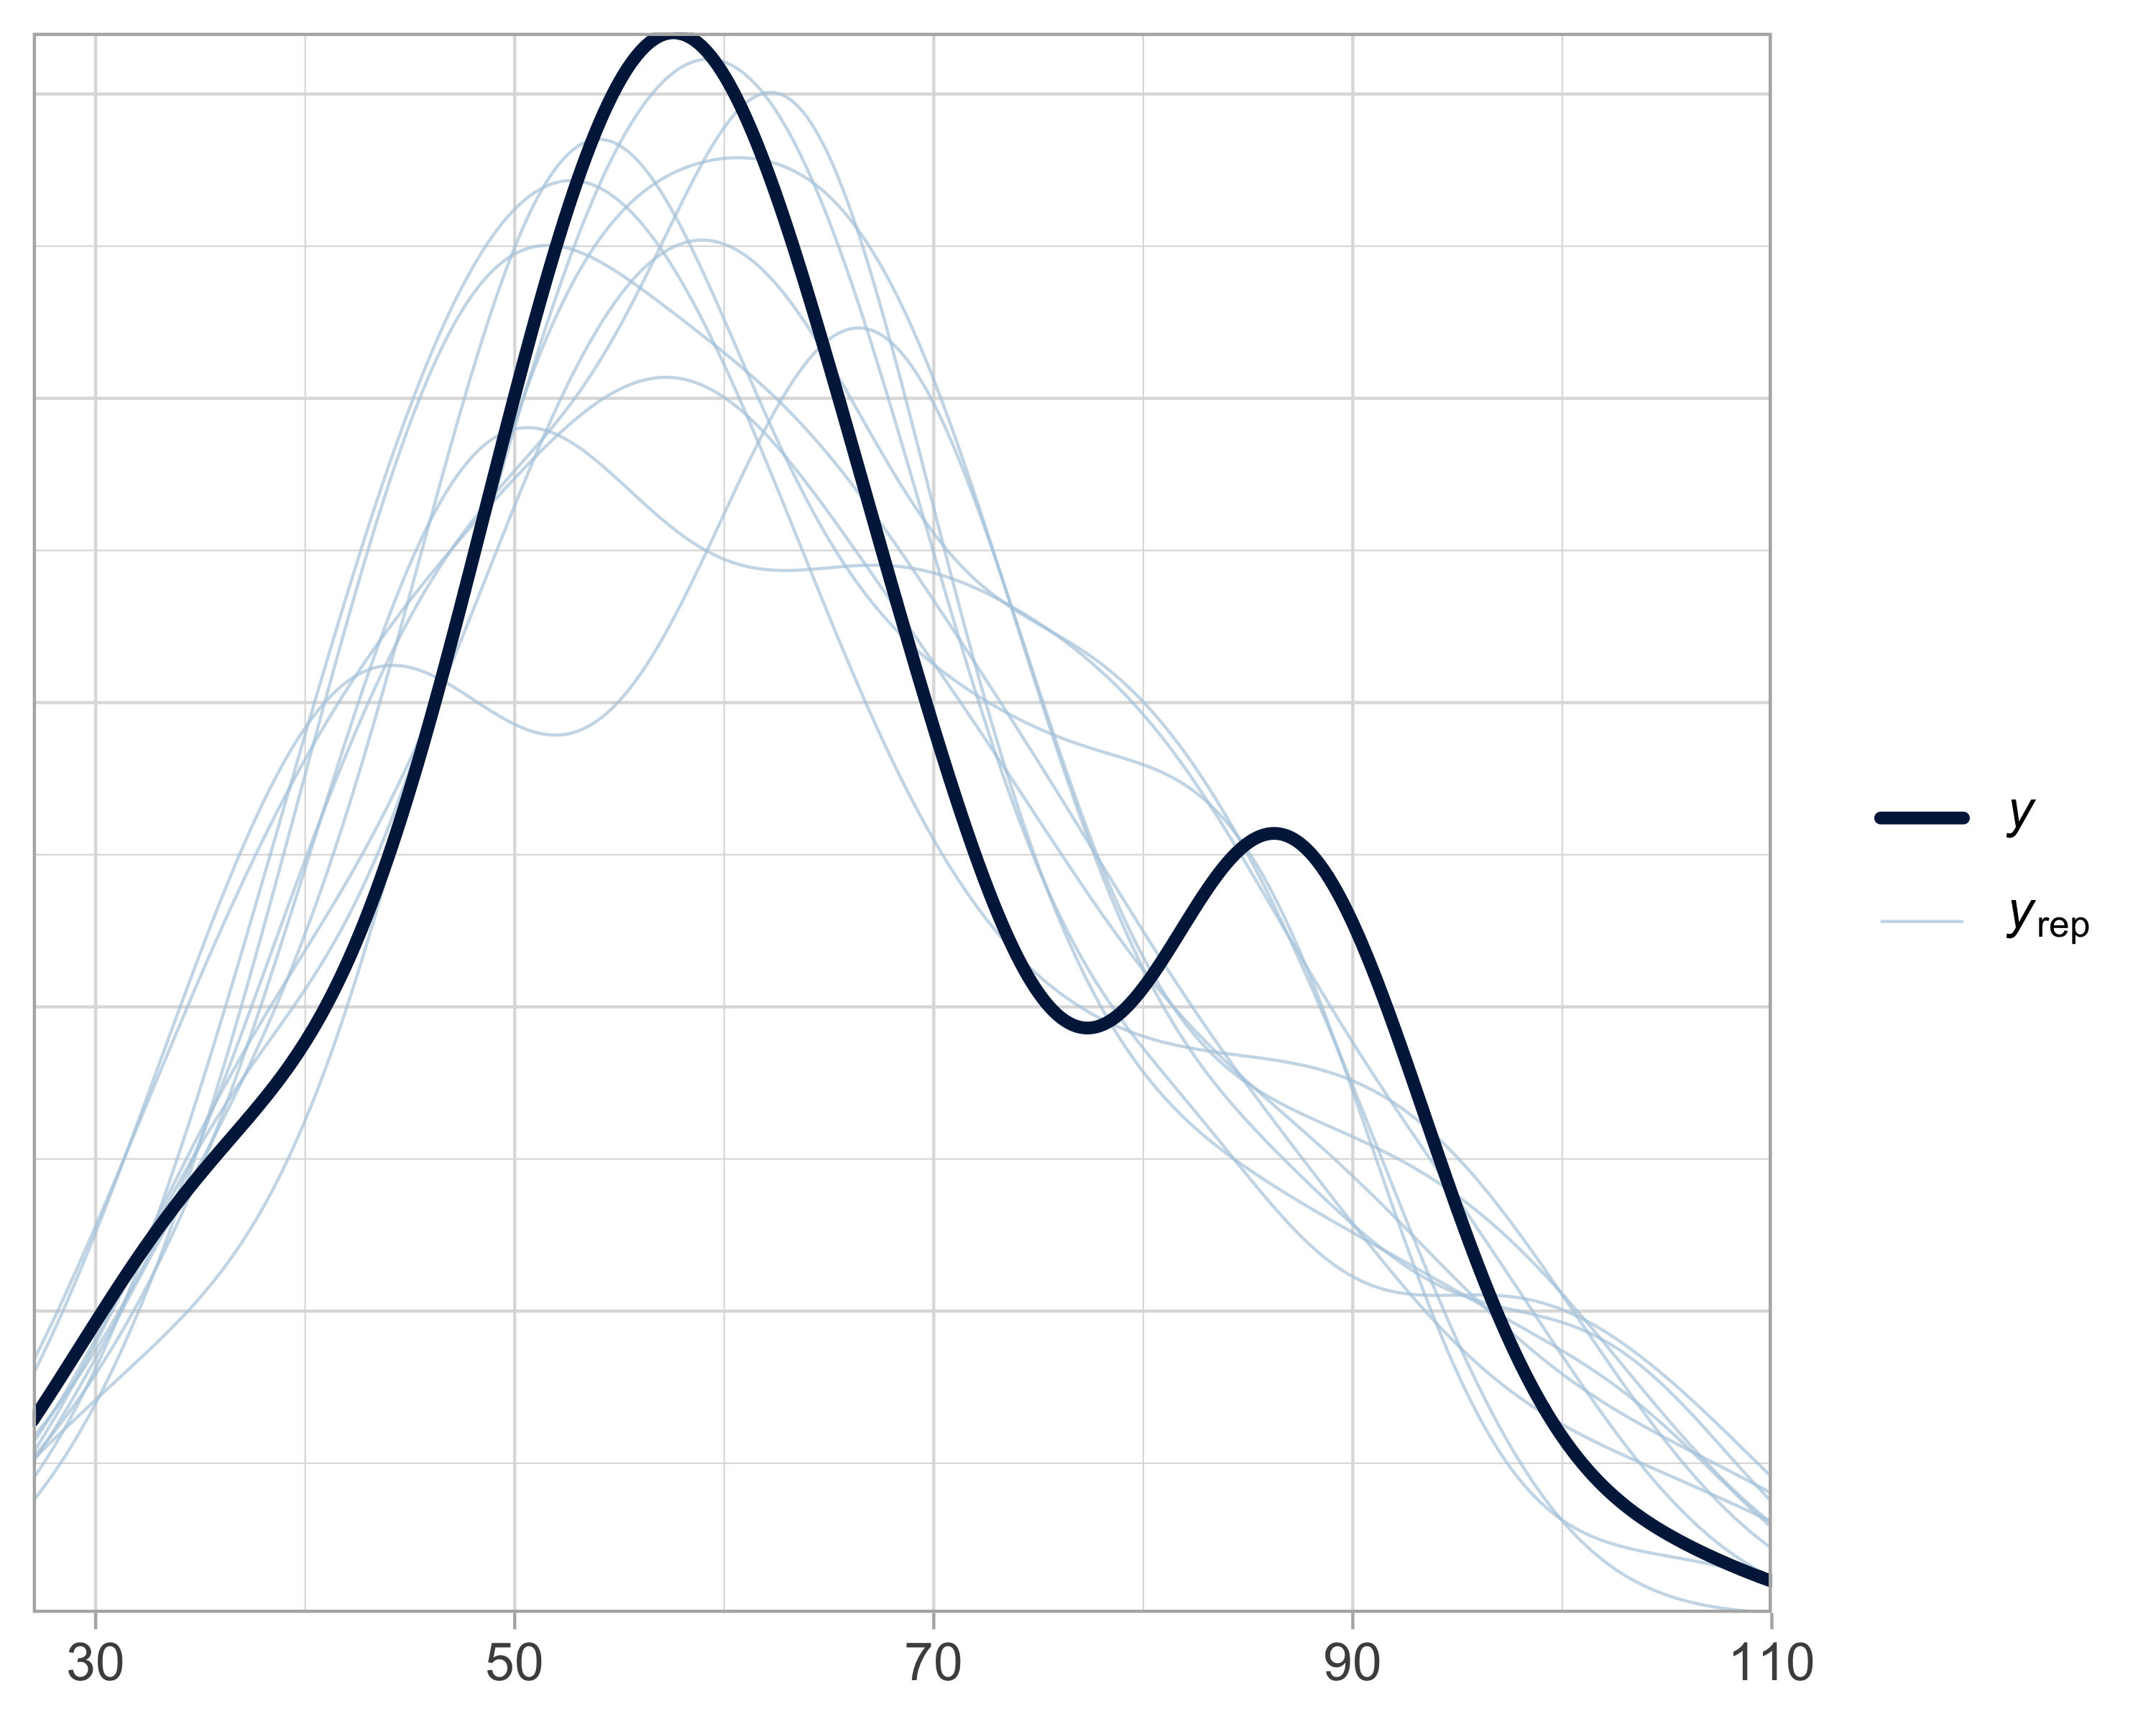

Figure 43: Model-check for the no pooling model. The x-axis shows possible values of the observed or simulated response. The y-axis shows the estimated density. Simulated distributions (blue) are compared with the observed data (black).

This **no pooling** model improves on the **complete pooling** model (Figure 44), but it remains unsatisfying. No pooling means fitting an independent model for each transect, without sharing information across groups. This creates two issues: (i) we cannot generalise conclusions beyond the specific transects observed, and (ii) we potentially waste information by assuming that each transect has nothing to learn from the others. This strategy becomes especially inefficient when some groups have few observations.

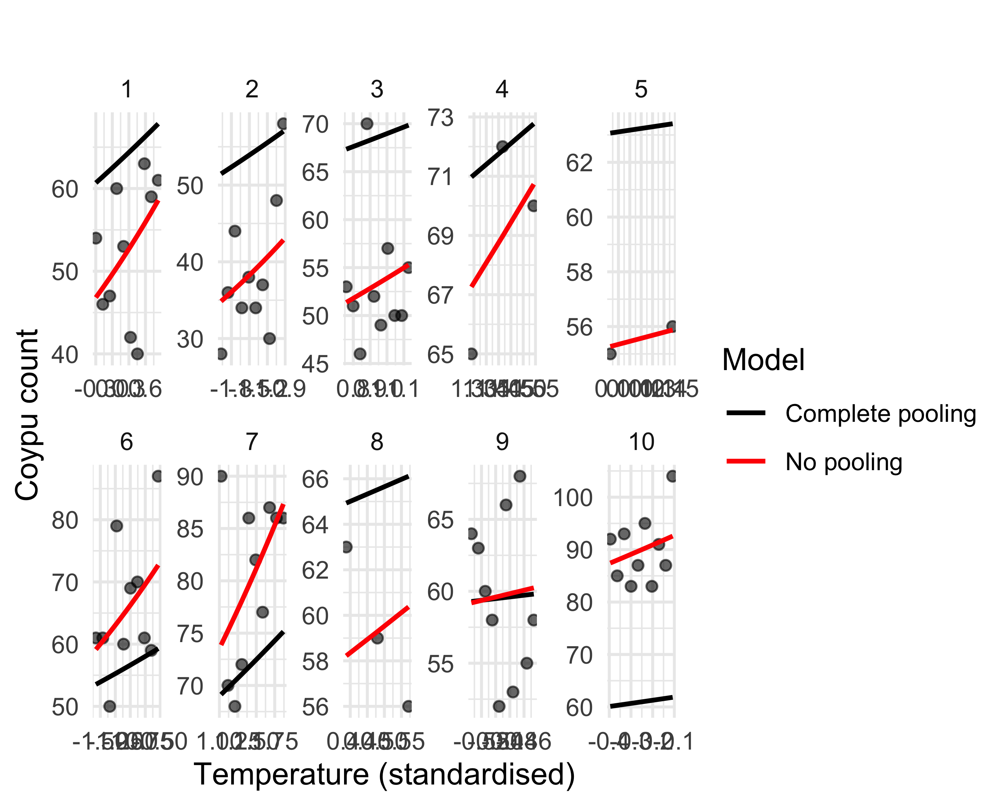

Figure 44: Comparison between complete pooling (black) and no pooling (red) models to predict coypu counts as a function of temperature, by transect. The no pooling model fits an independent curve for each transect, whereas complete pooling assumes a common relationship.

### The GLMM approach

Let us return to our objective: assess the effect of temperature on coypu abundance while accounting for the hierarchical structure of the data (segments nested within transects). So far, the complete pooling and no pooling models represented two extremes: either all transects share exactly the same temperature–abundance relationship, or each transect has a completely independent relationship (via a transect-specific intercept). **Generalised linear mixed models (GLMMs)** implement a more realistic compromise, often called **partial pooling**.

We build a GLMM where each transect has its own intercept—i.e., its own baseline abundance—but these intercepts are not treated as unrelated. Instead, they are modelled as random deviations around a global intercept $β_{0}$, drawn from a common normal distribution. This means that the transect-specific intercepts $β_{0j}$ (with $j=1,…,10$) are viewed as coming from a larger population of possible transects, where baseline abundance varies across space. We capture this heterogeneity with a random effect, written here as $β_{0j}∼\text{Normal}\left(β_{0},σ\right)$, where $σ$ is the between-transect variability.

Equivalently, each transect intercept can be written as $β_{0j}=β_{0}+b_{j}$, with $b_{j}∼\text{Normal}\left(0,σ\right)$. Here $β_{0}$ is the intercept for a “typical” transect, and $σ$ quantifies how much transects vary around that mean. For instance, if $β_{0}=2$ but transect 4 has $β_{04}=3$, then the transect-specific deviation is $b_{4}=1$, corresponding to higher-than-average abundance.

This hierarchical structure shares information across groups, which is particularly useful when some transects have few observations. You can also view the partial pooling model (3 parameters estimated here: $β_{0},β_{1},σ$) as a compromise between the complete pooling model (2 parameters: $β_{0},β_{1}$) and the no pooling model (11 parameters: 10 intercepts and 1 common slope $β_{1}$).

Formally, the GLMM can be written as:

$$\begin{matrix}y_{i} & ∼\text{Poisson}\left(θ_{i}\right) & \text{[likelihood]} \\ log\left(θ_{i}\right) & =β_{0j}+β_{1} {\text{temp}}_{i} & \text{[linear predictor]} \\ β_{0j} & ∼\text{Normal}\left(β_{0},σ\right) & \text{[random effect]} \\ β_{0} & ∼\text{Normal}\left(0,1.5\right) & \text{[prior for the mean intercept]} \\ σ & ∼\text{Exp}\left(1\right) & \text{[prior for the random-effect SD]} \\ β_{1} & ∼\text{Normal}\left(0,1.5\right) & \text{[prior for the slope]} \\ & & \end{matrix}$$

#### Fitting the model with brms

We first fit the partial pooling GLMM with brms:

# partial pooling model (transect random intercept)  
fit_partial <- brm(Ragondins ~ Temp + (1 | Transect), # count ~ temperature with a transect random intercept  
 data = sim_simple,  
 family = poisson("log"))

In this syntax, the random intercept is specified as (1 | Transect), where 1 means we are modelling the intercept, and | indicates “one intercept per transect”. If we wanted to include a random slope as well, we would write (1 + Temp | Transect).

The results are:

summary(fit_partial)  
#> Family: poisson   
#> Links: mu = log   
#> Formula: Ragondins ~ Temp + (1 | Transect)   
#> Data: sim_simple (Number of observations: 78)   
#> Draws: 2 chains, each with iter = 5000; warmup = 1000; thin = 1;  
#> total post-warmup draws = 8000  
#>   
#> Multilevel Hyperparameters:  
#> ~Transect (Number of levels: 10)   
#> Estimate Est.Error l-95% CI u-95% CI Rhat Bulk_ESS Tail_ESS  
#> sd(Intercept) 0.27 0.08 0.16 0.47 1.00 2119 3183  
#>   
#> Regression Coefficients:  
#> Estimate Est.Error l-95% CI u-95% CI Rhat Bulk_ESS Tail_ESS  
#> Intercept 4.09 0.09 3.92 4.27 1.00 2087 2747  
#> Temp 0.17 0.05 0.06 0.27 1.00 3559 4119  
#>   
#> Draws were sampled using sampling(NUTS). For each parameter, Bulk_ESS  
#> and Tail_ESS are effective sample size measures, and Rhat is the potential  
#> scale reduction factor on split chains (at convergence, Rhat = 1).

This summary reports posterior estimates for the fixed effects and the standard deviations of the random effects. The line sd(Intercept) corresponds to $σ$, close to the value 0.3 used to simulate the data (the credible interval includes the true value). The lines Intercept and Temp provide estimates of $β_{0}$ and $β_{1}$ on the log scale. We will see below how to check that these estimates are close to the values used in simulation.

We can also inspect posterior densities and trace plots (Figure 45):

plot(fit_partial)

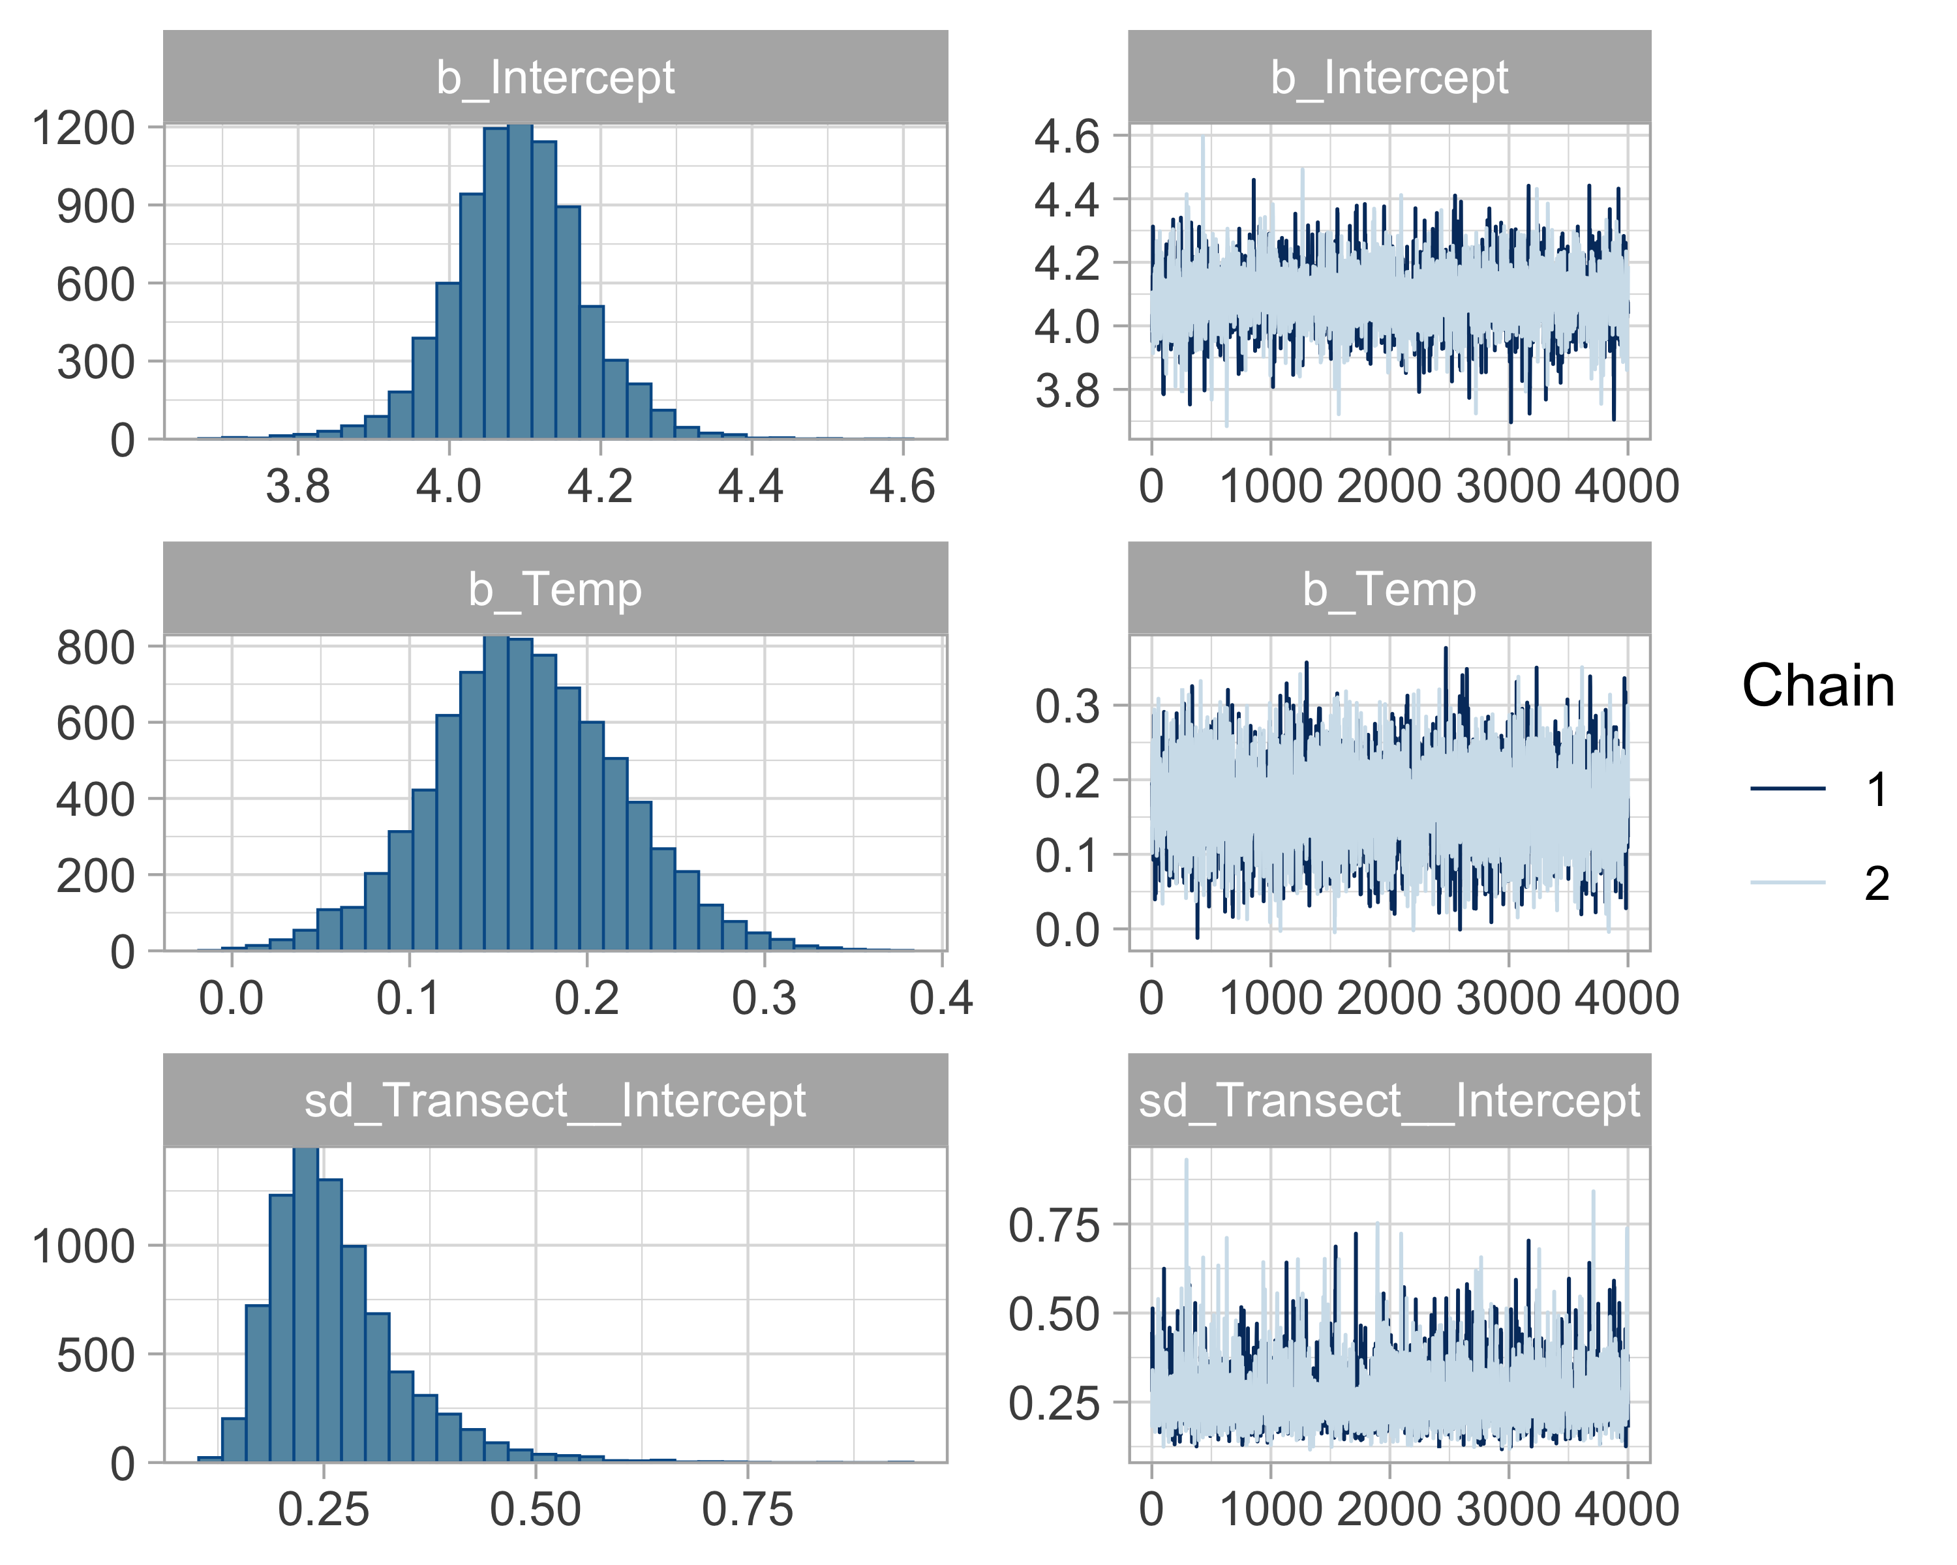

Figure 45: Convergence diagnostics for the partial pooling model. In the histograms (left column), the x-axis shows possible parameter values (intercept, slope, or SD) and the y-axis shows their frequency in the posterior sample. In the trace plots (right column), the x-axis shows the MCMC iteration and the y-axis shows the sampled parameter value.

We can now update Figure 44 with Figure 46:

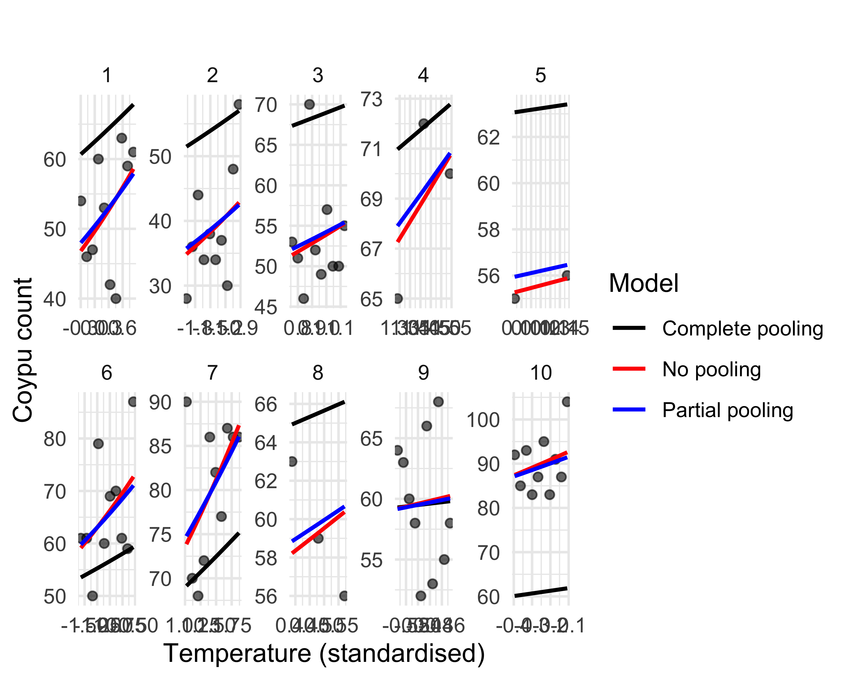

Figure 46: Comparison among complete pooling (black), no pooling (red), and partial pooling (blue) models to predict coypu counts as a function of temperature, by transect. No pooling fits a separate curve for each transect, complete pooling assumes a common relationship, and partial pooling provides a compromise via a transect random effect.

We see that the partial pooling fit is very similar to the no pooling fit, and much better than complete pooling. There is a small difference for transects with few sampling points (transects 4, 5, and 8): for those, partial pooling is closer to complete pooling. In the absence of much information for these transects, it is reasonable that their estimates are pulled toward the overall mean rather than toward extreme, transect-specific values.

This is the information-sharing mechanism known as **borrowing strength**. It leads to **shrinkage**, which buffers the tendency of the no pooling (fixed-effect) model to overfit. In that sense, partial pooling also provides a form of **regularisation**.

Model fit is validated in Figure 47:

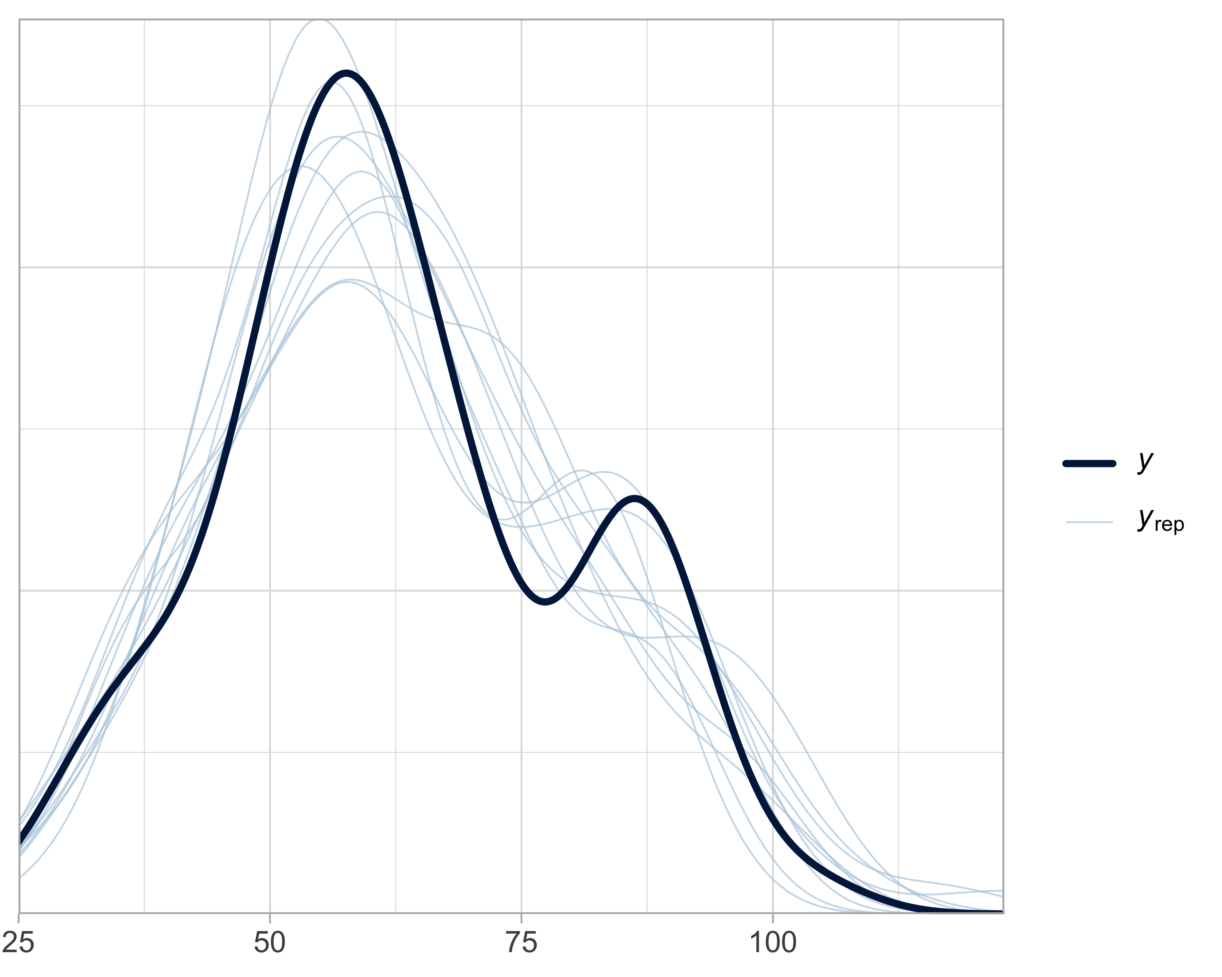

Figure 47: Model-check for the partial pooling model. The x-axis shows possible values of the observed or simulated response. The y-axis shows the estimated density. Simulated distributions (blue) are compared with the observed data (black).

When fitting a model with a standardised predictor (here, temperature), coefficients $β_{0}$ and $β_{1}$ are interpreted on that modified scale: $β_{1}$ corresponds to a one-standard-deviation change in temperature, and $β_{0}$ corresponds to the expected value when standardised temperature equals 0 (i.e., at mean temperature). In practice we often want effects in natural units (degrees Celsius) rather than in standard deviations. We can convert coefficients back to the original scale using:

$$β_{1}^{\text{original}}=\frac{β_{1}^{\text{standardised}}}{\text{SD}\left(\text{temperature}\right)}$$

$$β_{0}^{\text{original}}=β_{0}^{\text{standardised}}-β_{1}^{\text{standardised}}×\frac{\text{Mean}\left(\text{temperature}\right)}{\text{SD}\left(\text{temperature}\right)}$$

In R, you can use:

# extract posterior draws for fixed effects  
post <- as_draws_matrix(fit_partial)  
sbzero <- post[, "b_Intercept"]  
sbun <- post[, "b_Temp"]  
  
# mean and SD of temperature  
mu <- attr(scale(sim_simple$Temperature), "scaled:center")  
sg <- attr(scale(sim_simple$Temperature), "scaled:scale")  
  
# convert standardised coefficients to the original scale  
bun <- sbun / sg # beta1 (original scale)  
bzero <- sbzero - sbun * mu / sg # beta0 (original scale)

We can then visualise coefficients on the original scale and compare them to the values used for simulation (Figures 48 and 49):

tibble(b0 = bzero) %>%  
 ggplot(aes(x = b0)) +  
 geom_histogram(color = "white", fill = "skyblue", bins = 30) +  
 geom_vline(xintercept = 0, color = "red", linewidth = 1.2) +  
 labs(  
 x = expression(beta[0]),  
 y = "Frequency"  
 ) +  
 theme_minimal()

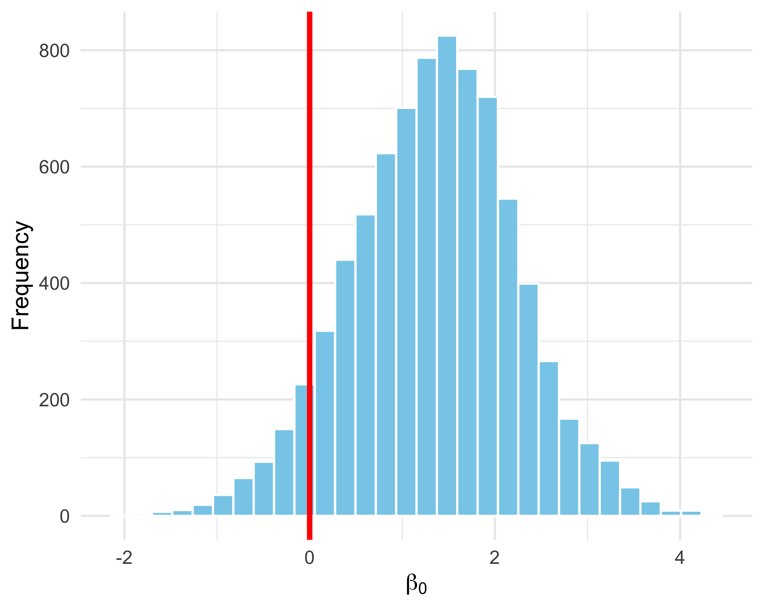

Figure 48: Posterior distribution of the mean intercept (original scale). The red line indicates the true value (0).

tibble(b1 = bun) %>%  
 ggplot(aes(x = b1)) +  
 geom_histogram(color = "white", fill = "skyblue", bins = 30) +  
 geom_vline(xintercept = 0.2, color = "red", linewidth = 1.2) +  
 labs(  
 x = expression(beta[1]),  
 y = "Frequency"  
 ) +  
 theme_minimal()

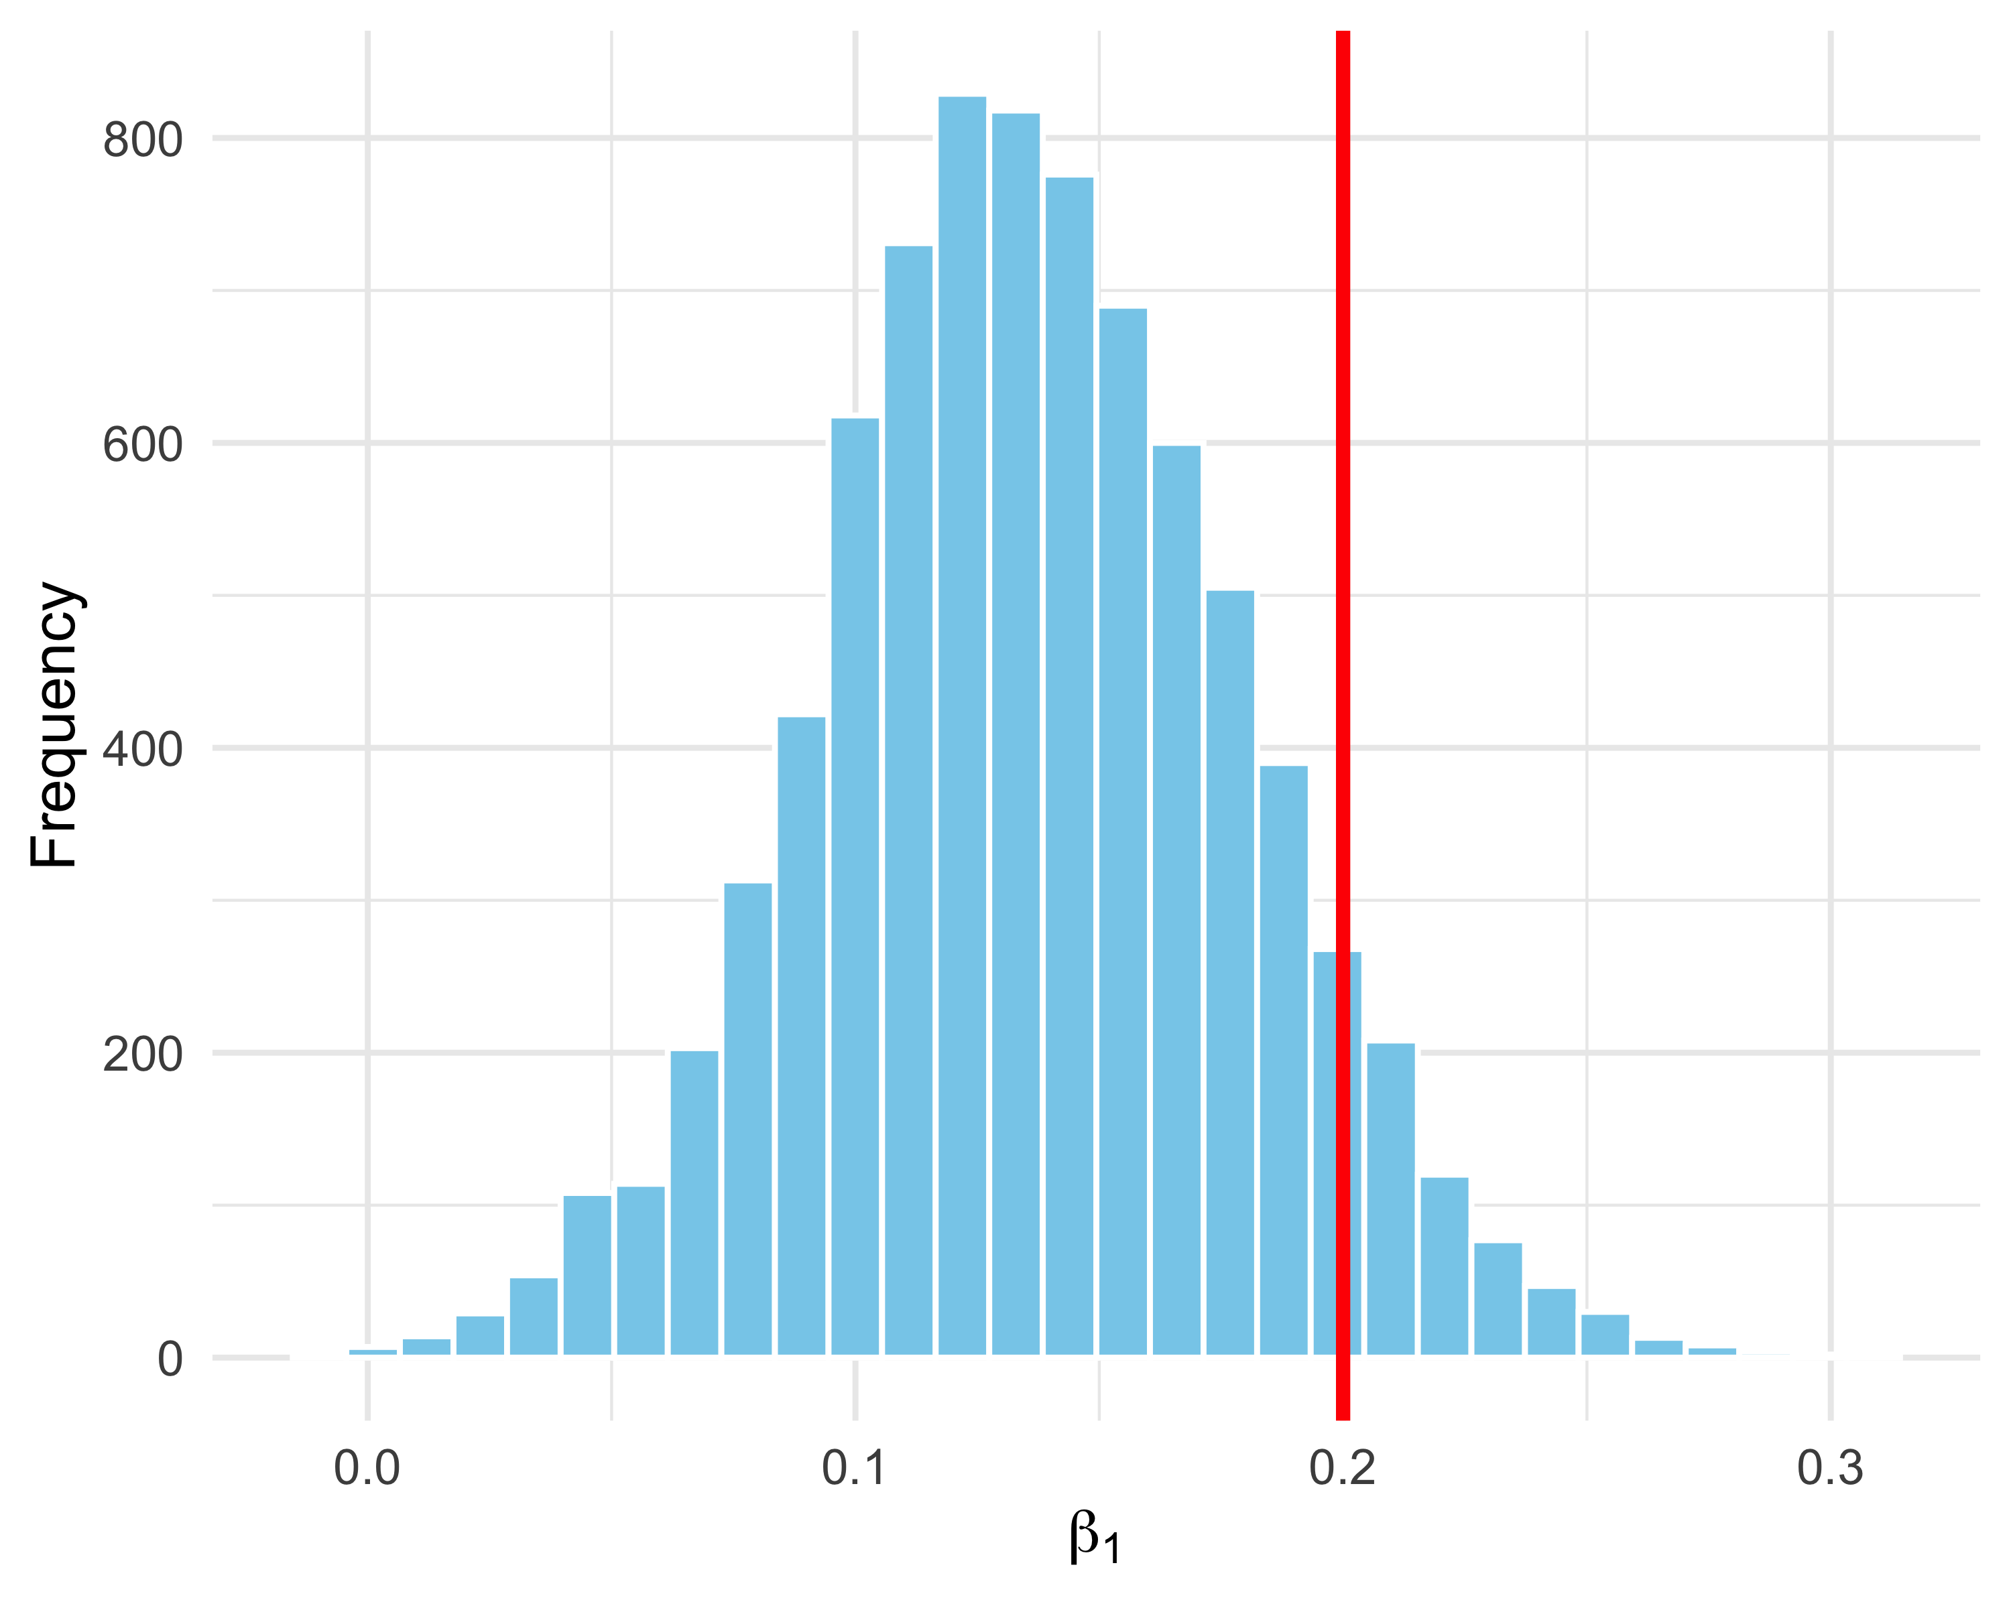

Figure 49: Posterior distribution of the temperature effect (original scale). The red line indicates the true value (0.2).

We recover the parameters used to simulate the data (in red). This is only one simulation run, so it is normal that the posterior mode does not coincide exactly with the true value. Repeating the simulation many times would allow us to assess bias and variability more formally.

As a bonus, let us compare models with and without a temperature effect. This evaluates whether temperature is a useful predictor:

# partial pooling model without temperature  
fit_partial2 <- brm(Ragondins ~ 1 + (1 | Transect),  
 data = sim_simple,  
 family = poisson("log"))

We compute WAIC for each model and compare:

waic1 <- waic(fit_partial)  
waic2 <- waic(fit_partial2)  
  
tibble(  
 Model = c("With temperature", "Without temperature"),  
 WAIC = c(waic1$estimates["waic", "Estimate"],  
 waic2$estimates["waic", "Estimate"])  
)  
#> # A tibble: 2 × 2  
#> Model WAIC  
#> <chr> <dbl>  
#> 1 With temperature 542.  
#> 2 Without temperature 551.

In conclusion, the model including temperature provides a better fit according to WAIC—which is reassuring since the data were simulated under that model.

#### Fitting the model with NIMBLE

We now repeat the analysis with a GLMM in NIMBLE. We start by writing the model code:

model <- nimbleCode({  
 for (i in 1:n){  
 count[i] ~ dpois(theta[i]) # Poisson likelihood  
 log(theta[i]) <- intercept[transect[i]] + # random intercept by transect  
 beta1 * x[i] # temperature effect  
 }  
  
 for (j in 1:nbtransects){  
 intercept[j] ~ dnorm(beta0, sd = sigma) # intercepts ~ Normal(beta0, sigma)  
 }  
  
 beta0 ~ dnorm(0, sd = 1.5) # prior for the mean intercept  
 sigma ~ dexp(1) # prior for the random-effect SD  
 beta1 ~ dnorm(0, sd = 1.5) # prior for the slope  
})

Let us comment briefly on this code. In the loop for (i in 1:n), we define a Poisson likelihood for each observation, count[i] ~ dpois(theta[i]). The intensity theta[i] (the expected number of coypus) depends on two components: intercept[transect[i]] is the intercept specific to the transect to which observation $i$ belongs, and beta1 * x[i] is the linear temperature effect.

The term intercept[transect[i]] illustrates **nested indexing**: for each observation $i$, we retrieve the appropriate intercept from a vector of transect-specific intercepts (intercept[j]) using the index transect[i]. The vector transect contains, for each observation $i$, the identifier of the transect it belongs to. For example, if observation 5 belongs to transect 3, then transect[5] = 3 and we use intercept[3]. This avoids writing a double loop over transects: each observation dynamically picks the intercept that corresponds to its group.

The block for (j in 1:nbtransects){ intercept[j] ~ dnorm(beta0, sd = sigma) } defines the hierarchical structure: transect intercepts are not estimated independently (as in a fixed-effect model), but are treated as random draws around a global mean beta0, with between-transect variability sigma.

We read constants and data:

my.constants <- list(  
 n = nrow(sim_simple), # number of observations  
 nbtransects = transects # number of transects  
)  
  
my.data <- list(  
 x = as.vector(sim_simple$Temp), # standardised covariate  
 count = sim_simple$Ragondins, # counts  
 transect = as.numeric(sim_simple$Transect) # transect ID  
)

We specify initial values for two MCMC chains:

init1 <- list(  
 intercept = rnorm(transects),  
 beta1 = rnorm(1),  
 beta0 = rnorm(1),  
 sigma = rexp(1)  
)  
  
init2 <- list(  
 intercept = rnorm(transects),  
 beta1 = rnorm(1),  
 beta0 = rnorm(1),  
 sigma = rexp(1)  
)  
  
initial.values <- list(init1, init2)

We also specify parameters to monitor and MCMC settings:

parameters.to.save <- c("beta1", "beta0", "sigma")  
n.iter <- 5000 # total iterations  
n.burnin <- 1000 # burn-in  
n.chains <- 2 # number of chains

Finally, we run NIMBLE:

mcmc.output <- nimbleMCMC(  
 code = model,  
 data = my.data,  
 constants = my.constants,  
 inits = initial.values,  
 monitors = parameters.to.save,  
 niter = n.iter,  
 nburnin = n.burnin,  
 nchains = n.chains,  
 progressBar = FALSE  
)

The results are:

MCMCsummary(object = mcmc.output, round = 2)  
#> mean sd 2.5% 50% 97.5% Rhat n.eff  
#> beta0 4.07 0.09 3.88 4.07 4.24 1.00 4587  
#> beta1 0.17 0.05 0.07 0.16 0.28 1.03 77  
#> sigma 0.26 0.08 0.16 0.25 0.46 1.00 856

As with brms, coefficients are estimated on the standardised temperature scale. To return to the original scale we use:

$$β_{1}^{\text{original}}=\frac{β_{1}^{\text{standardised}}}{\text{SD}\left(\text{temperature}\right)}$$

$$β_{0}^{\text{original}}=β_{0}^{\text{standardised}}-β_{1}^{\text{standardised}}×\frac{\text{Mean}\left(\text{temperature}\right)}{\text{SD}\left(\text{temperature}\right)}$$

In R:

# concatenate the two chains  
samples <- rbind(mcmc.output$chain1, mcmc.output$chain2)  
  
# posterior draws for coefficients (standardised scale)  
sbzero <- samples[, "beta0"] # beta0 (standardised)  
sbun <- samples[, "beta1"] # beta1 (standardised)  
  
# mean and SD of temperature  
mu <- attr(scale(sim_simple$Temperature), "scaled:center")  
sg <- attr(scale(sim_simple$Temperature), "scaled:scale")  
  
# convert to original scale  
bun <- sbun / sg # beta1 (original scale)  
bzero <- sbzero - sbun * mu / sg # beta0 (original scale)

We can then visualise coefficients on the original scale and compare to the simulation values (Figures 50 and 51):

tibble(b0 = bzero) %>%  
 ggplot(aes(x = b0)) +  
 geom_histogram(color = "white", fill = "skyblue", bins = 30) +  
 geom_vline(xintercept = 0, color = "red", linewidth = 1.2) +  
 labs(  
 x = expression(beta[0]),  
 y = "Frequency"  
 ) +  
 theme_minimal()

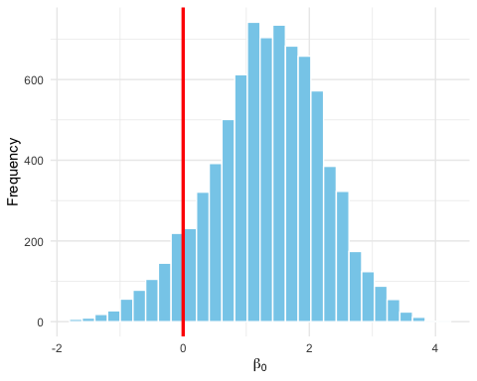

Figure 50: Posterior distribution of the mean intercept (original scale). The red line indicates the true value (0).

tibble(b1 = bun) %>%  
 ggplot(aes(x = b1)) +  
 geom_histogram(color = "white", fill = "skyblue", bins = 30) +  
 geom_vline(xintercept = 0.2, color = "red", linewidth = 1.2) +  
 labs(  
 x = expression(beta[1]),  
 y = "Frequency"  
 ) +  
 theme_minimal()

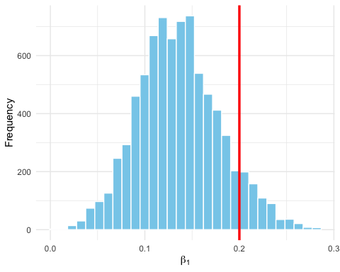

Figure 51: Posterior distribution of the temperature effect (original scale). The red line indicates the true value (0.2).

We recover the parameters used to simulate the data (in red). As with brms, we ran only one simulation, so it is normal not to match the true values exactly. Repeating simulations many times would provide a more formal assessment.

Let us compare models with and without temperature using WAIC. We need to fit the model without temperature:

# model code without temperature  
model.null <- nimbleCode({  
 for (i in 1:n){  
 count[i] ~ dpois(theta[i])  
 log(theta[i]) <- intercept[transect[i]]  
 }  
 for (j in 1:nbtransects){  
 intercept[j] ~ dnorm(beta0, sd = sigma)  
 }  
 beta0 ~ dnorm(0, sd = 1.5)  
 sigma ~ dexp(1)  
})  
  
# run the null model  
parameters.null <- c("beta0", "sigma")  
  
mcmc.null <- nimbleMCMC(  
 code = model.null,  
 data = my.data,  
 constants = my.constants,  
 inits = list(beta0 = 0, sigma = 1, intercept = rnorm(transects)),  
 monitors = parameters.null,  
 niter = n.iter,  
 nburnin = n.burnin,  
 nchains = n.chains,  
 progressBar = FALSE,  
 WAIC = TRUE  
)  
#> [Warning] There are 3 individual pWAIC values that are greater than 0.4. This may indicate that the WAIC estimate is unstable (Vehtari et al., 2017), at least in cases without grouping of data nodes or multivariate data nodes.

We also need to rerun the full model with WAIC = TRUE (not shown here).

We can then compare WAIC:

# WAIC values  
waic.full <- mcmc.output$WAIC$WAIC  
waic.null <- mcmc.null$WAIC$WAIC  
  
# comparison table  
tibble(  
 Model = c("With temperature", "Without temperature"),  
 WAIC = c(waic.full, waic.null)  
)  
#> # A tibble: 2 × 2  
#> Model WAIC  
#> <chr> <dbl>  
#> 1 With temperature 542.  
#> 2 Without temperature 552.

#### Frequentist fit with lme4

To close this chapter, let us run the same GLMM analysis in a frequentist framework using lme4.

We load the package:

library(lme4)

Then we fit the GLMM (note that brms syntax is inspired by lme4):

fit_lme4 <- glmer(  
 Ragondins ~ Temp + (1 | Transect), # full formula  
 data = sim_simple, # simulated data set  
 family = poisson # Poisson family for counts  
)

Results:

summary(fit_lme4)  
#> Generalized linear mixed model fit by maximum likelihood (Laplace  
#> Approximation) [glmerMod]  
#> Family: poisson ( log )  
#> Formula: Ragondins ~ Temp + (1 | Transect)  
#> Data: sim_simple  
#>   
#> AIC BIC logLik -2*log(L) df.resid   
#> 568.3 575.3 -281.1 562.3 75   
#>   
#> Scaled residuals:   
#> Min 1Q Median 3Q Max   
#> -1.9501 -0.6223 -0.1098 0.4779 2.3897   
#>   
#> Random effects:  
#> Groups Name Variance Std.Dev.  
#> Transect (Intercept) 0.04402 0.2098   
#> Number of obs: 78, groups: Transect, 10  
#>   
#> Fixed effects:  
#> Estimate Std. Error z value Pr(>|z|)   
#> (Intercept) 4.08804 0.06898 59.266 < 2e-16 ***  
#> Temp 0.15797 0.04863 3.248 0.00116 **   
#> ---  
#> Signif. codes: 0 '***' 0.001 '**' 0.01 '*' 0.05 '.' 0.1 ' ' 1  
#>   
#> Correlation of Fixed Effects:  
#> (Intr)  
#> Temp -0.106

How to read the output?

| Item | Meaning |
| --- | --- |
| (Intercept) | Mean log-abundance for a typical transect at mean Temp. |
| Temp | Linear effect of temperature. |
| Random effects | SD (Std.Dev) of the random intercept. |

You will notice that parameter estimates are very close to those obtained with brms and NIMBLE.

## Summary

* Generalised linear models (GLMs) extend linear models to situations where a normal error assumption is not appropriate.
* The general idea is to use a distribution adapted to the response – Bernoulli/binomial for binary responses (0/1), Poisson for counts (0, 1, 2, …) – and to link the mean of that distribution to predictors through a link function (such as logit or log).
* Adding random effects allows us to model hierarchical grouping structures (e.g., sites, individuals, transects), capturing heterogeneity while sharing information across groups.
* Generalised linear mixed models (GLMMs) jointly estimate fixed effects (population-level) and random effects (group-level, assumed drawn from a common distribution).
* A *complete pooling* model ignores group structure and assumes all data follow the same relationship. This can bias conclusions if groups truly differ. A *no pooling* model fits separate relationships per group with no information sharing, leading to highly variable estimates when some groups have small sample sizes. *Partial pooling* (GLMMs / hierarchical models) is a compromise: groups have their own parameters, but these are linked by a common distribution. This improves stability while still respecting between-group differences.

# Conclusions

## What we covered

I hope that with this book I have (at least a little) demystified Bayesian statistics and MCMC methods. I also hope to have given you the tools to understand the difference between frequentist and Bayesian approaches, to better read the “Methods” section of papers using Bayesian statistics, and to gain a certain level of autonomy in conducting Bayesian analyses.

Throughout the book, we covered several essential steps. We began by exploring the motivations for using the Bayesian approach. We then introduced Bayes’ theorem and discussed its interpretation. We discovered Markov chain Monte Carlo (MCMC) methods, and then worked with two powerful tools, NIMBLE and brms, to fit complex models. Particular attention was given to the role of prior distributions, whether non-informative or informative, as well as to the use of these approaches in case studies involving GLM and GLMM.

## Bayesian statistics, in a nutshell

The Bayesian approach offers many advantages. It allows uncertainty to be quantified coherently using probability, it enables the explicit integration of prior knowledge, and it makes it possible to fit complex models via MCMC. In addition, Bayesian credible intervals are more intuitive than frequentist confidence intervals.

Some caution is nevertheless required. Checking the convergence of MCMC chains is a crucial step, but sometimes a laborious one. The choice of prior distributions requires careful consideration. Model fit must always be evaluated. Finally, the computational cost is not negligible, especially for the most complex models and/or large datasets.

## A few tips

Before finishing, I would like to leave you with a few tips inspired by my own experience. These tips are not necessarily specific to Bayesian statistics, and they are worth what they are worth.

First, take the time to clearly formulate your question. This may seem obvious, but this step is essential to stay on track and make the right choices, for example deciding to use only a subset of the data to answer a specific question.

Next, think about your model first, and formalize it either with equations, by drawing it, or in words. What is the nature of your data, and therefore, if you are in a regression framework, which family of distributions should you use as we saw in Chapters 5 (normal) and 6 (Bernoulli/binomial and Poisson)? Do not rush to the keyboard. Make sure you understand it, for example by explaining it to colleagues.

On that note, remember to run simulations. Simulating data from your model often helps you understand it better, as in Chapters 5 and 6. It is an excellent way to test your assumptions and diagnose potential issues.

Choose the R environment you are comfortable with; I illustrated brms and NIMBLE (Chapter 2), but other solutions exist.

When fitting the model, start simple. A model with all parameters constant is a good baseline. This ensures that the data are read and formatted correctly, that there are no outliers (an extra zero, a misplaced comma), and that the priors do not generate unexpected behavior (see Chapter 4). This approach is particularly important in Bayesian statistics to ensure good performance and convergence of the MCMC algorithm (Chapter 2), while also giving you an idea of the time required to run the analysis. Once everything looks good, gradually add complexity, random effects for example (Chapter 6), until you reach the model structure that seems most appropriate to answer your question. This likely implies several iterations of fitting, comparing, and validating your models (Chapters 5 and 6).

For further practical guidance, I recommend reading the papers “Ten quick tips to get you started with Bayesian statistics” (Gimenez et al. 2025) and “Bayesian workflow” (Andrew Gelman et al. 2020).

## To conclude

Adopt a pragmatic approach. The choice of statistical approach (frequentist or Bayesian) depends on your objectives, whether they concern speed, model complexity, or the type of uncertainty you want to quantify. Discuss your options with more experienced colleagues if needed. Bayesian statistics is not a dogma: it is a powerful tool among others in your toolbox.

Thank you for your attention. Feel free to write to me if you have questions or if you would like to see a particular aspect developed in a new edition of this book. And enjoy exploring Bayesian statistics!

Albert, Jim. 2009. *Bayesian Computation with R*. 2nd ed. Springer.

Gelman, A., J. B. Carlin, H. S. Stern, D. B. Dunson, A. Vehtari, and D. B. Rubin. 2013. *Bayesian Data Analysis*. 3rd ed. Chapman & Hall/CRC.

Gelman, Andrew, Aki Vehtari, Daniel Simpson, Charles C. Margossian, Bob Carpenter, Yuling Yao, Lauren Kennedy, Jonah Gabry, Paul-Christian Bürkner, and Martin Modrák. 2020. “Bayesian Workflow.” <https://arxiv.org/abs/2011.01808>.

Gimenez, Olivier, Andy Royle, Marc Kéry, and Chloé R. Nater. 2025. “Ten Quick Tips to Get You Started with Bayesian Statistics.” *PLOS Computational Biology* 21 (4): 1–13.

Johnson, A. A., M. Q. Ott, and M. Dogucu. 2022. *Bayes Rules!: An Introduction to Applied Bayesian Modeling*. 1st ed. Chapman & Hall/CRC.

Kéry, M., and K. F. Kellner. 2010. *Applied Statistical Modelling for Ecologists: A Practical Guide to Bayesian and Likelihood Inference Using R, JAGS, NIMBLE, Stan and TMB*. 1st ed. Elsevier.

Kruschke, J. K. 2010. *Doing Bayesian Data Analysis: A Tutorial with R and BUGS*. Academic Press Inc.

Matthiopoulos, Jason. 2011. *How to Be a Quantitative Ecologist: The ’A to R’ of Green Mathematics and Statistics*. Chichester, West Sussex, U.K: Wiley.

McCarthy, M. A. 2007. *Bayesian Methods for Ecology*. Cambridge University Press.

McElreath, R. 2020. *Statistical Rethinking: A Bayesian Course with Example in R and Stan*. 2nd ed. Chapman & Hall/CRC.